Texas Department of Transportation
Safer by Design (SBD) Tool

https://sbd.txdot.gov

Frequently Asked Questions (FAQ)

by Texas Department of Transportation
February 2024 V1.0

TxDOT updates this FAQ periodically

Question 0-1: Can the tool evaluate Design1 and Design2 without Existing?
No, the Existing configuration is required for each segment or intersection. Both Standard and Optimal configurations are based on Existing, thus, Existing configurations must be finished. For a future project, users may use the proposed configuration and projected traffic volume as the existing configurations.

Question 0-2: The tool does not ask for password and automatically logs me in?
The tool uses the technique of Single-Sign-On (SSO). This happens if the user has already signed in to TxDOT (e.g., TxDOT email) on the computer, the SSO server still recognizes the user.

Question 0-3: Tool shows Error Message?
Please check the inputs, it is possible that some required elements are missing or incorrect. Alternatively, try opening a new tab and re-assess the project. If the error persists, please make a screen print with error message and inputs, and send it to the tool development team (DES_SaferByDesign@txdot.gov and SBDToolSupport@tti.tamu.edu). Although the tool development team has conducted various types of testing, it is possible there are still some special cases causing the calculation failure.

Urban Segments

Category 1: General Questions

Question 1-1: What urban segment projects are eligible for this Tool?
Eligibility Matrix - Safer by Design Urban Segment
Added Capacity/Mobility | Yes
Major Rehab/widening | Yes
Bridge Replacements (On-system) | Yes
Bridge widening/major rehab (On-system) | Yes
Seal Coats/Overlays | Yes
Full Depth Spot Repair | Yes
Replacing existing signs/striping | See Note 1 | No
Freeways or Frontage Roads |  | No
Bridge Maintenance/Repair |  | No
Bridge Replacements (Off System) |  | No
Sidewalk/SUP/Bike Path Project | Yes
On-system Locally Let Projects | Yes
Off-system Locally Let Projects |  | No
Border Infrastructure |  | No
Category 8 Widening projects (all) | Yes
Category 8 HSIP (non-widening) |  | No
*RTZ projects will be reported separately.
Note 1: Will be required if changes to signing/striping alter roadway cross section

Question 1-2: Can the tool be used on suburban projects?
Yes, Urban Tool applies to both urban and suburban highways. Note that on suburban highways, posted speed limits (PSLs) are relatively higher, SPFs and CMFs in the tool have considered the PSLs when applicable.

Question 1-3: Can the tool be used for 8-lane undivided roadways?
No, this type of roadway is rare, and SPFs or CMFs are not available. For other types of rare roadways (e.g., 2-lane divided, uneven lane number roadways), SPFs and CMFs are not available either. Currently, the tool cannot assess safety levels for those types of highways.

Question 1-4: Some driveways have high volumes (e.g., a restaurant), should they be considered as intersections?
Usually, those driveways count as a major driveway. The user may consider it as an intersection, and split the segment at that location. Engineering judgements should be used based on specific driveway situations.

Question 1-5: What to do if there is lane drop on the segment?
Need to split the segment at the lane drop location.

Question 1-6: What if the sidewalk stops/changes in a segment?
No need to split the segment. The user may examine the proportion of the segment with sidewalk/pedestrian facility, and fill the tool based on the majority of the segment.

Question 1-7: What is the project submission flow?
There are three types of user’s roles in the tool: general user (referred as analyst), district level manager and TxDOT division-level administrator. The submit flow is that an analyst completes each project safety assessment, then a corresponding district level manager reviews the project and make modifications when needed, and finally submit to TxDOT level administrators. TxDOT level administrators may send back a submitted project to the district level managers and analysts when needed. District level managers and analysts shall address comments and re-submit.

Question 1-8: Can users/admin send back a project with attachments?
No, this tool is not for communication purposes. The user is encouraged to use email for sending attachments.

Question 1-9: Is there an ability to account for railroad crossing?
No. Highway-Railroad grade crossing or intersection SPFs are unavailable. Tool development team will incorporate it in future updates when research is available.

Question 1-10: Does turning lane count?
No, only Two-Way Left-Turn Lane (TWLTL) counts. CMF for turning lane on urban segments is not available. Tool development team will incorporate in future updates when research is available.

Question 1-11: What are the references for SPFs and CMFs?
Users who are interested in the SPFs and CMFs may contact TxDOT Design Division to request a copy of the project Technical Memorandum, which documents the methodology, SPFs, and CMFs for assessing roadway safety.

Question 1-12: Can the tool have more designs in addition to Design 1 and Design 2?
That makes it too complicated. The user needs to use Design 1 and Design 2 to compare different configurations.

Question 1-13: Not all elements are reflected in the vortex plot.
The current vortex plot only shows elements with CMFs. In the case the safety effect is captured by a SPF (e.g., driveway number on urban 4-lane undivided), it is not shown in the plot. Those elements will be added to vortex plots in the future version of the tool.

Question 1-14: Can the tool connect to TxDOT CONNECT, CRIS, RHiNO, etc.?
Yes, this is a long-term objective of the tool. The tool shows the TxDOT roadway network map, users zoom in, click on a segment, tool loads data from TxDOT roadway inventory, CRIS, etc. The research team will explore the feature in the future version.

Question 1-14: Is it possible to conduct sensitivity analyses using the tool? Can the tool show scores instantly?
This is not the main purpose of this safety scoring tool. The user needs to test sensitivity in Design1 or Design2 by changing their element values. The scores cannot be shown instantly as users change the values.

Category 2: Basic

Question 2-1: Should a segment exclude the intersection influence area?
Yes, if the segment begins with an intersection, the from DFO should add 0.047 (i.e., 250 ft); likewise, if ends with an intersection, to DFO should deduct 0.047.

Question 2-2: Is ADT the existing or projected ADT? Which year of ADT should be used? Opening, existing, or design year?
It should be existing. For future/new roadways, the user needs to use the projected ADT of opening year. The use of ADT should be consistent among all the designs (i.e., columns of Existing, Design1, and Design2).

Question 2-3: Is truck ADT or truck ADT percentage considered?
No, the CMF of truck ADT/percentage in the urban environment is not available. Tool development team will incorporate truck ADT in future version when research is available.

Category 3: Geometric

Question 3-1: Options for median width on divided roadways are 10, 15, etc. There are some roadways with median width less than 10 ft.
CMFs for median less than 10 ft are not available. The user needs to select 10 ft if it is less than 10 ft (i.e., the closest in the option list).

Question 3-2: There are grass medians. Should they be considered as divided or undivided?
Divided, whether there is a curb or not.

Question 3-3: If one element has multiple super-elevations, how to fill the number?
Use the worst case (i.e., sharpest curve).

Category 4: Roadside

Question 4-1: How to measure the parking length? Is it the single parking lot length or the whole length?
Count the objects within the Right-of-Way up to 30 feet from the edge of pavement. Fence and barriers should not be counted as fixed objects.

Question 4-2: Does it matter if you have a barrier curb? Is vertical curb counted as fixed object?
No, a curb does not prevent a vehicle from departing the roadway. Vertical curb should not be considered as a fixed object on lower speed roadways (PSL <= 45 mph); should be considered as a fixed object on higher speed roadways (PSL > 45 mph).

Category 5: Pedestrians

Question 5-1: Is the shared path only for designated pedestrians?
Share use paths are for any and all non-motorized modes (e.g., walking and cycling and likely roller blading, skateboarding and scooters)

Question 5-2: Does the side (i.e., left or right) sidewalk matter?
Yes, the sidewalk should be considered by side, as for the pedestrian flow level. The current version of the tool does not differentiate sidewalk by direction due the pedestrian crash prediction methodology. It will be updated in the future.

Category 6: Bicyclists

6-1: What shoulder width is necessary for a shoulder to be considered bikeable?
A 5-ft or wider paved shoulder may serve as a bike lane.

Urban Intersections

Category 1: General Questions

Question 1-1: What urban intersection projects are eligible for this Tool?
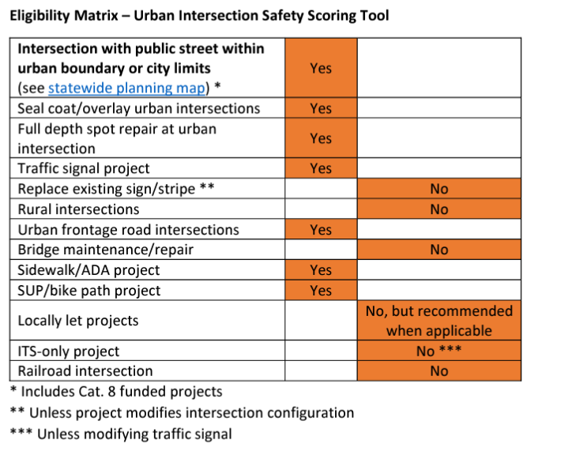

Question 1-2: a. During which stage should this tool be used?
b. Where can we find that Excel spreadsheet?
a. The tool can and should be used for all phases of development including planning, preliminary design (schematics) and final design (PS&E). The most value will be when using it during the initial project scoping.
b. The Excel-based urban intersection tool has been deprecated, the web-based tool can be found from: https://sbd.txdot.gov

Question 1-3: How is the rural segment scoring tool related to the intersection tool? Is there a plan to combine all these tools in a single tool to minimize confusion or misunderstanding on what spreadsheets are required as more come into use?
These are two separate tools as of now. The rural segment scoring tools are applicable to rural roadways, whereas the urban segment and urban intersection scoring tool is applicable to urban and suburban areas. Eventually, there will be integrated segment and intersection tools for both rural and urban roadway projects. The long-term plan is to have integrated segment and intersection tools for rural and urban facilities.
As of date, the urban segment and intersection tools have been integrated into the web-based tool. Rural segment and rural intersection tools will be integrated into the web-based tool in the near future.

Question 1-4: Can the intersection tool be used for suburban or rural town intersections within the urbanized boundary?
Yes, the tool should be used for all intersections classified as urban and suburban. The tool can also be used for rural town intersections.

Question 1-5: What is the timeline for urban segment and/or rural intersection tools?
As of date, the urban segment and intersection tools have been developed in the web-based tool. The Team will start web-based rural tool development from March2024.

Question 1-6: If the recommendations from the tool are not implemented, do we need to justify?
This tool is not intended to mandate intersection configuration selection or the implementation of other intersection characteristics. This is a scoping tool focused on how much we can improve safety on each individual project. However, the primary constraints preventing project from achieving optimal score should be documented on the “Reporting” tab. We understand scoping decisions may impact project cost and overall District programming. The goal is for the tool to assist in design discussions and help Districts maximize the amount of safety we can get out of each project.

Question 1-7: What if the crossing streets/roadways have major changes? Examples: How do evaluate the proposed intersection configuration from 3-leg to 4-leg or from 4-leg to 3-leg? Widening roadways: how do you fill out scoring tool? The tool currently assumes capacity of approach legs is fixed. Cannot show a “widening” currently. Have to fill out existing a 4 lane, then start a new tool and fill out existing as 6 lane (for example).
The current version of the intersection scoring tool assumes that there are no significant changes at the intersections, i.e., number of legs, crossing streets (one-way/two-way, speed limit, number of through lanes).
If users need to evaluate intersections with major changes, enter the proposed intersection characteristics (e.g., number of legs, lanes, projected AADT, projected pedestrian and bicyclist volume level, etc.) in the “General Site Features” section. The evaluation will be based on the proposed intersection. Comparison between existing and proposed intersection configurations cannot be conducted directly, so for reporting purposes, the existing score would be “not applicable”.

Question 1-8: How are frontage road intersections handled?
A diamond intersection needs to be considered as two separate intersections along each of the frontage roadways. For example, a 3-leg intersection at a one-way frontage roadway can be analyzed by specifying the crossing frontage roadway as one-way.

Question 1-9: Is the Safety Scoring Tool required if no federal money is included?
All applicable TxDOT statewide construction projects – regardless of funding – are required to be evaluated with the tool, and to report safety scores. On-system locally let projects are also required to report safety scores. Off-system locally let projects are not required to report safety scores, but it is still recommended that the tool be used for local let projects that include urban intersections.

Category 2: Intersection Basic Information and Safety Performance Functions (SPFs)

Question 2-1: How recently were the SPFs developed?
While developing the intersection scoring tool, the team referred to a wide variety of literature and identified a number of state-of-art research reports (see references at the end of this document) that focused on modeling intersection crashes. All of them were developed in the last 5 years. It is worth mentioning previous studies have shown that most of the SPFs for roadway entities remain relatively stable over the years. The reference sources provided most of the safety performance functions. As new research, including Texas-specific research, develops new SPFs, they will be incorporated into the tool.

Question 2-2: Is SPUI considered in tool
The Single-Point Urban Interchange (SPUI) is not considered in the intersection scoring tool, because the safety performance or crash modification factor for SPUI is still unknown. We do recognize this as an item we plan to incorporate in a future update to the tool if the research is available.

Question 2-3: What types of crashes are considered in the tool? Does the tool use fatalities & injuries (KABC) crashes or total crashes (KABCO)?
The safety score is calculated based on total crashes, i.e., all severity levels and crash types. In terms of crash types, vehicular (single motor vehicle or multiple motor vehicle crash), pedestrian (a crash involving a pedestrian and a motor vehicle), and bicyclist (a crash involved a bicyclist and a motor vehicle) crashes are analyzed separately.

Question 2-4: Does the tool distinguish between truck and car traffic?
Trucks and passenger cars are not distinguished in the tool. The tool uses average daily traffic (ADT), which is consistent with the manner in which the SPFs were developed.

Question 2-5: Can the tool analyze 5-leg intersections?
For 5-leg intersections, there is only one control type ‘signal’ because the only SPF available for 5-leg intersections is for a signalized intersection. As more research becomes available in the future (particularly regarding 5-leg roundabouts), more options will be available to analyze for 5-leg intersections.

Question 2-6: If the intersection has two roadways with the same classification, how are the major and minor roadways identified?
The roadway with the higher traffic volume should be considered as the major roadway, and the roadway with the lower traffic volume is considered as minor. Both roadways may also have the same classification and similar elements.

Question 2-7: What is the effect of speed limit?
The speed limit affects the safety analyses in two ways: (1) depending on the speed limit, the base SPF varies. Two identical intersections (except for the speed limit) may have different safety scores. (2) the speed limit influences the pedestrian and bicyclist safety. The tool automatically selects the appropriate SPF based on the entered speed limit information.

Question 2-8: Why does the tool ask for crashes within 250 feet of the intersection? What if I want to extend to 500 feet?
Only crashes within 250 feet from the center point of an intersections should be counted as intersection crashes. A distance of 250 feet is consistent with how SPFs utilized in the tool were developed.

Question 2-9: How the tool uses observed crash at intersections? What is the relationship between the observed crash number and the safety score for an intersection?
The tool uses observed crash numbers in two ways: (1) when determining the standard and optimal configurations, the tool uses observed crash number as well as other characteristics (i.e., volume, speed limit) to examine if the intersection meets the signal warrants; (2) when calculating the total weighted score of the corridor (Edit Report page of the web-based tool), the tool uses the observed crash number at each intersection as its weighting factor. In the case that the intersection has experienced no crash (i.e., observed crash is zero), the tool uses predicted annual total crash number. For an individual intersection, the safety score is calculated based on annual predicted total crash number, the observed crash number has no effect on its score. In addition, the predicted crash number and observed crash number are independent. The tool does not utilize the empirical Bayes (EB) method to combine the two, because multiple safety performance functions are used when predicting the number of crashes and the commonly used EB method cannot be applied directly.

Question 2-10: How do we obtain NCHRP reports for the tables?
The NCHRP 17-68, 17-70, and 17-84 reports are publicly available from the National Academy of Sciences website (https://trid.trb.org/view/1847942, https://trid.trb.org/view/1580387, https://nap.nationalacademies.org/catalog/27294/pedestrian-and-bicycle-safety-performance-functions, and https://www.trb.org/Publications/Blurbs/182691.aspx.respectively); More details of these studies can be found in the Reference section in the end of this FAQ.

Category 3: Elements and Crash Modification Factors (CMFs)

Question 3-1: Are peaking characteristics of the facility (such as peak hour) considered in the safety evaluation of the signalized intersection?
Peaking characteristics are not considered in the intersection scorning tool, because the tool mainly focuses on safety performance rather than the capacity. In almost all intersection SPF and CMF developments, peak hour characteristics are not analyzed.

Question 3-2: For the left-turn lane, does it matter whether the left turn lanes are on the major or minor approaches? Why are the selections for stop-controlled intersections limited to two approaches?
The element options and CMFs for left-turn lane are limited by information from the studies that documented the safety effects. The research report does not distinguish between whether the left-turn lanes are on major or minor roadways. Thus, left-turn lanes are treated equally on major and minor approaches in the tool. In addition, any left turn lane counts, whether on the major or minor approach.

Question 3-3: I am working of on HSIP project where free intersection is proposed to restrict to LTL from major road only. How can I evaluate intersection safety score?
Enter the total number of left turns that are prohibited. The research studies did not distinguish between major and minor roads.

Question 3-4: Will the number of inputs change in future?
As new research results become available, the tool will be updated periodically to incorporate the latest intersection safety studies. There will be changes on the elements as well as the options of each element. As such, the number of inputs will likely increase.

Question 3-5: Why is sight distance only required for unsignalized condition? Why is sight distance not considered for signalized intersections?
The safety impacts of sight distance are most critical for unsignalized operations. The CMF for sight distance (http://www.cmfclearinghouse.org/detail.cfm?facid=9656) was developed for stop-controlled intersections. For signalized intersections, the primary sight distance issue is for right-turns-on-red. We suggest that the analyst determines if AASHTO Green Book criteria are met for the right turns, and that right-turns-on-red prohibitions should be considered if the AASHTO Green Book sight distance cannot be achieved.

Category 4: Pedestrian and Bike

Question 4-1: How does the tool use bike and pedestrian data?
The tool considers peak hour ped & bike flow and annual ped & bike crashes in both directions of the roadway.

Question 4-3: How do I determine ped and bike demand for future condition if there is no existing bike/ped facilities?
TTI researchers have developed models and tools to estimate the pedestrian volume at intersections (https://cts.tti.tamu.edu/safetytools/). Users may refer to the tool to estimate the pedestrian volume for the future. The tool does need a few inputs, including intersection control type; number of schools within 1 mile; commercial and multifamily proportion; posted speed limit (mph); and CBD indicator.

Category 5: Others

Question 5-1: Can we provide a link to CRIS to obtain crash data?
Users (both internal and external to TxDOT) can use the TxDOT crash query tool (https://cris.dot.state.tx.us/public/Query/app/home) to obtain crash data at an intersection.
The tool development team has developed a step-by-step (https://sbd.txdot.gov/cris-instruction) instruction detailing how to obtain intersection crashes within 250 feet from the intersection specifically for the tool.

Question 5-2: Will the tool be updated on a regular basis?
Yes, the tool will be updated periodically. The update will (1) address comments and feedback received from users; and (2) incorporate latest intersection safety studies.

Question 5-3: If at an existing railroad highway grade crossing, an elevated intersection is proposed, how do I use the tool to evaluate that intersection?
The elevated highway intersection configuration can be analyzed as any other intersection. The current version of tool is only applicable to highway intersections. Railroad highway grade crossing or interchanges cannot be evaluated using the tool. See response to question 1-6 for additional details about how to fill out the tool.

Question 5-4: If the project limits have five intersections but only on 3 intersections are to be improved, should we include 3 or 5?
Users should include all 5 intersections in the tool. All the intersections within the project limits should be analyzed and included in the scoring.

Question 5-5: In metro areas, intersections will often already have all the options built out that are optimal in the tool. Are there other design options that can be included to help hone in on available improvements (type of right turn channelization - smart right, etc.)
The tool can only evaluate options where the safety affects are known. The future version of tool will consider other options if the research becomes available.

Question 5-6: Is the selection of alternative configuration based on ADT?
The tool does not automatically select an alternative intersection. Alternative intersections are evaluated only if the analyst selects them as an option. Specifically, the selection of alternative intersections (DDI, DLT, MUT, and RCUT) are based on two situations: (1) the predicted number of crashes, which is related to various factors, e.g., ADT, number of lanes, speed limit, etc. and (2) if the alternative intersection has been selected in existing, design 1 or design 2. In other words, if the existing is not an alternative, and the user does not consider any of them in design 1 or design 2, the tool will not consider alternatives in the optimal configuration. Only at least one of the existing, design 1 and design 2 is an alternative, the optimal would possibly be an alternative configuration. TxDOT is developing an intersection control evaluation (ICE) tool to assist designers in deciding what type of control is needed to accommodate traffic demands. This tool evaluates the safety effects of different design controls and configurations.

Question 5-7: Can alternative intersection be considered for 3-leg
The tool currently considers only a 4-leg intersection as an alternative intersection.

Question 5-8: How do these tools apply to Preventive Maintenance Projects?
Just like the rural tools, the urban intersection tool will be required for urban PM, 2R, 3R, and 4R projects. See eligibility matrix (Question 1-1) for additional details on when the tool is required. Addressing safety needs in every project is critical. In the past Cat. 1 project scopes may have been limited. But in order to improve system safety performance, every project (including Cat. 1) needs to consider including safety elements that might have previously been thought of as “out of scope”. If we’re thinking about safety in every project, there will be fewer missed opportunities for improvement.

Question 5-9: What is permissive, protective and permissive-protective signal phases
- Permissive-only (also known as “permitted-only”) phasing allows left turns after yielding to conflicting traffic and pedestrians.
- Protected-only" phasing consists of providing a separate phase for left-turning traffic and allowing left turns to be made only on a green left arrow signal indication, with no pedestrian movement or vehicular traffic conflicting with the left turn.
- Protected/Permissive (P/P) left-turn signal phasing is a combination of a protected phase, in which a green arrow indicates a protected turn, and a permissive phase, in which the left-turning vehicles must yield to the opposing traffic during the green indication.

Category 6: Visual Representations

This category provides visual presentations of a few intersection elements and alternative intersection examples included in the scoring tool.

6-1: Figure 6-1 illustrates negative offset left-turn lanes, no offset left-turn lanes, and positive offset left-turn lanes.
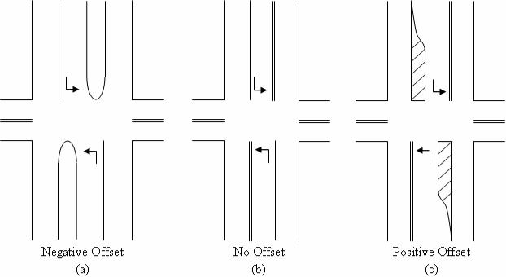
Figure 5-1 Left-Turn Lane Offset
Source: FHWA-HRT-09-035

6-2: Figure 6-2 illustrates RCUT intersections and their features.
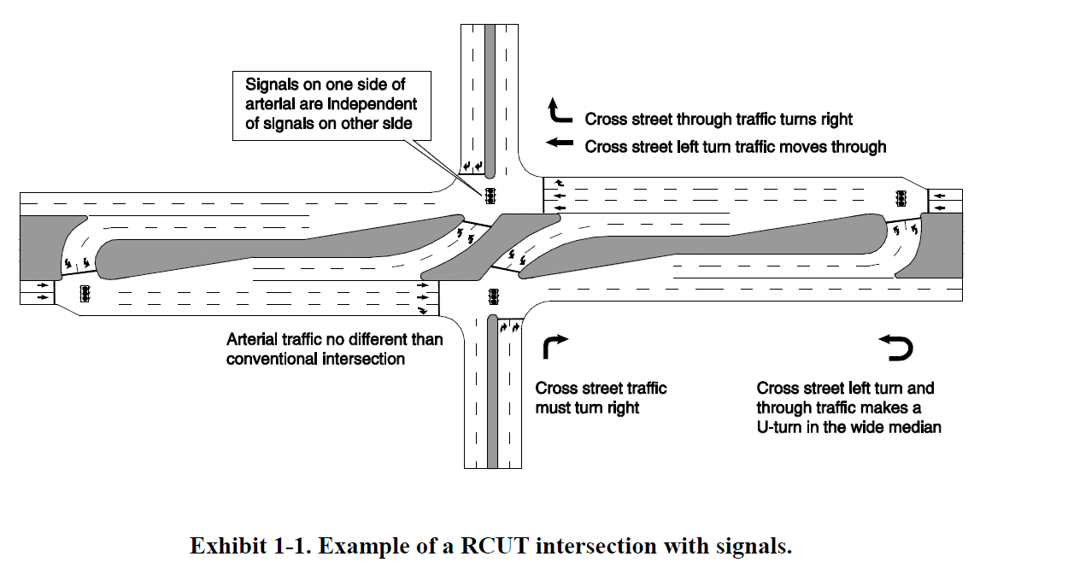
Offset Distance
(a) Example of a RCUT Intersection with signal
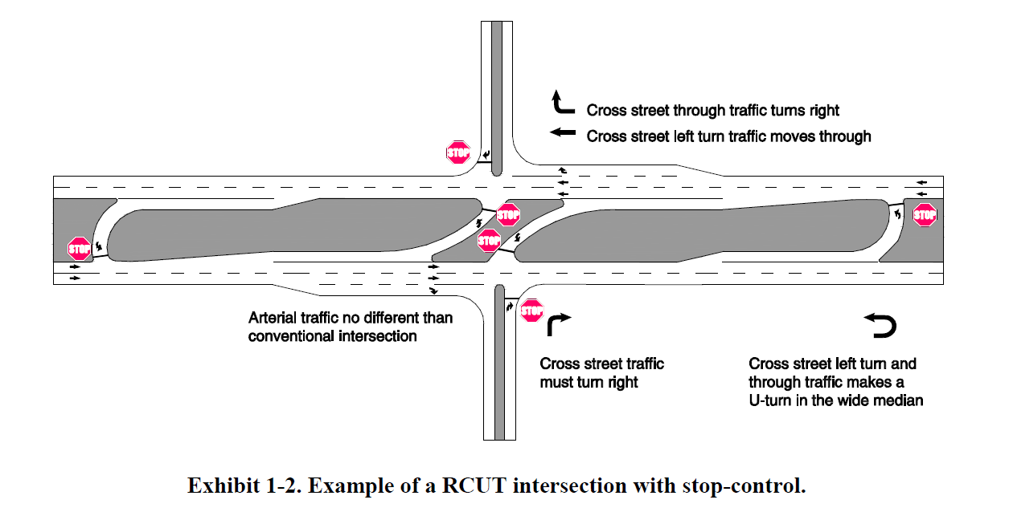
(b) Example of a RCUT Intersection with stop-control
Figure 6-2 Example of RCUT Intersections
Source: FHWA-SA-14-070

6-3: Figure 6-3 illustrates right-turn bypass lane at a roundabout.
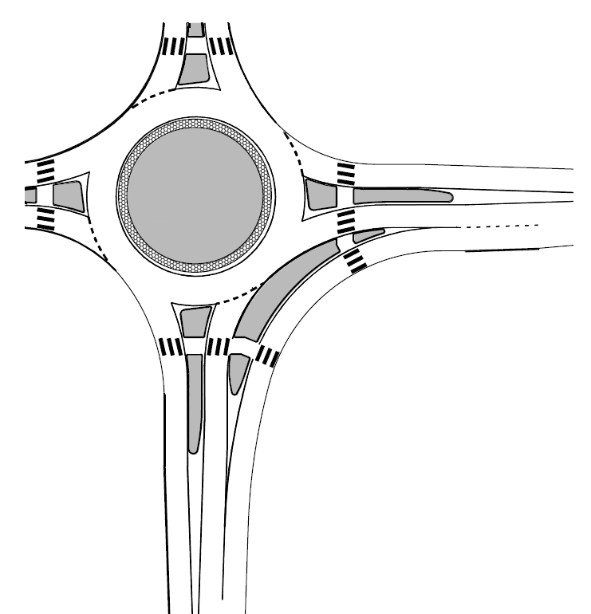
Right-turn bypass lane
Figure 6-3 Example of right-turn bypass lane at a roundabout
Source: NCHRP Report 672

6-4: Figure 6-4 illustrates DDI intersection design sketch and its key characteristics
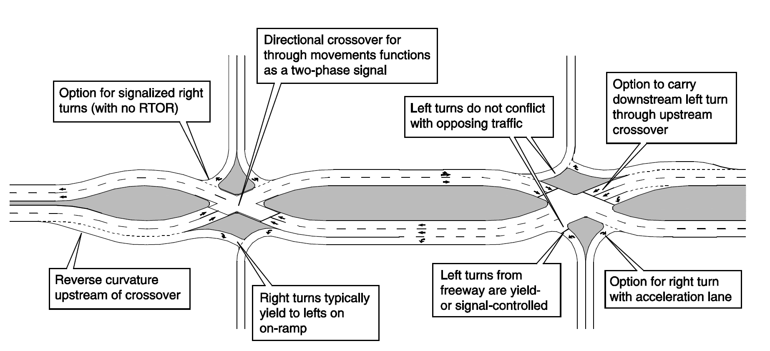
Figure 6-4 Example of a DDI intersection and its key characteristics
Source: FHWA-SA-14-067

6-5: Figure 6-5 illustrates a typical 4-leg DLT intersection design sketch
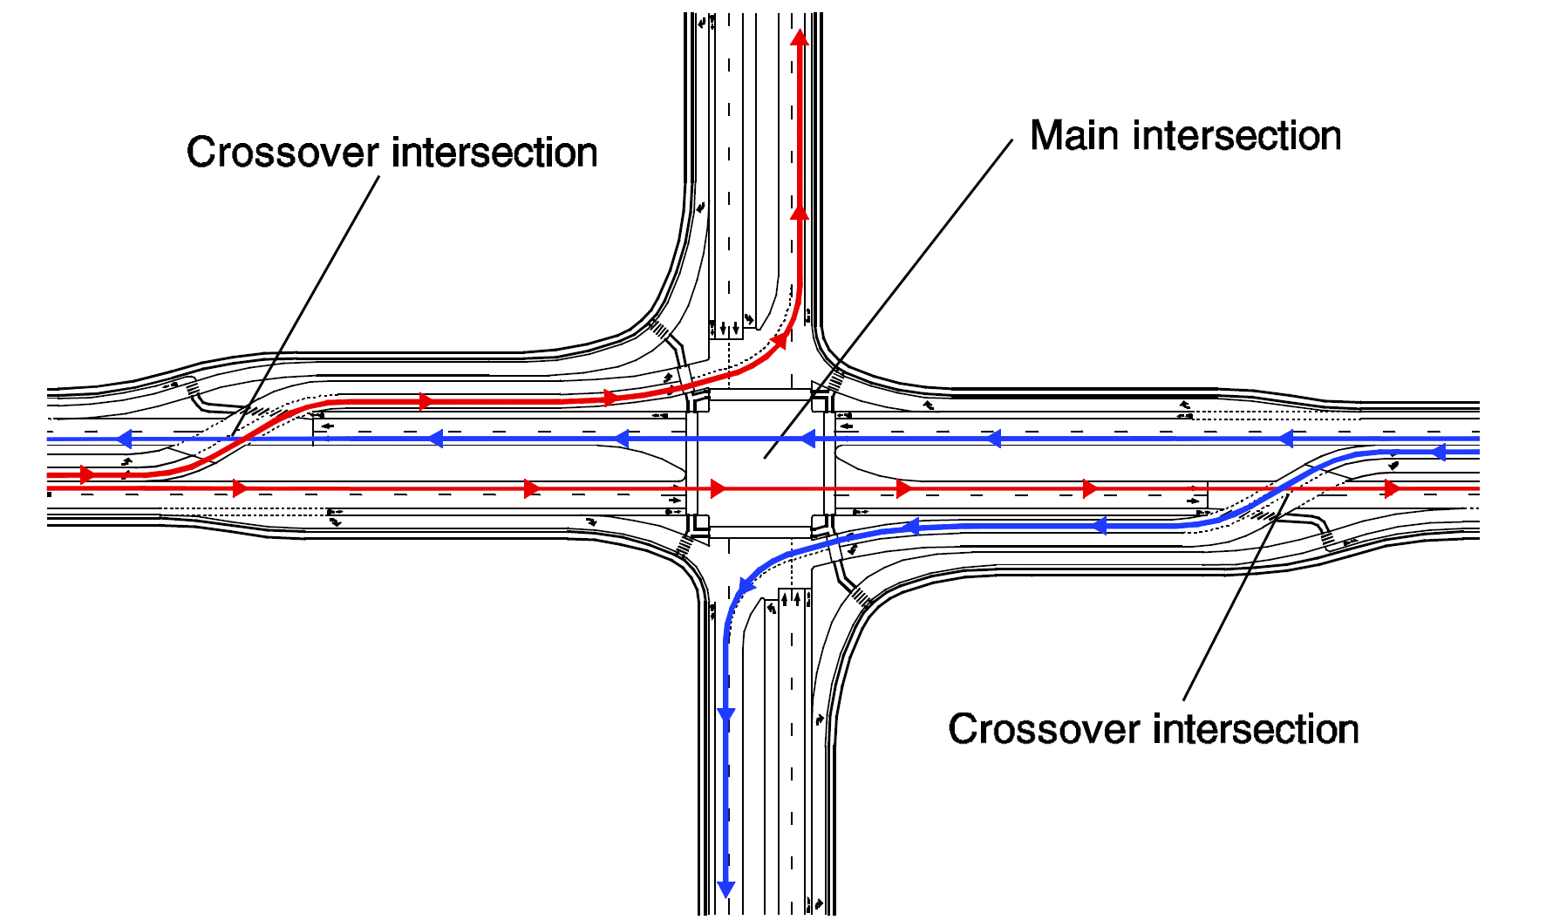
Figure 6-5 Example of a DLT intersection design sketch
Source: FHWA-SA-14-068

6-6: Figure 6-6 illustrates a typical MUT intersection design sketch
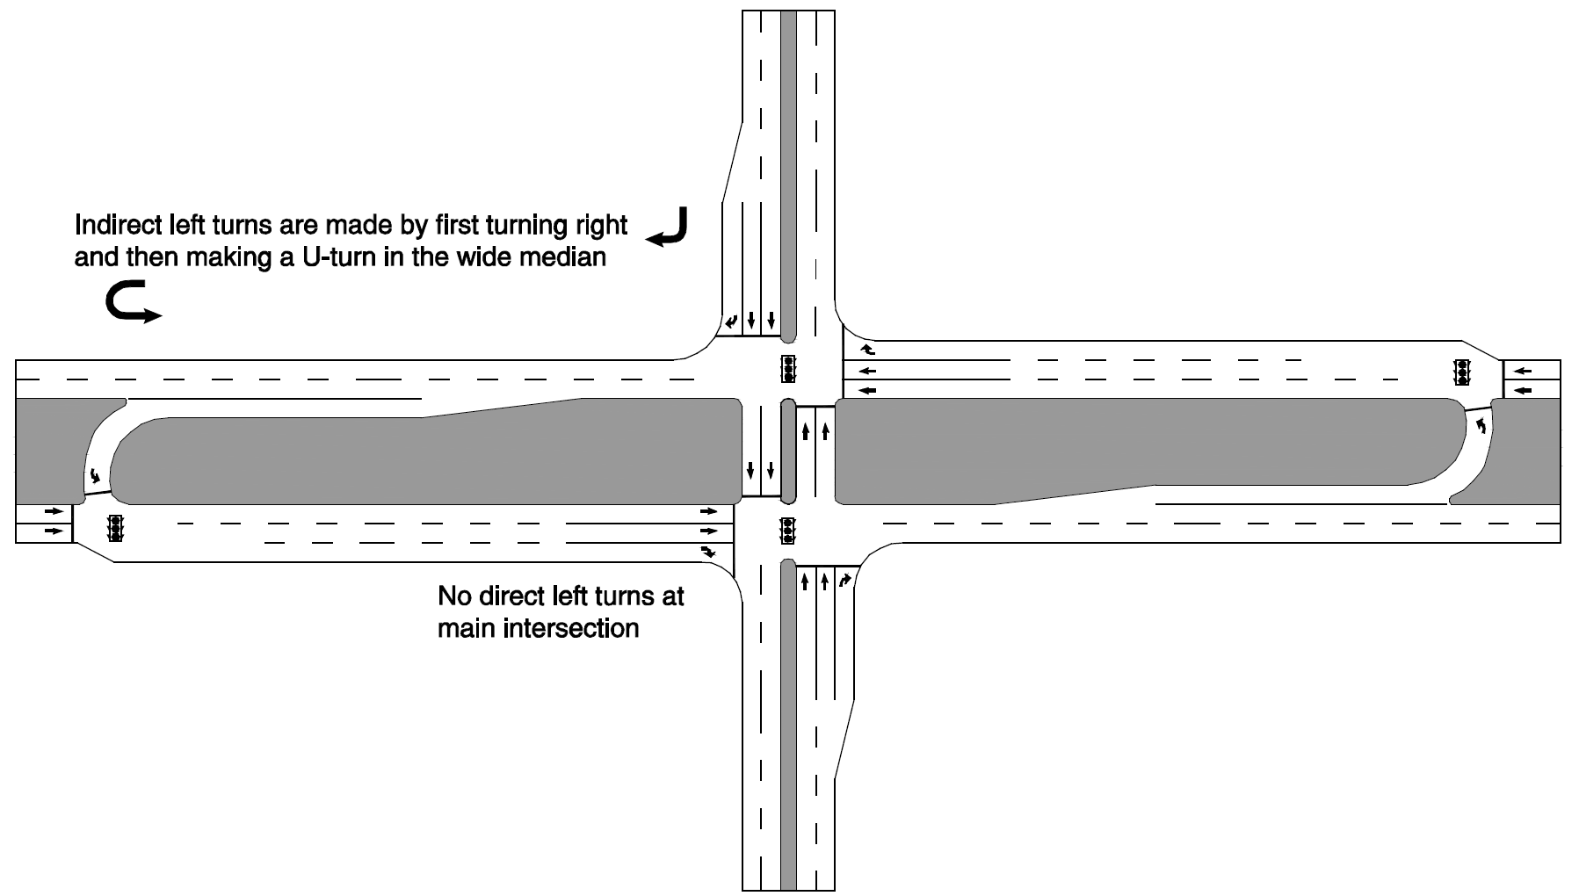
Figure 6-6 Example of a MUT intersection
Source: FHWA-SA-14-069

References
- Lord, D., S. Geedipally, M. Pratt, E. S. Park, S. H. Khazraee, and K. Fitzpatrick. Safety Prediction Models for Six-Lane and One-Way Urban and Suburban Arterials. No. NCHRP Project 17-58. 2017. https://www.trb.org/Main/Blurbs/182691.aspx
- Torbic, Darren J., Daniel J. Cook, Karin M. Bauer, Joseph R. Grotheer, Douglas W. Harwood, Ingrid B. Potts, Richard J. Porter et al. Intersection Crash Prediction Methods for the Highway Safety Manual. No. NCHRP Project 17-68. 2021. https://trid.trb.org/view/1847942
- Ferguson, Erin, James Bonneson, Lee Rodegerdts, Nick Foster, Bhagwant Persaud, Craig Lyon, and Danica Rhoades. Development of Roundabout Crash Prediction Models and Methods. No. Project 17-70. 2018. https://trid.trb.org/view/1580387
- Torbic, Darren et al. Pedestrian and Bicycle Safety Performance Functions for the Highway Safety Manual. No. Project 17-84. 2023 https://doi.org/10.17226/27294

