

Freight Advisory Committee Meeting #39
November 30, 2023, 8 a.m. to 12 p.m.
In-Person Meeting at TxDOT Ric Williamson Hearing Room

ATTENDEES

Committee Members | Organization | Attendance
Judge Ed Emmett – Chair | Rice University | Present
Ron Beeson | East Harris County Manufactures Association | Not present
Randy Brogoitti | Brogoitti Construction | Not present
Murray (Drew) Crutcher | Landgraf, Crutcher & Associates | Not present
Adriana Cruz | Office of the Texas Governor | Present
Michael A. Dyll | Texas International Freight LLC | Not present
John Esparza | Texas Trucking Association | Dana Moore  serving as proxy
Roger Guenther | Port Houston | Present
Bruce Mann | Port Houston | Present
Charlie Leal | Texas Farm Bureau | Not present
Robert MacDonald | Texas Association of Metropolitan Planning Organizations (TEMPO) | Present
Tiffany Melvin | North American Strategy for Competitiveness | Not present
Lindsay Mullins | BNSF Railway | Present
Rolando Ortiz | Killam Development Ltd. | Not present
Keith Patridge | McAllen Economic Development Corp. | Not present
Clint Schelbitzki | Union Pacific Railroad (UPRR) | Not present
Gerry Schwebel | International Bank of Commerce, San Antonio | Not present
VJ Smith | Marathon Petroleum Company | Edwardo Calvo  serving as proxy
Todd Stewart | Gulf Winds International | Not present
Paul Treangen | TNW Corporation | Not present
Matt Woodruff | Kirby Corporation | Not present
Todd Wright | H-E-B | Not present
Ex-Officio Members | Organization | Attendance
Brenda Gunter | City of San Angelo | Not present
Hon. Armando “Mando” Martinez | Texas House of Representatives | Not present
Hon. Sergio Muñoz | Texas House of Representatives | Not present
Phyllis Saathoff | Port of Freeport | Not present
Sean Stibich | Port of Victoria | Not present
Victor D. Treviño | City of Laredo | Not present
Cameron Walker | Permian Basin Metropolitan Planning Organization | Not present
Vacant | United Corpus Christi Chamber of Commerce | Not present

Count of Ex-Officio Members Present: 0
Total Count of Committee and Ex-Officio Members Present: 8

TxDOT
Commissioner Alvin New
Andrew Canon
Emily Clisby
Kale Driemeier
Lorena Echeverria de Misi
David Ford
Yvette Flores
Lauren Freriks
Stephan Gage
Tito Gonzalez
Tyler Graham
Brandye Hendrickson
Erika Kunkel
Steve Linhart
Caroline Mays
Travis Milner
Marc Williams
Giacomo Yaquinto

Agency/Consulting Team
Cameron Gaddy | Foresight Planning & Engineering Services, LLC
Mitch Carlson | Green Corridors
Robert Hinchcliffe | Green Corridors
David Leininger | Green Corridors
Brian Comer | HNTB
Paula Dowell | HNTB
Travis Norton | HNTB
Jeremy Upchurch | HNTB
Elizabeth Story | Poznecki-Camarillo, LLC
Bill Eisele | TTI
Dan Middleton | TTI
Curtis Morgan | TTI
Allan Rutter | TTI
Sushant Sharma | TTI
Jason Wallis | TTI
Jeff Warner | TTI
Lizzie Welch | WSP

Other Attendees
Jim Meyer | AECOM
Daniel Wong | Cambridge Systematics
Genevieve Bales | FHWA
Susan Chavez | Garver
Jolanda Peozzi | Jacobs
Dan Seedah | Jacobs
Vicky Carrasco | Kleinman
Nishant Kukadia | Novus

1. Welcome and Introductions

Judge Ed Emmett, Texas Freight Advisory Committee (TxFAC) Chair and Fellow in Energy and Transportation Policy Rice University’s Baker Institute for Public Policy, welcomed the committee at 8:18 a.m. The committee introduced themselves from the dais.

TxDOT leaders gave opening comments as follows:
- Commissioner Alvin New, Texas Transportation Commission, noted his support for the border area and freight initiatives as critical to the success of our economy. He added that statewide connectivity is his responsibility as a commissioner.
- Marc Williams, TxDOT’s Executive Director, noted the invaluable work of the committee provides ground truthing with what TxDOT’s doing regarding multimodal programs statewide.
- Brandye Hendrickson, TxDOT’s Deputy Executive Director for Planning and Administration, noted it is an exciting time in transportation in Texas as we experience historic levels of investment. Planning and execution are in line with freight investments needed by the state. Ms. Hendrickson then noted her interest in the upcoming discussion on truck parking due to its importance for safety, connectivity, and freight mobility statewide.
- Caroline Mays, TxDOT’s Director of Planning and Modal Programs, thanked the committee and Chair Emmett for shaping freight planning for the agency.

2. Individual Member Updates

Following TxDOT administration, individual members provided their updates.

Lindsey Mullins, with BNSF Railway, noted that overall railroad volumes were down this year nationwide, although peak season volumes are higher than expected. From a Texas perspective, she noted that rail is doing well in the state comparatively and that BNSF has a new intermodal service from Texas to Mexico through Eagle Pass. She added that intermodal service from Houston to Dallas was also implemented. She emphasized that safety and security related to migrants riding trains in Mexico was a pressing issue. BNSF is securing what they can with their infrastructure in the United States. Ms. Mullins said manufacturers in Mexico are concerned about the impact of inspections at the border.

Roger Guenther, with Port Houston, noted that the Houston ship channel is the busiest waterway in the nation and the container terminal is the fifth largest port in the country. While volumes on the left and right coast are down, Houston is stable. He mentioned they export a lot and that imports have grown thanks to significant investments in the area such as new distribution centers. He expressed gratitude for a recent TxDOT grant to the port and noted the investment will go to terminals, cranes, and docks. There are significant capital investments ongoing, such as deepening and widening the channel and preparing the terminals for an increase in shipping. However, he noted that as the port grows, the majority of shipments come and go by truck on Texas roads. Multimodal options are needed to move freight efficiently. Since most freight moves by truck, rail freight options should be expanded.

Robert MacDonald, with Texas Association of Metropolitan Planning Organizations (TEMPO), noted that freight is being integrated into planning across the state and that he continues to share TxFAC information with TEMPO members.

Eduardo Calvo, proxy for the Marathon Petroleum Company and Executive Director of the El Paso MPO, noted that freight resiliency was important to focus on for the future of border trade. The disruptions to the freight industry due to the temporary closure of the Bridge of the Americas in El Paso were tremendous. Future proofing is necessary. He stated the need for modernizing bridges to enhance the movement of people and goods.

Mr. Dana Moore, Vice President of Policy and Government Relations with the Texas Trucking Association, noted truck parking could not be more critical to the trucking industry in Texas and to the nation. He also noted that the freight industry is impacted by border operations.

Chair Emmett recommended people listen to Sirius XM 146 Road Dog Trucking channel because Mr. John Esparza of the Texas Trucking Association is often featured there. He said that there is a lot to learn from listening to what truck drivers have to say on the channel.

Adriana Cruz, Executive Director of Texas Economic Development and Tourism with the Office of the Governor, noted that our robust infrastructure and transportation network makes Texas attractive to companies interested in relocating. She added that the reason Texas is the number one exporter is due to our ports, roads, rail, and trucking network. Several organizations have awarded Texas as having the number one business climate in the country. The quality and size of developments considered by her office this year is unprecedented. She noted how this committee is important for the future of the state’s economy.

Chair Emmett began his update to the committee noting the transition from Ms. Sherry Pifer to Mr. Andrew Canon, TxDOT’s new Director of International Trade, Freight and Corridor Planning. In reference to USDOT’s recent focus on transportation equity, he mentioned an upcoming report from the Baker Institute on the history of highway construction and the impacts on adjacent communities. He discussed the need to study emerging fuel options under consideration for various modes of transportation, and the impacts of Proposition 4 in Houston, which could see the City of Houston leave Houston-Galveston Area Council (HGAC).

3. Overview of Today’s Meeting and Recap of June 22nd Meeting

Tyler Graham, Senior Freight Planning Project Manager with TxDOT’s Freight Planning Branch, provided a brief recap of the June 2023 meeting. That meeting included the announcement that Texas Delivers 2050 was approved by Federal Highway Administration (FHWA). In addition, recent implementation activities were reviewed, such as Multimodal Rural Connectivity Program, the Third Coast Gateway Study, the Texas Triangle Advanced Mobility Plan, and the Texas Freight Resiliency Plan. The committee also received updates on the Statewide Long-Range Transportation Plan and the US 90 Corridor Study.

He summarized the day’s agenda topics, which include truck parking studies, the Unified Transportation Program (UTP), the 2023 Freight Investment Plan, elevated freight technologies, and corridor planning.

4. Unified Transportation Program (UTP) 2024 and the Growth of Funding

David Ford, Director of UTP at TxDOT, shared an update on the 2024 UTP. He mentioned the UTP is TxDOT’s 10-year transportation plan that guides the funding and development of projects across the state. He said it projects the revenues expected over the next 10 years and places funding in 12 different categories for a variety of project types. It is adopted approximately every August.

Chair Emmett asked Mr. Ford about revenue projections and if port funding was in the UTP. Mr. Ford replied that they make assumptions based on historical revenues and the growth of funding over time. Mr. Ford added that ports could be funded through the UTP, but that they generally focus on highway construction projects and the general revenue fund is usually used for ports.

Mr. Ford noted that the growth of the UTP has been significant, particularly due to Propositions 1 and 7. He said the 2024 UTP has $100.6 billion distributed across 12 categories addressing needs in Metro, Urban, and Rural Districts. He shared that TxFAC members should focus on Category (Cat) 2 for Metro, Cat 4 for Statewide Connectivity, and Cat 12 for Strategic Priority (Figure 1).

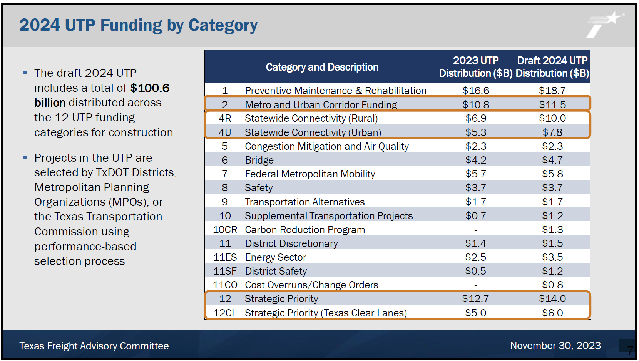
Figure 1. 2024 UTP Funding by Category; slide from TxFAC #39 presentation.

Chair Emmett asked Mr. Ford about how a Rural District would transition to an Urban District. Director Williams stated that Metro Districts are typically those that have a sizable metro area. He added that Urban Districts include regions who include a large metropolitan statistical area (MSA). He noted that communities that do include an MSA are classified as rural. Mr. Williams added that Metro, Urban, and Rural categories TxDOT labels useful for illustrating investment patterns. Commissioner New mentioned that the process adds consistency and allows for comparison over time. The Chair then asked about the distribution of counties within districts and how potentially, for example, some counties in the Yoakum District would be better served under the Houston District’s purview. Mr. Williams noted that TxDOT is tracking the growth of urban areas, such areas in the Paris District falling inside the Dallas MSA, there is no active effort underway to redistribute counties in TxDOT’s 25 districts.

Mr. Ford said they have begun working on the 2025 UTP and that Districts are working with MPOs right now to identify projects to submit for additional funding. TxDOT staff is working on funding scenarios for distribution.

Ms. Mays asked about the distribution of freight funds. Mr. Ford replied that freight needs are dispersed throughout funding categories, such as highway widening projects and through Cat 2, 4, and 12. He added that elements of the freight plan will be in the UTP.

Humberto "Tito" Gonzalez Jr., TxDOT’s Director of Transportation Planning and Programming Division, mentioned that this work dovetails with the work of this committee’s purview and demonstrates the progress of the freight investment plan.

5. Status of 2023 Freight Investment Plan (FIP)

Kale Driemeier, a Planner with TxDOT’s Freight Planning Branch, shared an update on the 2023 Freight Investment Plan (FIP). The FIP is required by FHWA and it includes both fully funded and unfunded projects. He noted that TxDOT has let 36 percent of the projects within the plan to date. Projects are classified in five categories: Asset Management, Mobility, Safety, Connectivity, and Other (Figure 2).

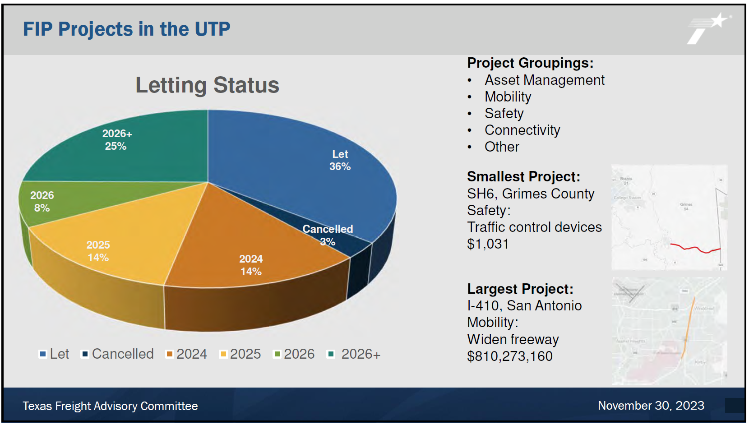
Figure 2. FIP Projects in the UTP; slide from TxFAC #39 presentation.

He detailed the overall progress of the projects in the plan and included information about the restricted eligibility requirements to receive funding from the National Highway Freight Program. Mr. Ford discussed recent major projects including US 90 in Houston, US 59 in Laredo, and I-10 in Columbus.

Mr. Gonzalez Jr. highlighted the significance of the US 59 Laredo upgrades to freight movement, and TxDOT is moving forward to designate it as the future I-69. This project is one of the key projects to expand and build out interstate standards for safe freight movement. Mr. Ford added that this project shows the importance of the committee’s freight plan work. FHWA is relying on local expertise to expand the eligible network. The freight plan directly helped this project become eligible for funding.

Chair Emmett stated his support for the I-10 Columbus project, noting its importance to addressing growth in the Houston region.

6. Elevated Freight Technologies

Mitch Carlson, CEO of Green Corridors, provided a presentation about elevated freight technology and proposed elevated guideways for the separated movement of freight to and from inland terminals. He was assisted by his CFO, David Leininger, in the presentation. They detailed the concept with a review of potential alignments and location of inland terminals near Port Houston and in El Paso/Juarez (Figure 3).

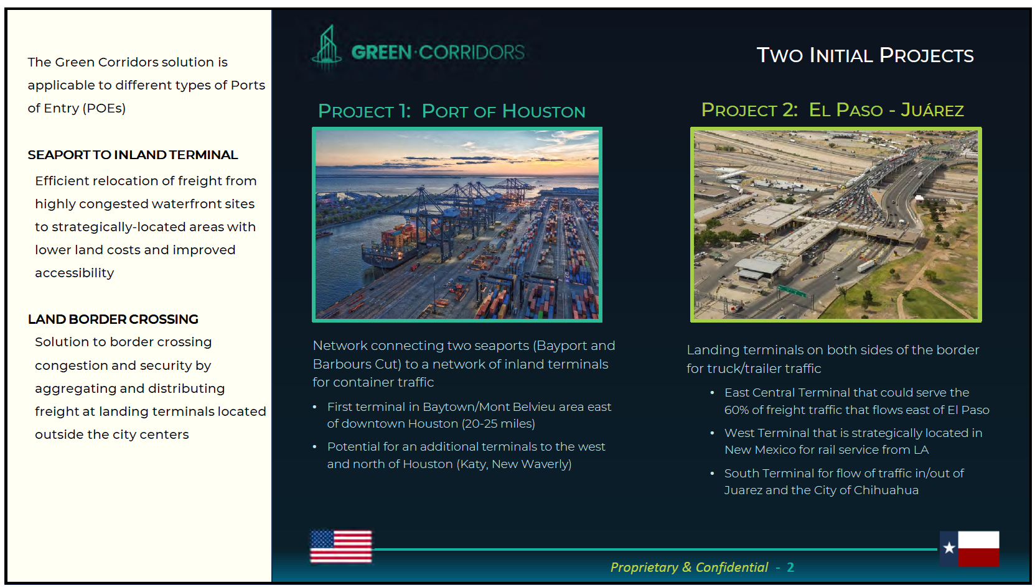
Figure 3. Green Corridors – Two Initial Projects; slide from TxFAC #39 presentation.

Major potential benefits noted were zero emissions due to the autonomous shuttle fleet on tracks, reduction of traffic congestion with a percentage of trucks taken off highways, reduction of public road maintenance costs, reduction of crashes, and economic improvements for the overall freight industry. The guideway would connect the port to a network of freight hubs. Mr. Carlson noted coordination occurring with Port Houston and showed the potential alignments for the Houston area (Figure 4).

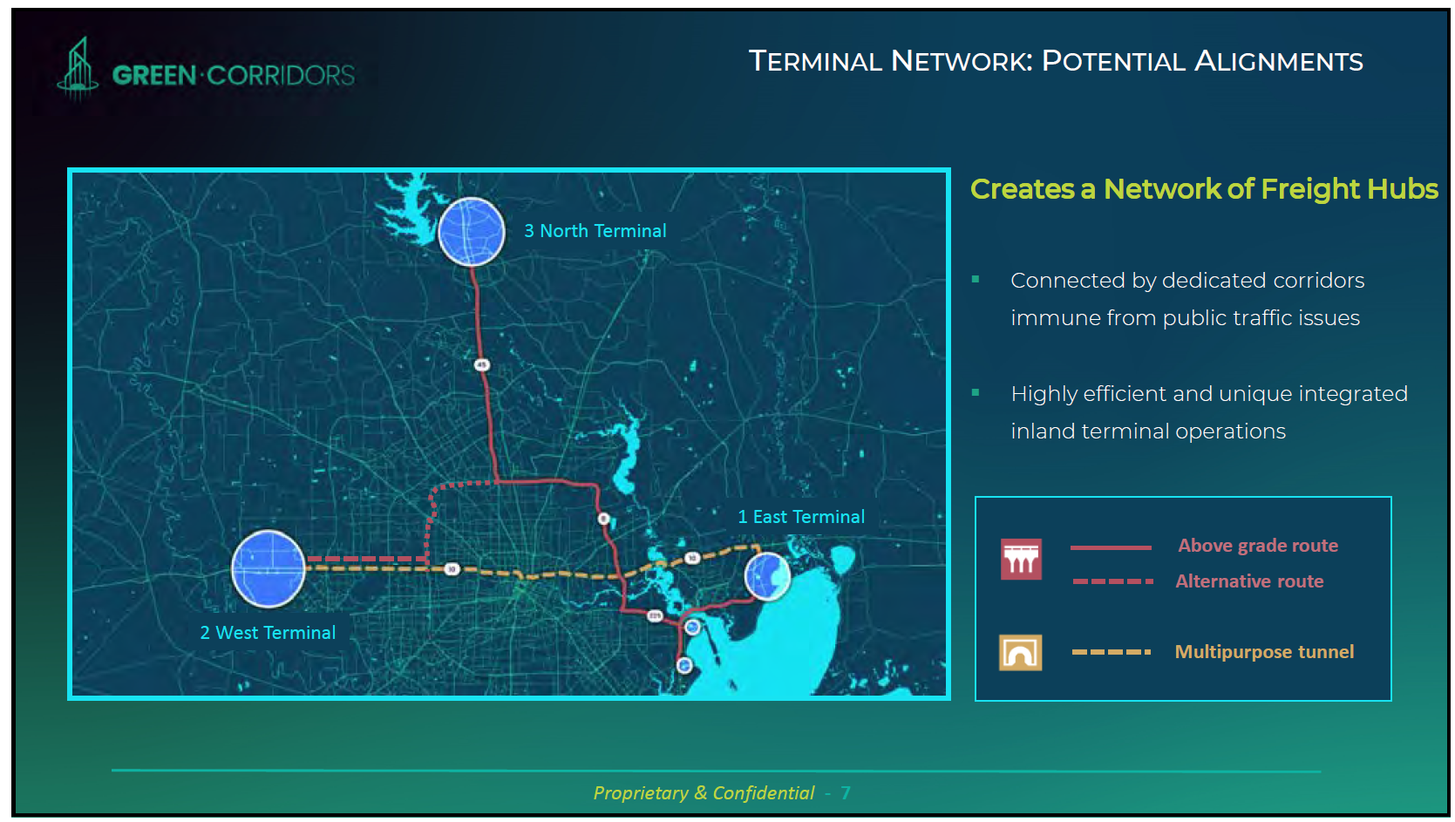
Figure 4. Terminal Network: Potential Alignments (Houston Area); slide from TxFAC #39 presentation.

Mr. Carlson mentioned that the ship channel crossing could either be accommodated through expansion of the existing bridge or tunnelling. Chair Emmett asked how they will avoid impacting utilities and drainage with a potential tunnel. Mr. Carlson mentioned that solutions existed to dig deep enough to avoid such utilities to allow for efficient and integrated inland terminal operations.

Ms. Mullins asked if the Green Corridors team were talking to companies about automation. Mr. Carlson confirmed that they are reviewing this. Ms. Mullins stated the rail industry was warming up to the concept of rail integration. Mr. Guenther said freight facilities have to be complementary to rail. He noted that continued freight growth cannot be accommodated by highways alone. Ms. Mullins said optimizing the multimodal freight network with the right capacity and transportation options is important.

Mr. Carlson then discussed details about inland terminals, synergy with other freight-related plans, considerations that the east terminal could be under operation in 2029, and the need for public private partnerships to implement the plans.

Mr. Leininger also mentioned the need for public private partnerships and provided examples of what those relationships could look like. He is confident that they will have a fully priced project discussion with Port Houston in early 2024.

Mr. Carlson explained how an elevated guideway with trailers on automated shuttles could work in El Paso at the border crossing with dedicated at-grade corridors on both sides of the U.S./Mexico border (Figure 5).
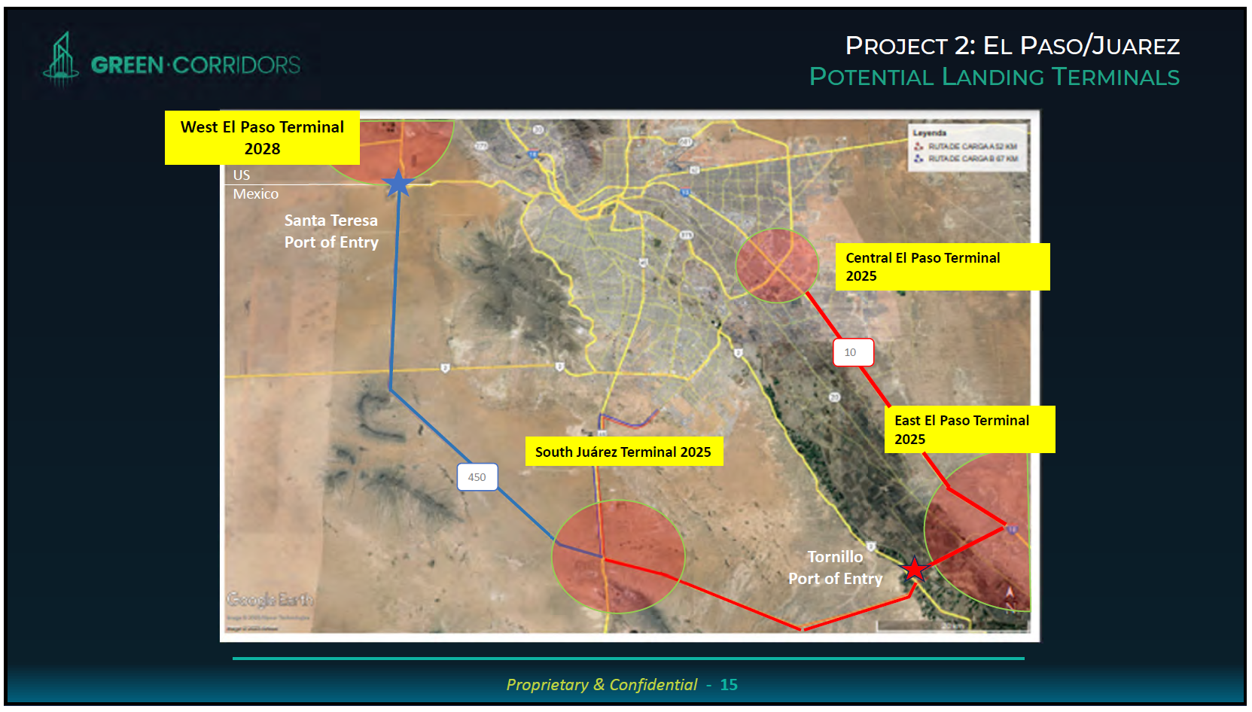
Figure 5. Project 2: El Paso/Juarez, Potential Landing Terminals; slide from TxFAC #39 presentation.

Mr. Calvo added that the El Paso MPO has heard about this effort for a long time, and they are waiting on additional operational and logistics details.

7. Truck Parking Availability System Test Bed Update
Jeff Warner, a Program Manager with the Texas A&M Transportation Institute (TTI), provided an update on the truck parking availability system test bed. He explained the history of the project and the existing test systems are located on I-45 and reported on observations they have noted, partnerships, and next steps (Figure 6). The test areas are well used by the trucking community. TTI is continuing to explore opportunities to track usage of the truck parking. The test bed will continue to be under evaluation and additional systems will be installed.

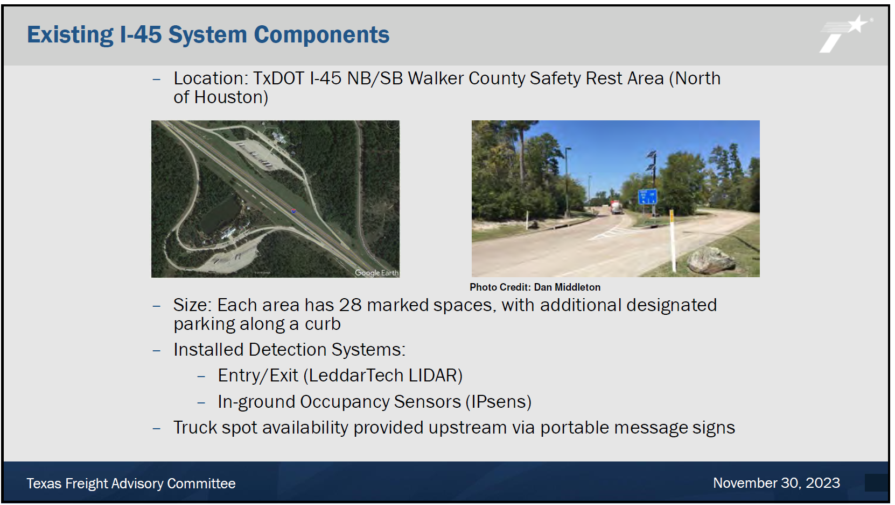
Figure 6. Existing I-45 System Components; slide from TxFAC #39 presentation.

Mr. Moore suggested they coordinate and partner with Pre-Pass along with Drivewyze. Mr. Warner mentioned that Drivewyze is a long-term partner for TTI, but agreed that it would be worthwhile to explore other options.

Chair Emmett asked about the timing of the project. Mr. Warner said TxDOT does not want to implement the sensor system in the ground across the state, but that with more technologies under consideration, there is the potential for implementing similar systems across the state.

Ms. Mays said it is important to understand the utilization of our truck safety rest areas and that TxDOT is interested in helping truck drivers plan their trips so they know where to have a safe rest. She added that it will also help TxDOT to know the needs for safety rest area expansion.

Chair Emmett asked how many total spaces there are in Texas, and how many are private vs. state owned. Ms. Mays said there are about 27,000 private spaces and about 1,500 from the state, which is not enough for the need. She noted that some private companies charge for the spaces.

Chair Emmett asked about the Environmental Defense Fund collaboration to electrify truck stops and if it was an ongoing effort. Ms. Mays said that it did not prove to be a viable option.

8. Truck Parking Action Plans

Brian Comer, a Project Manager with HNTB, and Stephan Gage, TxDOT Houston District, discussed the truck parking action plans currently underway.

Mr. Comer began with the background on their efforts and detailed their areas of focus. He mentioned the first two action plans underway: (a) the Southeast Region Truck Parking Action Plan includes the Houston and Beaumont Districts, and (b) the El Paso/Far West Region Truck Parking Action Plan includes the El Paso District and portions of the Odessa District. Each plan includes its own agency, port, and stakeholder coordination. He noted the results of the study and outreach in a series of opportunity sites for further review (Figures 7 and 8).

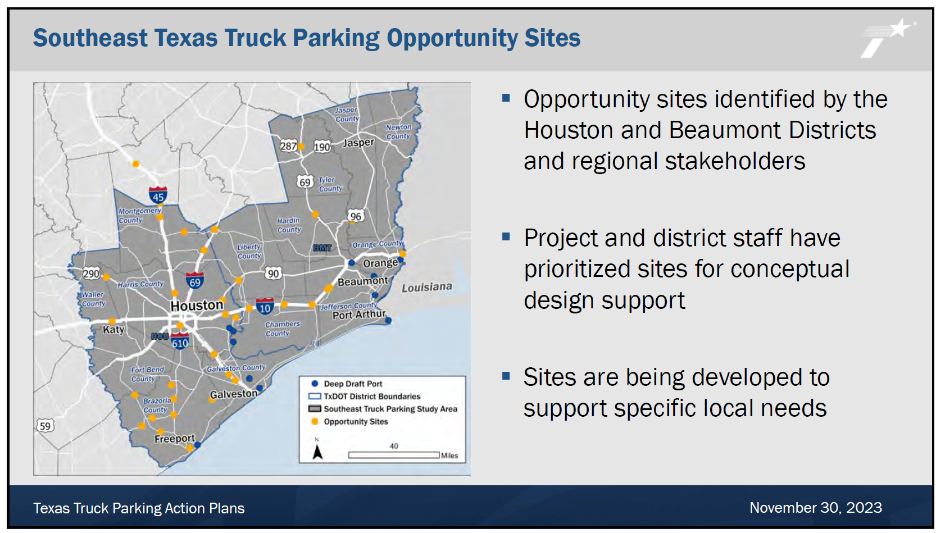
Figure 7. Southeast Texas Truck Parking Opportunity Sites; slide from TxFAC #39 presentation.

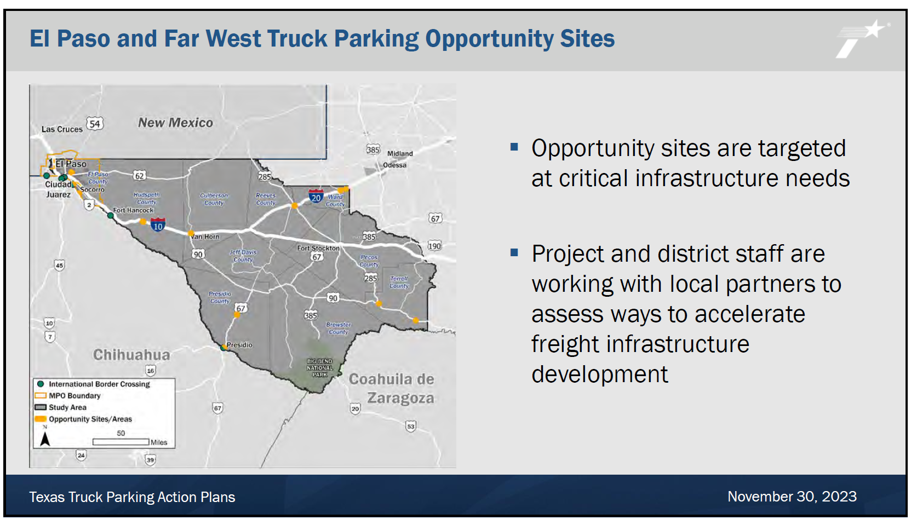
Figure 8. El Paso and Far West Truck Parking Opportunity Sites; slide from TxFAC #39 presentation.

Mr. Comer detailed the facility needs and safety concerns for long haul drivers. He noted that community resistance to new truck parking locations continues to be an issue. Mr. Comer also detailed TxDOT led efforts, such as truck parking guidance, technology, and new parking capacity, and the TxDOT supported efforts, including industry-provided truck parking, emergency, and evaluation, manage curbside truck parking, and new private parking capacity.

Chair Emmett shared some concerns he heard from female truck drivers such as lack of facilities, lighting, amenities, and food service in rural areas. Mr. Moore added that his association is trying to get more women into trucking, but safety is a consideration.

Mr. Comer shared additional concerns such as need for wayfinding to queueing areas around ports, available land, emergency response, and natural hazards, and again, the resistance from communities for truck parking. The need for incentivizing private development and creative land use, such as shared-use facilities, was discussed.

Mr. Gage discussed the REAL Plan 2.0 Implementation and the concept of freight villages (Figure 9). He explained that the goal is to connect mobility hubs with logistics services and facilities. There is the potential to implement this concept in the Katy-Brookshire area as a nexus between Port Houston and the Port of Freeport as well as the proposed 36A corridor. The proposed REAL lanes on I-10 could connect and be additive and complementary to the proposed Green Corridors. This solution would allow freight to move in a wholistic way, not just in one mode on one route. Mr. Gage shared that they are exploring a special district to control land use to avoid conflicts. The county is helping create a progressive vision for managing this proposed concept.

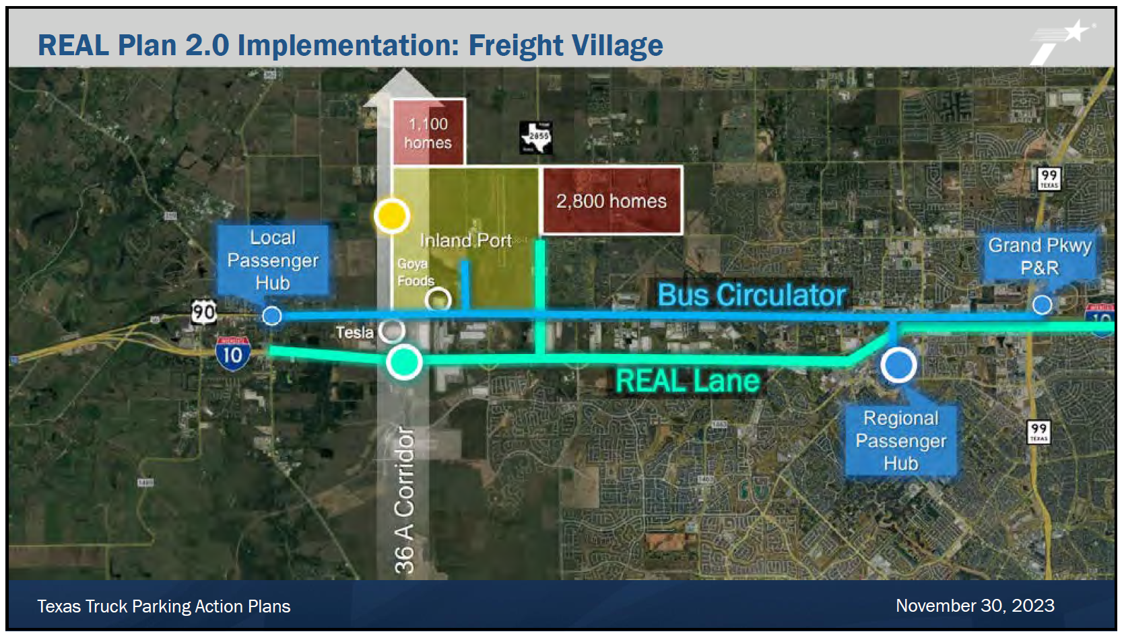
Figure 9. REAL Plan 2.0 Implementation: Freight Village; slide from TxFAC #39 presentation.

Mr. Comer then discussed the City of Pecos Pilot Site, the El Paso International Airport Warehousing Master Plan, and strategies being developed for other areas such as Fort Worth/Dallas and the Permian Basin.

Ms. Mullins asked how freight villages would address conflicts with nearby homes. BNSF has seen tensions due to incompatible land uses in the past. Mr. Gage noted the need for land development planning dovetailing with transportation, and Mr. Comer noted the need for buffers and screening for residential areas. Mr. Comer added that the village could be developed so an owner/operator driver could park and then potentially walk to their home.

Chair Emmett suggested they look at I-35/59/69 coming out of Laredo, as numbers continue to grow. Freight from Laredo heads to I-35, US 59/I-69, and I-27. With Mexico as the number one freight partner for the United States, this movement will grow.

Mr. Gonzalez Jr. pointed out that this was the first year that there was a dedicated program for truck parking and that the action plans are leading to results. Over 1,300 additional truck parking spaces are being implemented by the Maintenance Division (Figure 10).

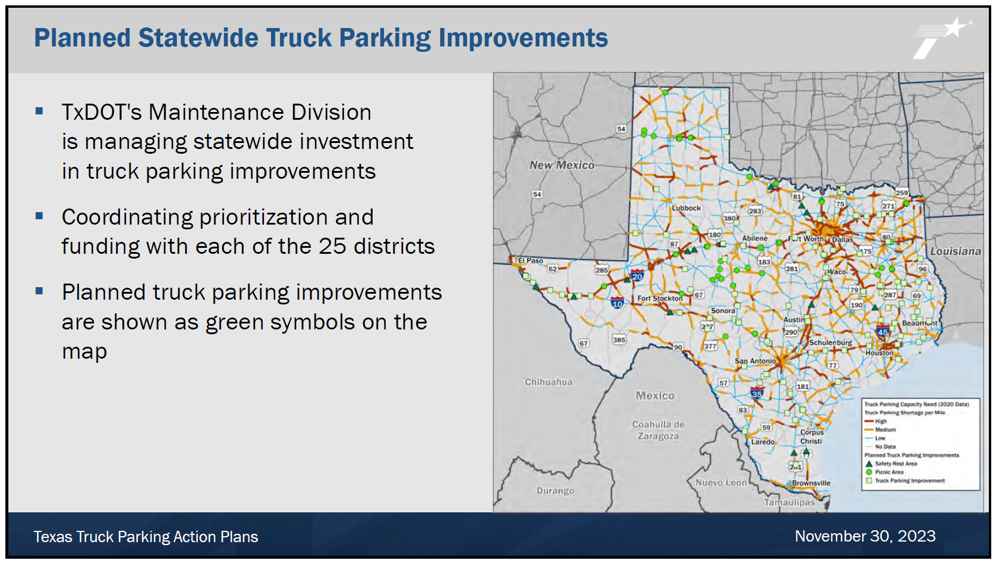
Figure 10. Planned Statewide Truck Parking Improvements; slide from TxFAC #39 presentation.

Ms. Mays said the 10-year plan is going to add a significant amount of truck parking, but it is not going to be enough. She noted issues along I-35. She added that TxDOT’s interest in the truck parking effort will continue.

Ms. Cruz reiterated that Laredo should be looked at as well as the I-35 corridor.

9. Corridor Planning Presentations

TxDOT staff from the Corridor Planning Branch provided presentations on corridors under study, the Ports-to-Plains system in Texas and the I-14 system in Texas.

Lorena Echeverria de Misi, TxDOT’s Corridor Planning Branch Manager, began by providing the background on the Ports-to-Plains System and other future interstates in Texas. She noted that when interstates are built out, Texas will double our interstate infrastructure. Ports-to-Plains specifically has international significance as the only north/south corridor connecting Texas’ most significant economic sectors – energy, agriculture, and the international border.

She reviewed the enabling legislation for the development of I-27 as an interstate highway. She noted the context of the needs for this corridor and the planning approach for implementation, which will take decades. Multimodal considerations underway include transit, rail, port connections, active transportation, and international trade (Figure 11).

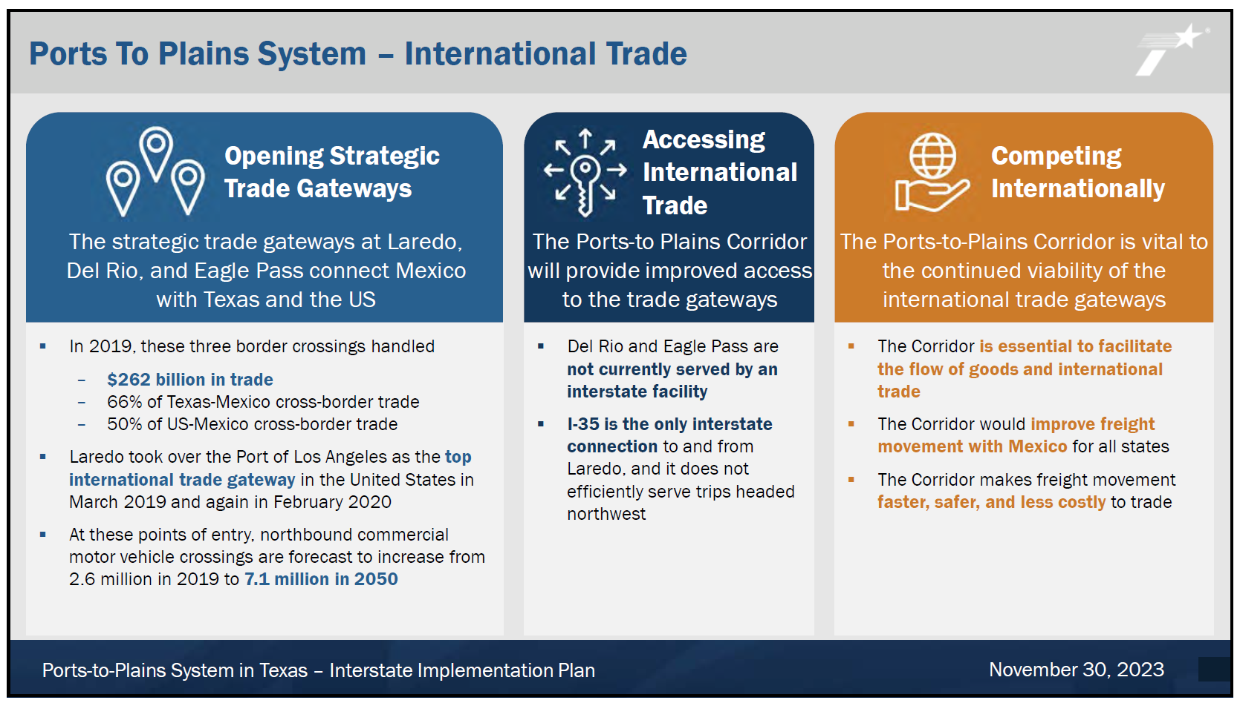
Figure 11. Ports to Plains System – International Trade; slide from TxFAC #39 presentation.

Chair Emmett noted that future generations will benefit from this project. Ms. Mays noted that this is a newly designated future interstate, and its significance to freight movement was crucial to this new designation. She added that strategic corridors help with economic development throughout the state and transcend regions.

Steve Lindhart, a Project Development Manager in the Corridor Planning Branch, then discussed the I-14 system by reviewing background beginning with the enabling legislation (Figure 12). He noted the population, freight flow, and daily truck traffic growth along the corridor.

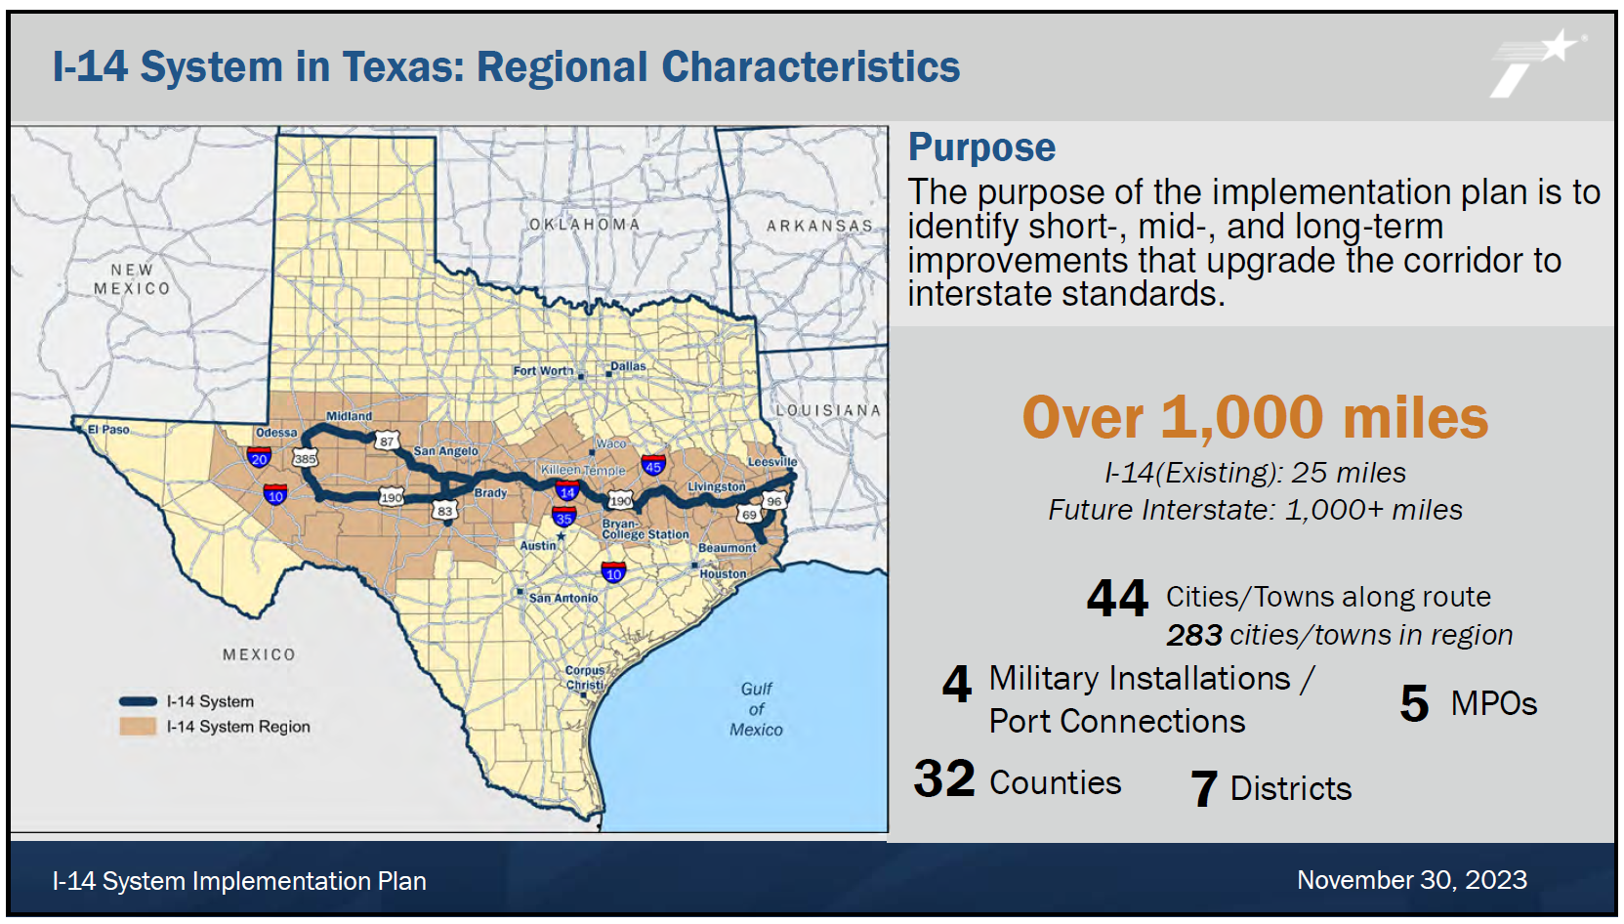
Figure 12. I-14 System in Texas: Regional Characteristics; slide from TxFAC #39 presentation.

He noted that a lot of this proposed network is in proximity to military installations. He stated that in Texas, the system is approximately 1,000 miles long and would upgrade over a dozen existing roadways. There are a significant variety of characteristics across the corridor in Texas. He then covered the key elements of the implementation plan currently under development.

10. Final Remarks

Chair Emmett discussed the next freight plan’s timeline, potential committee meeting location changes, the need for a committee participation and membership review, and the need for a committee leadership succession plan.

Commissioner New noted it is critical for Texas to have more ways to move freight, especially with growth at the border and our ports.

Chair Emmett added that I-14 will help with national security support when I-10 shuts down due to future extreme weather, such as when we saw I-10 shut down due to Hurricane Harvey. New technologies also support the movement of freight. He reiterated that the committee is hand in hand with the governor’s office to move the Texas economy forward.

Ms. Mays noted the need for committee meetings in 2024 for continued momentum and suggested holding them at locations across the state with tours of related facilities. There are many planning elements that the committee can provide input on for TxDOT next year. She emphasized that TxDOT looks to the TxFAC committee for idea generation regarding freight planning and policy making.

Chair Emmett adjourned the meeting at 11:55 a.m.

