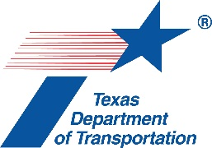
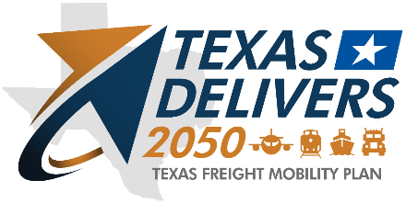

Freight Advisory Committee Meeting #40
April 10, 2024, 8 a.m. to 12 p.m.
In-Person Meeting at TxDOT Stassney Campus

ATTENDEES

Committee Members | Organization | Attendance
Judge Ed Emmett – Chair | Rice University | Yes
Adriana Cruz | Office of the Texas Governor | Yes
John Esparza | Texas Trucking Association | Yes
Roger Guenther | Port Houston | Yes
Bruce Mann | Port Houston | Yes
Charlie Leal | Texas Farm Bureau | Yes
Robert MacDonald | Texas Association of Metropolitan Planning Organizations (TEMPO) | Yes
Tiffany Melvin | North American Strategy for Competitiveness | Yes
Lindsay Mullins | BNSF Railway | Yes
Rolando Ortiz | Killam Development Ltd. | Yes
Keith Patridge | McAllen Economic Development Corp. | Did not attend
Clint Schelbitzki | Union Pacific Railroad (UPRR) | Richard A. Zientek  serving as proxy
Gerry Schwebel | International Bank of Commerce, San Antonio | Yes
Paul Treangen | TNW Corporation | Yes

Total Count of Committee Present: 13

TxDOT
Amanda Austin
Andrew Canon
Leah Casey
Marvina Cephas
Chad Coburn
Farideh Dassi
Kale Driemeier
Yvette Flores
Lauren Freriks
Tyler Graham
Elisa Greenberg
Curtis Jones
Cary Karnstadt
Erika Kunkel
Mildred Litchfield
Caroline Mays
Commissioner Alvin New
Wesley Starnes
Trent Thomas
Sergio Vasquez
Luis M. Villarreal
Casey Wells
Giacomo Yaquinto

Agency/Consulting Team
Matt Miller | Cambridge Systematics
Mike Williamson | Cambridge Systematics
Daniel Wong | Cambridge Systematics
Carl L. Tucker | Federal Emergency Management Agency
Jermaine Francis, Sr. | Federal Emergency Management Agency
Derek Barrs | HNTB
Paula Dowell | HNTB
Eva Esquivel | HNTB
Carlos Lopez | HNTB
Jeremy Upchurch | HNTB
Shannon Lambert | Jacobs
Lorraine McChesney | Jacobs
Carl Seifert | Jacobs
William Long | Poznecki-Camarillo, LLC
Elizabeth Story | Poznecki-Camarillo, LLC
Paulina Lopez | WSP
Lizzie Welch | WSP

Other Attendees
Genevieve Bales | Federal Highway Administration
Sydni Ligons | Houston Galveston Area Council
Don Rodman | I-69 Alliance
Dhruva Lahon | Kimley-Horn
Mark Lenters | Kimley-Horn
Tim Juarez | Stanley Consultants
Bill Eisele | Texas A&M Transportation Institute
Curtis Morgan | Texas A&M Transportation Institute
Allan Rutter | Texas A&M Transportation Institute
Jeff Warner | Texas A&M Transportation Institute
Jim Morales | Texas Senate, Senator Campbell
Bobby M. Franklin | TNW Corporation

1. Welcome and Introductions

Judge Ed Emmett, Texas Freight Advisory Committee (TxFAC) Chair and Fellow in Energy and Transportation Policy Rice University’s Baker Institute for Public Policy, welcomed the committee at 8:05 a.m.

Tyler Graham, Interim Freight Planning Manager with TxDOT’s Freight Planning Branch, provided a safety minute regarding the upcoming National Work Zone Safety Week (April 15-19) and advised everyone to be mindful of traveling in work zones.

Chair Emmett added that the freight advisory committee’s goal is to get ahead of growth, transportation, and safety needs, noting the number of distribution centers, rail, and roadways that drivers pass as they travel to the TxDOT Stassney Campus.

TxDOT leaders gave opening comments as follows:
- Mildred Litchfield, TxDOT Deputy Director, sent her appreciation for the committee’s participation.
- Commissioner W. Alvin New, Texas Transportation Commission, sent his appreciation to the committee and appreciation for the opportunity to listen.
- Caroline Mays, TxDOT Director of Planning and Modal Programs, thanked the committee members for their continued participation and emphasized that their efforts are critical to the work done at TxDOT.

2. Individual Member Updates

Following TxDOT administration and individual members provided their updates.

Roger Guenther, with Port Houston, noted that the port continues to grow as a major gateway. He stated that they are the fifth largest container port in the nation and second in the country for exports. He mentioned they export hydrocarbons in containers. They have doubled their volume in the last six years going into the Houston region; the resiliency and growth of the supply chain in and out of the port remains a concern. He added that plastics are being produced, packaged, and distributed in their region. He said freight goes by truck to local and regional destinations. He mentioned they do get some freight onto rail, but it is mostly trucks that leave the port. He concluded with the news that he will retire this year and his successor will become engaged in this process.

Chair Emmett advised TxDOT to continue to coordinate with Mr. Guenther even after he retires.

Rolando Ortiz, with Killam Development Ltd., noted that Laredo’s international trade continues to grow and is the largest port in the country now. He stated that Mexico is the largest trading partner to the United States. Evoking the term “the Texas Triangle”, he suggested consideration of a Texas “rectangle” that includes Laredo. He mentioned that Laredo has a lot of construction underway or coming for freight growth. He said there is interest in roundabouts. They are interested in identifying ways to get truck traffic moving more efficiently including via alternative routes such as I-69 through Freer and Goliad as an alternative to I-35 and I-10.

Chair Emmett asked about empty containers. Mr. Guenther said these are still being exported.

Richard A. Zientek, Union Pacific Railroad (UPRR), noted his appreciation for the committee and the continued investment in railroads by the State of Texas. He said UPRR is investing millions of dollars in Texas and that the Gulf Coast has been a major focus for them.

Lindsay Mullins, BNSF Railway, noted the need to get freight shipments out of the ports. She said there are good conversations ongoing between the Texas legislators and railroads. She added that safe rail crossings are a focus and something for the committee to consider. She mentioned BNSF testified about the impacts of recent wildfires in north Texas on their operations adding wildfires have impacted national trade. Rail freight volume receded last year and continues this year. BNSF is watching market share and ensuring that containers are moving the appropriate way. Volume has not recovered the way they expected, so the railroad is repositioning and reallocating resources.

Chair Emmett thanked UPRR and BNSF for their steady participation in the committee and urged TxDOT to invite additional rail providers to be at the table for the advisory committee.

John Esparza, with the Texas Trucking Association, noted that this committee is what drives the trucking industry. He added that the committee works to put people who understand what we do where they can make a difference. There is a shortage of drivers and there is an issue of folks entering the trucking business who should not be driving. He mentioned accidents have increased and more needs to be done within the industry to “End the Streak”.

Robert MacDonald, with the Texas Association of Metropolitan Planning Organizations (TEMPO), noted they added an MPO in Eagle Pass and there are 24 MPOs in the association now. He stated that freight was always a topic of discussion and that the freight mobility plan is important to all MPOs. They weave the information and analyses from the freight plan into their regional plans. He mentioned his appreciation for the last mile considerations, truck parking, railroad crossings – all helpful to see what is happening in the committee. He concluded by encouraging participants to work with their local MPOs for planning integration and data sharing.

Chair Emmett noted the importance of MPOs in how we plan for the growth of regions.

Charlie Leal, with the Texas Farm Bureau, noted that Texas agriculture is strong in the face of adversity. He added that even with many challenges at play, resiliency has shown through. He said that there has been a loss of ranchland in the panhandle and farming families have also experienced losses with wildfires. He stated that farmers and ranchers work through all-weather so we can all eat. He thanked everyone in the room for keeping agriculture moving. He shared that the production of sugar cane in Texas has come to an end. Texas was one of three states that produced sugar, but due to Mexico and the water treaty from 1944, the sugar industry has closed. He added that it is a loss of over 500 jobs and a $600M impact to South Texas. He mentioned other industries may be affected if the issue is not addressed.

Tiffany Melvin, with North American Strategy for Competitiveness, noted that all modes of transportation and supply chain are represented in their organization. They focus on supply chain and logistics, workforce gaps, energy, and the environment. She mentioned there have been discussions about a national roadway digital infrastructure transcontinental corridor strategy for I-35 to get major DOTs along the corridor to work together in planning for illumination, truck parking and other issues.

Gerry Schwebel, with the International Bank of Commerce, San Antonio, noted that it is important to know that the 2025 truck traffic projections in the border master plan were exceeded in 2022. The current infrastructure cannot keep up with the current needs. He suggested a need for a more visionary strategy for how we plan for the increase of trade. Focusing on supply chain disruptors in the North American region to maintain competitiveness is a critical area of concern. He said bridge closures in Texas should only be a last resort. He suggested spending time on establishing protocols for disruptors to supply chain networks. Texas is a major exporter of petrochemicals and the mobility of our fuel exports, gasoline in trucks, and ports of entry are critical in how we plan those exports. He mentioned there is a critical focus on border cold supply chain networks and refrigerated/frozen products. He mentioned that Commissioner New has been very involved and a big promoter of the role the border plays to the entire state of Texas. He then thanked the commissioners for keeping them engaged.

Adriana Cruz, with Office of the Texas Governor, noted that Texas is the 8th largest economy in the world and that trade is an important part of the state economy. She said that Texas is the number one exporting state in the country and number one in high tech exports. She stated that “Made in Texas” is a powerful global brand for the state to promote. She added that the state is well positioned for near shoring and ranks number one in the United States for foreign direct investment. She mentioned companies such as SAMSUNG, TOYOTA, JCB are manufacturing in the state. She added that to support that foreign investment, Texas has an office in Monterrey, Mexico City, and will open an office in Taiwan to support our international trade and foreign investment. They are working on a strategic plan for the state of Texas that includes coordination with TxDOT. She added that they are looking at four pillars: business and industry, innovation and entrepreneurship, workforce development, and infrastructure. She stated that reliable extensive infrastructure is critical. She said their office is not responsible for workforce development or infrastructure, but working together will provide data and information so we can be in alignment. She said they are doing an analysis of existing industry clusters and currently are focusing on eight clusters. She mentioned they look forward to a continued partnership with TxDOT.

Chair Emmett asked Ms. Cruz to give our thanks to the governor noting that whatever comes out of their strategic plan will impact their work in this committee.

Paul Treangen, with TNW Corporation, noted there are three short line railroads in Texas. He said most are operated by small businesses that cover first and last mile logistics as well as rural connectivity. He mentioned they work closely with the larger rail partners to provide a seamless network. He stated they appreciate being a part of the transportation planning process.

Chair Emmett noted a study by the Baker Institute about why the highways were built where they are versus the narrative that freeways are bad things. He said we must admit where mistakes were made in the past and show the benefits of the interstates. He stated that supply chains and logistics will be impacted if we do not improve our interstates. He said there is consideration for a new study about fuels of the future and what infrastructure is needed to deliver them.

Ms. Mullins, with BNSF Railway, noted the Texas Railroad Association is doing work in the future of fuel space for rail. She asked if there was a correlation between where highways were built and where rail already existed. Chair Emmett noted that highways were built adjacent to rail corridors.

3. FEMA: Disaster Recovery in Texas and Critical Supply Chain Operators

Chair Emmett welcomed the Federal Emergency Management (FEMA) noting that they have been great agency partners with the most dedicated group of professionals.

Carl Tucker, Federal Emergency Management Agency, Region 6, opened with an overview about FEMA’s response to hurricanes in Texas. FEMA’s mission is helping citizens before, during, and after disasters. FEMA works hand in hand with state and tribal governments. From FEMA’s perspective, the length of any one disaster can be several years; Hurricane Harvey recovery is still underway. FEMA’s distribution centers are located throughout the nation with the Texas branch in Fort Worth.

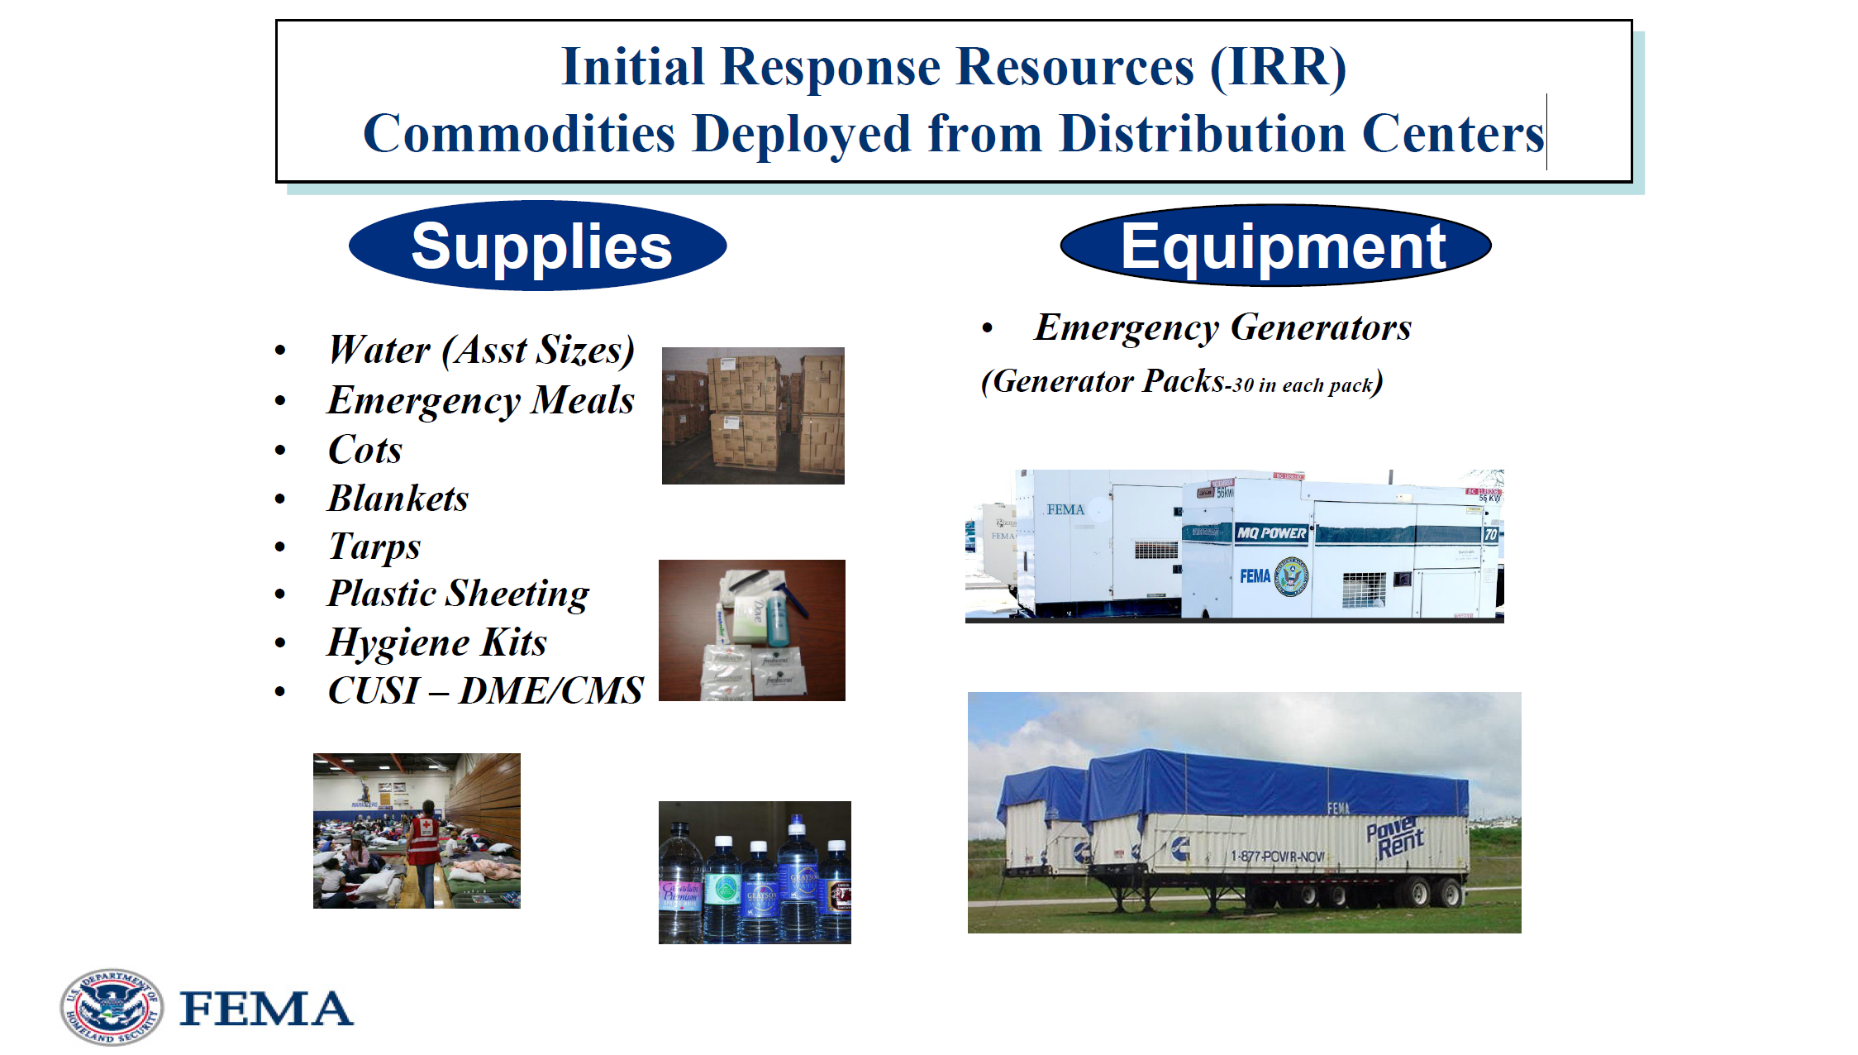
Figure 1. Initial Response Resources (IRR) Commodities Deployed from Distribution Centers; slide from TxFAC #40 presentation.

Main items that FEMA deploys include water, emergency meals, cots, blankets, tarps, plastic sheeting, and hygiene kits, common use shelter items (such as medical supplies/equipment), and emergency generators. The other items that states request include baby items such as diapers and bottles.

Chair Emmett asked for further information on temporary trailers. Mr. Tucker gave an overview of the new FEMA design for travel trailers that were used during the Hurricane Harvey response; this design was developed working with the commercial industry and it is unique, ADA compliant, and sturdy. FEMA’s mobile home frames and tires are stronger than commercial mobile homes. In addition, FEMA can rely on commercial, off-the-shelf trailers and mobile homes to augment existing inventory if needed. The distribution center specifically for travel trailers is in Alabama.

Mr. Schwebel asked about distribution. Mr. Tucker noted that FEMA stores materials and then tasks other government agencies to help source and distribute. FEMA also has access to government approved providers.

A big mission for FEMA is to bring in and park thousands of trailers. Locations are pre-negotiated with landowners prior to disasters. Most response locations are state, county, and federal property such as military bases, county fairgrounds, and airports. Due to commercial entities requiring contracts, FEMA usually does not have time in the initial response to have those negotiations in play. Trailers can be moved to commercial locations following a disaster when there is time for negotiating a contract. Of note, however, FEMA has a longstanding contract with FedEx.

The staging area in Texas is located at the Joint Base San Antonio-Randolph Seguin Auxiliary Airfield in Seguin. From there, FEMA moves into the impacted areas. FEMA moves into Seguin 96 hours before the landfall of a hurricane. He noted that Hurricane Harvey required 3000 trucks. The hurricane hit multiple states and Puerto Rico, so FEMA had significant work to do across the United States.

There are two types of truck drivers that FEMA will contract during disaster recovery. The first are drivers to move trailers, and the second are shuttle drivers which is a premium position. FEMA has a running list of registered and vetted drivers.

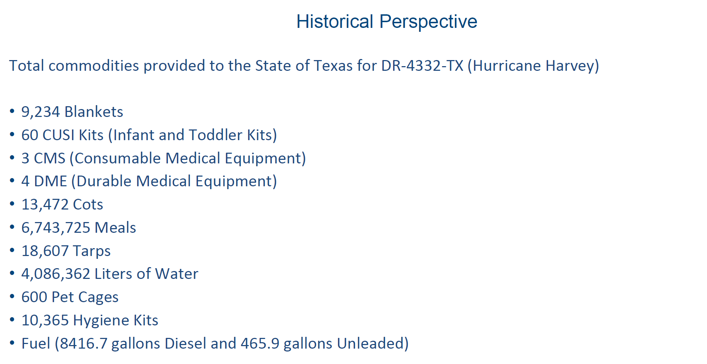
Figure 2. Historical Perspective; slide from TxFAC #40 presentation.

Specific to the Hurricane Harvey response, Mr. Tucker noted what were the top commodities provided in Texas, including over 6 million meals, 4 million liters of water, and 10 thousand hygiene kits.

Chair Emmett added from his experience that FEMA couldn’t get into the Houston area in the early days of the Hurricane Harvey response due to flooding. The City of Houston and Harris County provided shelters and all the food came from private suppliers. Critically, FEMA works with private groups and partners when they can’t get into the damaged area; the local staff of the Red Cross in Houston could assist for example.

Mr. Tucker added that FEMA could only fly supplies, such as infant and toddler kits, into flooded areas of Houston by way of helicopter. High water vehicles are active military vehicles with specific requirements such as lifeguards, which are hard to quickly mobilize. Food banks were also necessary partners to distribute items for FEMA.

Ms. Mays inquired about how aviation plays a role and if FEMA has aircrafts. FEMA coordinates with Texas Emergency Management’s air branch that is set up during a disaster. The branch tasks the mission, and all aircraft providers and aircraft control folks can be involved. Aircraft can come from any federal entity (e.g., FAA, National Guard). In Hurricane Harvey, planes flew from Fort Hood to Seguin and then into Houston.

Mr. Schwebel asked Mr. Tucker to talk about how FEMA comes into a disaster and who is in charge. Mr. Tucker stated that FEMA is never in charge of a disaster unless directed by the United States Senate, such as if a federal agency caused the disaster. At the local level, the county judge is in charge. They request needs from the State of Texas. If the state doesn’t have it, Texas asks FEMA for it. The only person to make a request from FEMA is the Governor or his authorized representative. There is a cost share. The president makes a declaration and then FEMA can help. FEMA needs emergency declaration in advance of disaster.

Ms. Mays asked about rescue. Mr. Tucker stated FEMA has a paid task force that can provide ambulances.

Jermaine Francis, Sr., Federal Emergency Management Agency, discussed his role as FEMA Transportation Capabilities and Logistics Management Directorate. His work involves FEMA logistics and transportation planning. His job is to develop plans for disaster responses for hurricanes, earthquakes, etc.

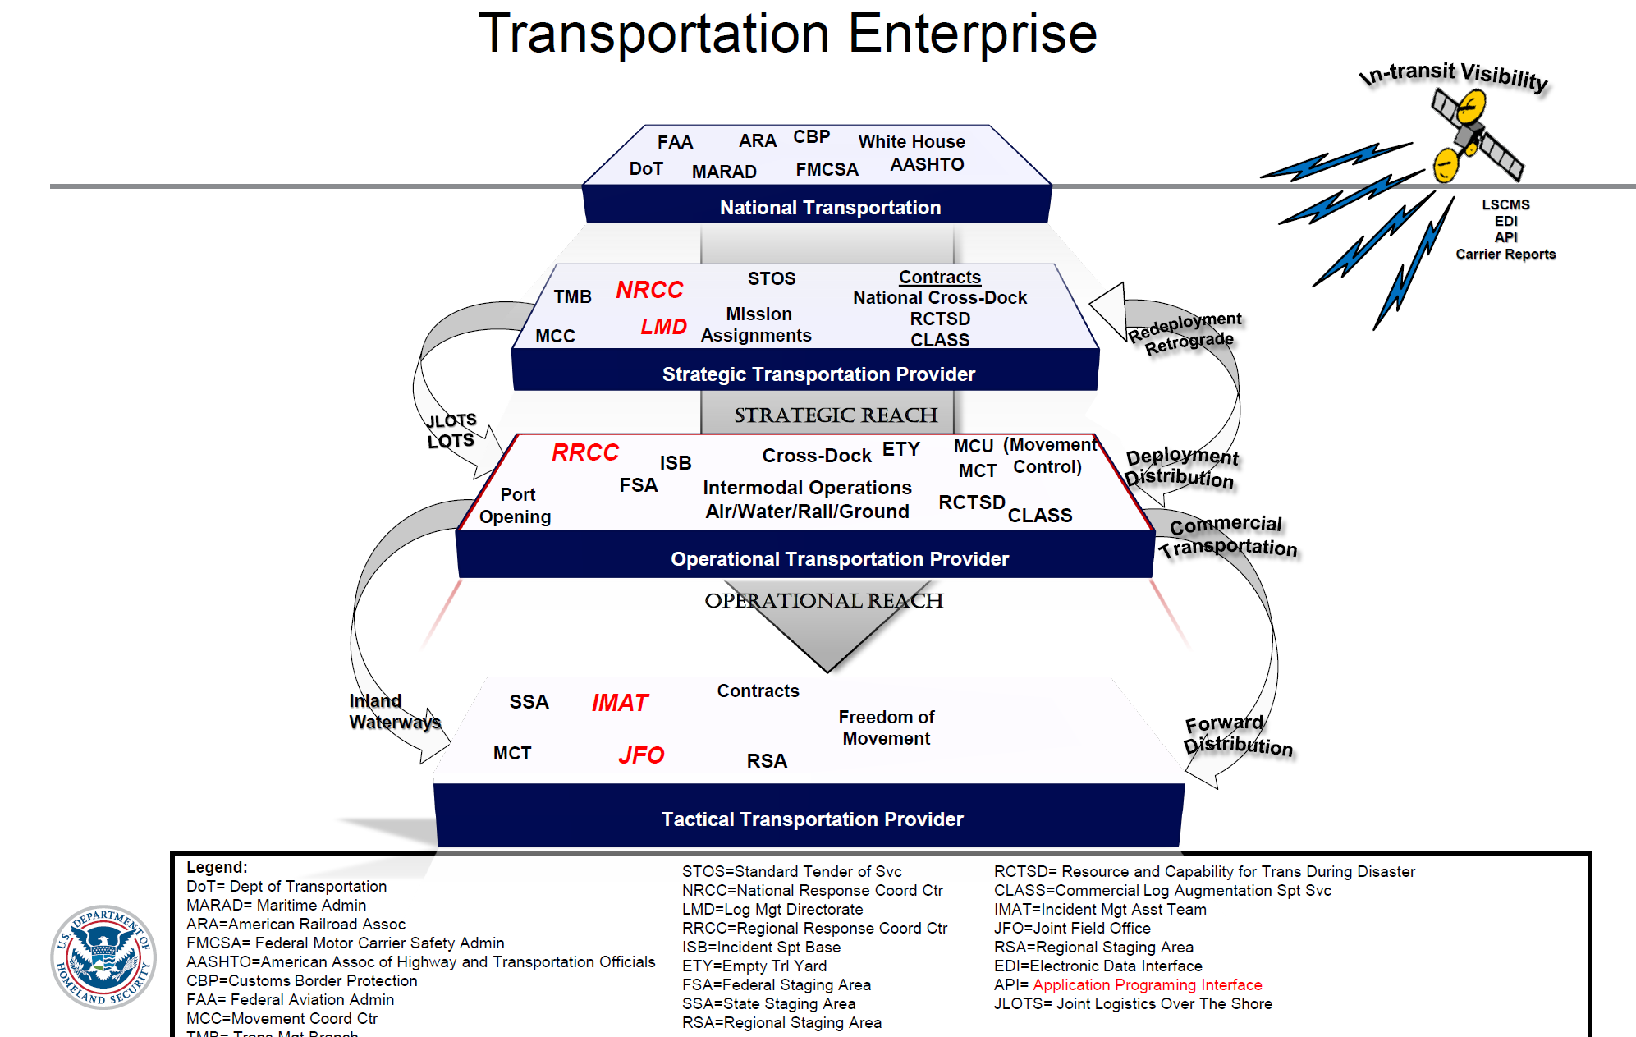
Figure 3. Transportation Enterprise; slide from TxFAC #40 presentation.

He noted FEMA does not own any transportation assets. Transportation enterprise, strategy or national level, and tactical level depicts all of FEMA’s different partners.

With FEMA transportation capabilities, all assets can be accessed through three ways: 1. FEMA STOS (standard tender of services) which is internal to FEMA and a group of vetted service providers. 2. Contracts. 3. Mission assignments external to FEMA, working with other government agencies.
There are also ways for a one time only or spot bid award for resources to move at a moment’s notice/short notice.

Chair Emmett asked if FEMA has contracts who decline due to the truck driver shortage. Mr. Francis, Sr. responded yes; they can decline. However, FEMA does not have an issue finding drivers. FEMA pays premium dollar, and they can also get drivers from out of state.

Mr. Francis, Sr. then discussed the national cross dock contract that allows FEMA to deploy transportation services. This contract provides the capability to develop and employ a network of transportation and emergency cross dock/freight forwarding service operation centers, along with disaster staging area support services. The contract provides personnel, training equipment, tools, and materials.

FEMA is a small agency. Commercial logistics augmentation support services are contracted for bench strength and trained personnel who understand the logistics and transportation to place at key nodes.

Mr. Schwebel asked if these are long-term contracts. Mr. Francis, Sr. noted that they can be, and task orders may be only issued for 30–90-day periods. With a 30-day task order, FEMA can get a better understanding of the event and make informed decisions to scale contracts up or down.

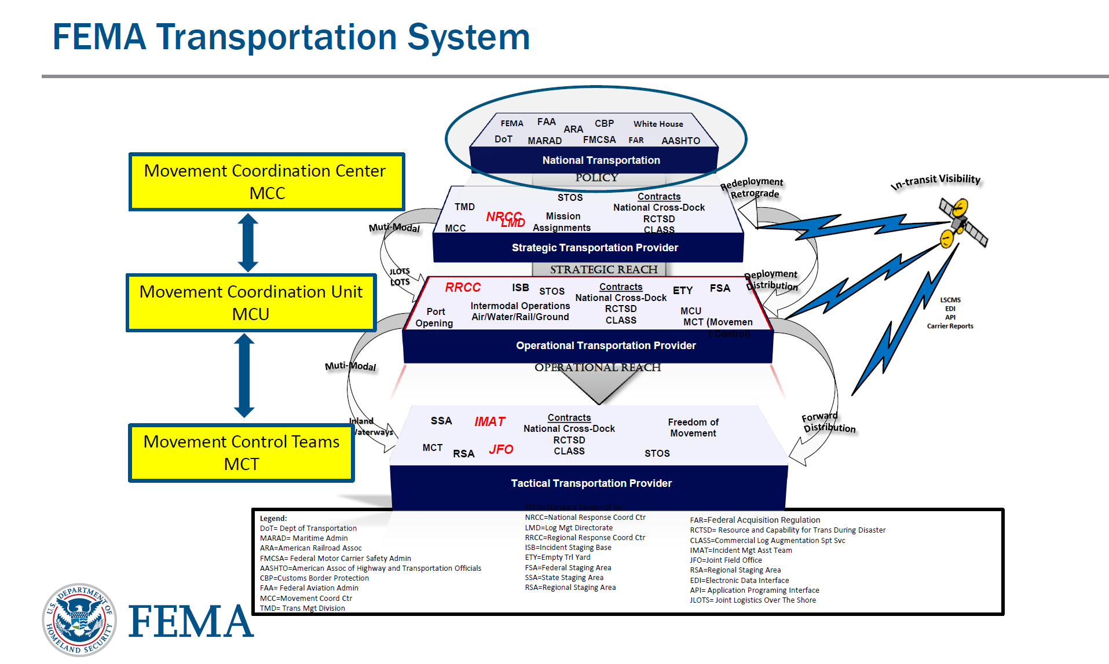
Figure 4. FEMA Transportation System; slide from TxFAC #40 presentation.

Mr. Francis, Sr. provided an overview of the transportation system for FEMA and how FEMA fields requests from the region. The Movement Control Unit (MCU) is a unit of trained FEMA personnel deployed to coordinate, control, and track all modes of transportation within the incident area. The Movement Control Team (MCT) are trained transportation facilitator personnel at critical nodes
where movement priorities and requirements originate, stage, or deliver to help control the flow of resources, maintain visibility of FEMA/Inter-Agency equities, and provide situational awareness.

Chair Emmett thanked the presenters and noted that FEMA is effective because they are prepared and do this work all the time. As a local official, he noted there is not a better partner out there. When we ask, “can you do this?” they say yes. FEMA’s preparedness and professionalism in a disaster is appreciated.

Mr. Ortiz asked if the United States Army Corps of Engineers is a teaming partner, and Mr. Tucker affirmed. FEMA will not replicate something that exists at another federal agency, so the Corps often serves as a major partner due to their engineering capability.

4. Texas Freight Mobility Plan Implementation Update

Mr. Graham provided an update on the implementation of the Texas Freight Mobility Plan. He opened noting that the Infrastructure Investment and Jobs Act (IIJA) updated the required frequency of state freight plans from every five years to every four years. TxDOT anticipates submitting the next update in 2027.

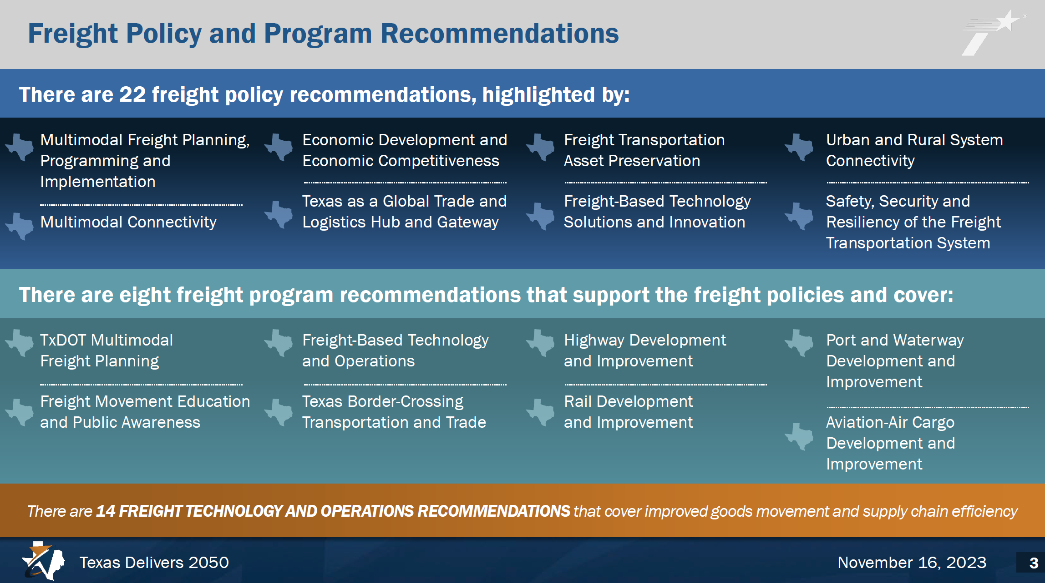
Figure 5. Freight Policy and Program Recommendations; slide from TxFAC #40 presentation.

The policy recommendations in the freight plan were informed by this committee. Pursuant to these policy recommendations, items to be completed include the Houston/Southeast Texas Truck Parking Action Plan and the El Paso/West Texas Truck Parking Action Plan; items that are current and ongoing include: Freight and Supply Chain Resiliency Plan, Third Coast Strategy for Texas Report, and the I-10 Truck Parking Availability System; and items to be underway soon include: Hazardous Materials Transportation Report, Additional Truck Parking Action Plans, and the Texas Triangle Multimodal Strategic Plan (TTMSP).

Mr. Schwebel asked if printed copies of the plan could be provided to MPOs across the state. Mr. Graham affirmed that materials can be provided upon request.

Chair Emmett asked for an executive summary of the freight policy and program recommendations. Mr. Graham said they will provide an executive summary with the recommendations and mapping out the accomplishments from the freight planning process.

5. Freight and Supply Chain Resiliency Plan Update

Mr. Graham provided an update on the ongoing effort to develop TxDOT’s first freight and supply chain resiliency plan.

Freight resilience is currently defined as the ability of Texas’s freight system to reliably operate and quickly recover from diverse disruptions. It encompasses robust infrastructure, effective risk management, and adaptive operational strategies to minimize disruptions to the state’s critical supply chains. The key components of freight resiliency are robust infrastructure, operational flexibility, effective risk management, strategic planning, stakeholder collaboration, and leveraging technology. He emphasized operations and partnerships as a major focus.

An interactive survey question using the platform, Menti, was presented to the committee and the question asked was: What does freight resiliency mean to you? A word cloud of the responses is below.

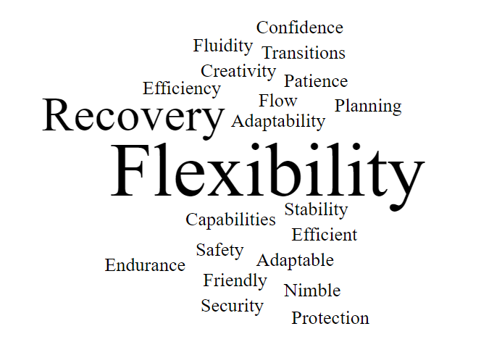

Texas residents and businesses experience many types of disruptions. Mitigation strategies enhance pre-, during-, and post- event actions that reduce impacts. Supply chain resiliency represents a key
competitive factor for industry. A Freight Resiliency Plan (FRP) will: strengthen the Texas economy, enhance the quality of life for residents and visitors, and prepare the state for new growth opportunities.

TxDOT plays a key role in freight resiliency including within strategic planning, operational management, policy, and investment prioritization. Modal partners are specifically a key part of the stakeholder engagement effort. The purpose of the plan is to reinforce supply chain resilience, articulate TxDOT’s strategic role, focus on infrastructure resiliency and adaptation, and develop an investment plan for increasing Texas Multimodal Freight Network (TMFN) resiliency.

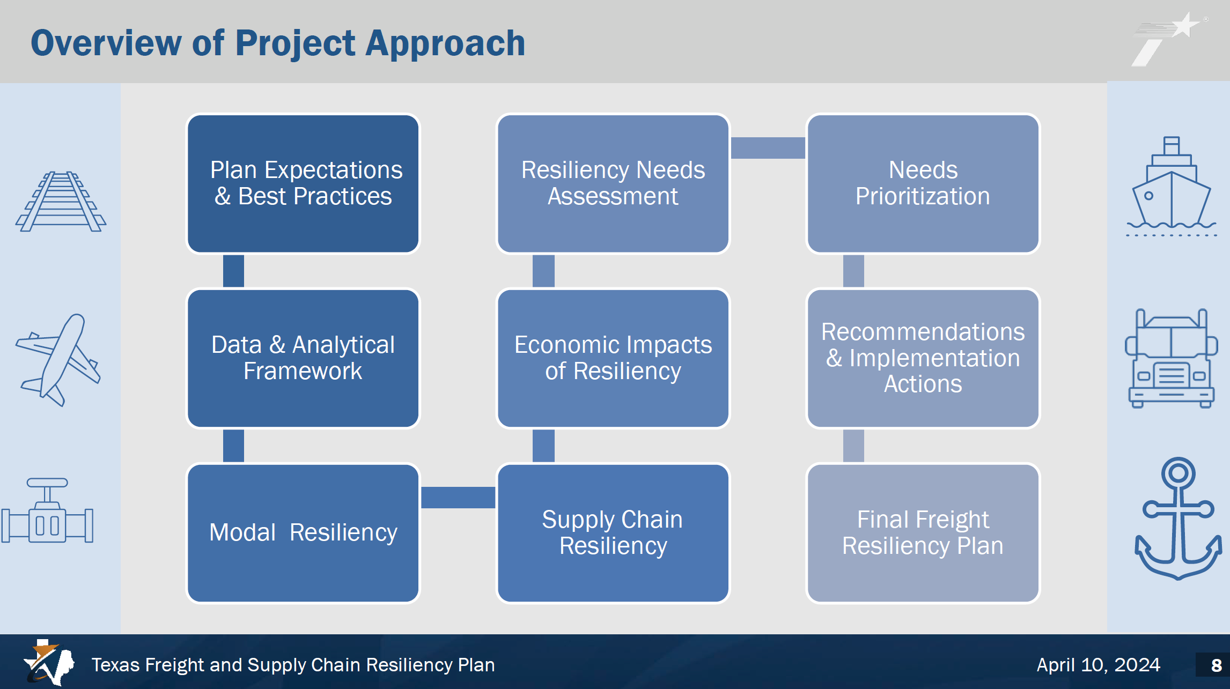
Figure 6. Overview of Project Approach; slide from TxFAC #40 presentation.

The ongoing data gathering has included a literature review to examine best practices across the country including the Alabama, Georgia, Illinois, and Tennessee DOT. This stage also includes coordination with the ongoing TxDOT Statewide Resiliency Plan (SRP) which is underway and anticipated to be completed this summer.

Next, Mr. Graham reviewed key definitions including exclusivity, which is the focus on certain areas where we get specific things in those specific areas, e.g., citrus fruits in the Rio Grande Valley, the cotton industry supply chain, and the petrochemical industry. If an issue impacts one part of the state that provides one exclusive item, there is no other part of the state that provides that specific item.

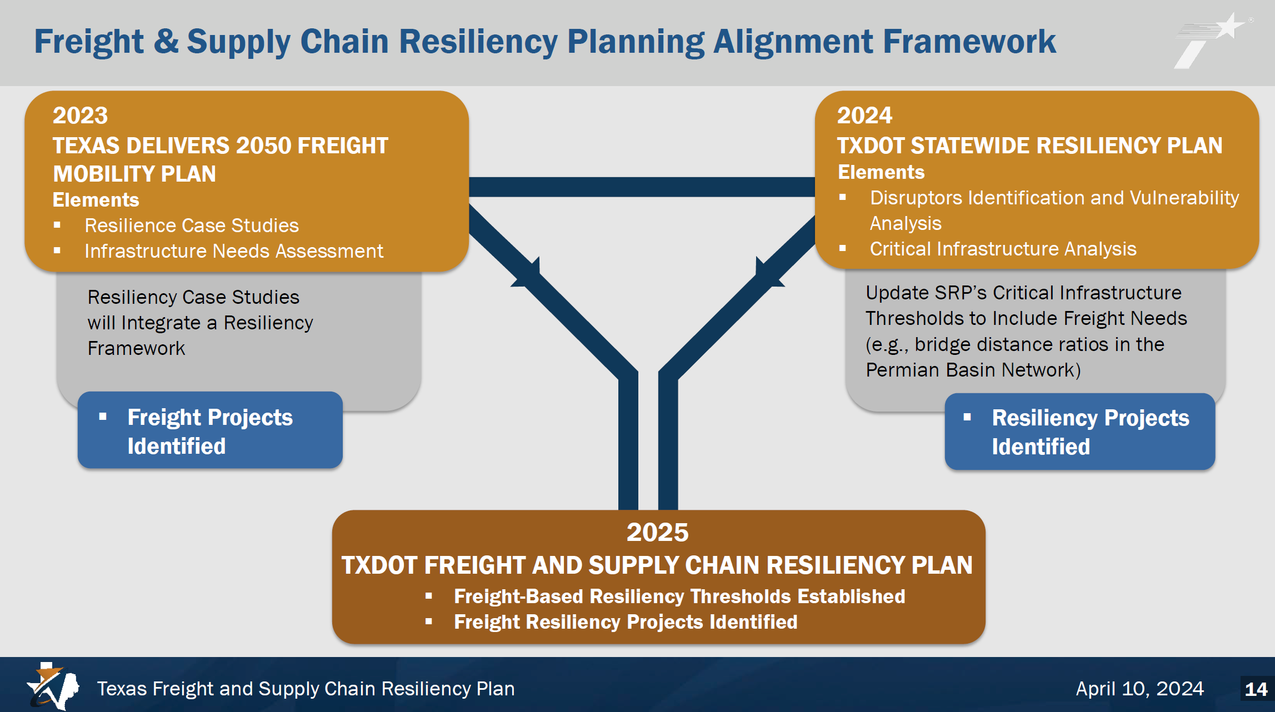
Figure 7. Freight & Supply Chain Resiliency Planning Alignment Framework; slide from TxFAC #40 presentation.

Mike Williamson, with Cambridge Systematics, provided additional information on the alignment of this plan with the SRP. The alignment with the SRP includes the assessment of threats, modal resiliency, infrastructure exposure, threat sensitivity of infrastructure, and modal and supply chain vulnerability. Mr. Williamson noted there are key dependencies broken if supply chains break.

He led the committee through an interactive exercise to receive committee guidance on the development of this plan.

An interactive survey question was asked of the committee: What do you think is the most important factor to consider for assessing the freight resilience of each mode in the Texas Multimodal Freight Network? The answers provided are as follows:

- Education and engagement of TxDOT and state legislators.  - Understanding specific mode needs.  - The locations/facilities that impact multiple modes and a variety of freight.  - Realistic alternatives.  - Alternative routes.  - For trucking, it’s the shortage of drivers and developing the need for training next generations of drivers. | - The geopolitical challenges that impact supply chains.  - Know the current conditions of the modal assets related to life cycle costs.  - Multiplying effect of disruptions due to governance. Stopping freight at the border.  - Criticality of the economic impact of disruption and infrastructure needs to engineer in the system. | - Key infrastructure that would take a long time to replace.  - Better infrastructure.  - Challenges that impact supply chains locally, regionally, and globally.  - What types of disrupters impact their operations and how.  - Adding crossings or expanding current capacity.

The FRP project outcomes were noted as:

- Awareness of the parts of the TMFN most at-risk to potential threats/disruptions.
- Understanding the impact of geopolitical events on Texas supply chains that operate in a global and interconnected economy.
- Understanding of the economic impacts to the State economy and industries from disruptions to supply chain operations (loss of economic output, wages, and trade).
- Prioritization of the freight projects identified in the UTP for benefits or contributions towards increasing freight network resiliency.
- Freight-specific recommendations that address the needs identified throughout the Plan development.

An interactive survey question was asked of the committee: Are we missing anything in terms of project outcomes? The answers provided are as follows:

- What role TxDOT should play when political decisions at the state level impact freight movement. | - How to work with the governor’s office to explain the negative impact. | - Please conduct a scan of the TXDOT Districts and MPOs/COGS for their status of resiliency plans in general and for freight.

Chair Emmett started the discussion stating for example, if Port Houston goes down that impacts the port, the rail, and all the trucks going in and out. There is a hierarchy of facilities. A highway bridge going down is critical for some, but a port going down impacts multiple modes. Ms. Mullins added that if rail is down for over a day at the border or due to a wildfire, this impacts international and national commerce.

Mr. Ortiz noted that at the border with Mexico, the two countries have different IT systems. When Mexico’s system goes down, it can be an extreme impact. Chair Emmett responded noting that cyberspace resilience should be considered as a major disruptor.

Mr. Schwebel discussed the geopolitical challenges and impacts with Mexico as Texas’ number one trading partner. International trade sees a lack of both state and federal government coordination. Specifically, proper protocols are needed for who makes decisions at the local level and how that escalates through a chain of command. For example, government leadership states a decision, there is no measurement of the impacts of that decision or any stakeholder input for that decision. When the railroad was shut down for a week, that had significant impacts on jobs and the economy. There are challenges in years to come, including elections. We must plan how we move around those challenges, especially when rhetoric about the border is negative. Trade is positive. The need includes proper infrastructure planning, a highway network, and border processing imports and exports. Currently, the plans are inadequate and underfunded to facilitate growth in trade. Ms. Mullins noted both political parties use this as a tool and that planning should be in place regardless of election results.

Mr. Ortiz responded saying the speed of execution is the major issue. For example, there are challenges with the World Trade Center check points. Planning takes significant time and implementation needs multiple funding sources. Mr. Williamson added the hope is to prioritize both needs and projects based on resiliency.

Chair Emmett asked if there were considerations of how activity outside the state of Texas impacts freight resiliency and if that is being studied, to which Mr. Williamson affirmed.

Next, the FRP team will define modal resiliency considerations, conduct supply chain resiliency assessments, meet with a Multimodal Resiliency Working Group, and continue stakeholder interviews. The FRP effort will wrap up in summer 2025.

6. HB 4422 Update

Sergio Vasquez, International Trade and Border Planning Branch with TxDOT’s Transportation Planning and Programming Division, provided an overview of Texas House Bill 4422.

HB 4422 passed unanimously during the 88th Regular Session of the Texas Legislature. It directs TxDOT to conduct a study on enhancing border security outcomes near Texas-Mexico border crossings for commercial motor vehicle (CMV) activity.

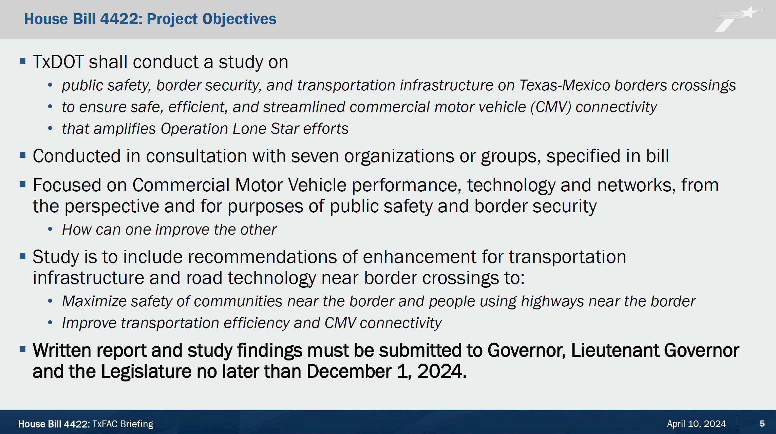
Figure 8. House Bill 4422: Project Objectives; slide from TxFAC #40 presentation.

The objectives focus on CMV performance and the approach involves coordination between TxDOT, the Texas Department of Public Safety, the Texas Military Department, and a working group to guide the study. The report is due this December.

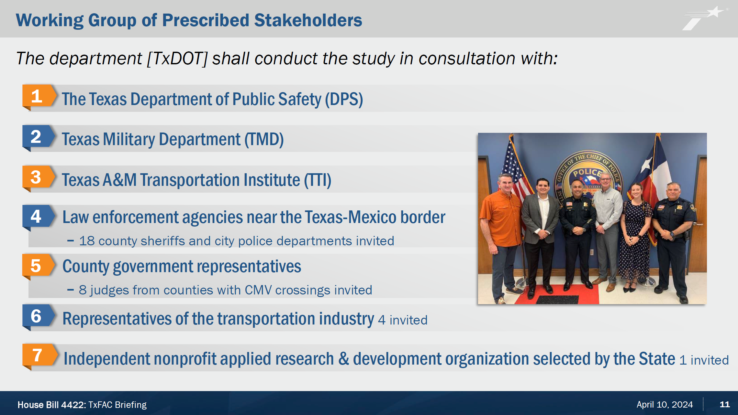
Figure 9. Working Group of Prescribed Stakeholders; slide from TxFAC #40 presentation.

Engagement is required as part of this effort, and all 16 border crossings have been visited. There is representation across the board in the working group. Additional interviews and roundtables are planned with the public sector, private sector, CMV Crossing Site visits, as well as several roundtables with Mexican partners. Law enforcement is providing ride-alongs and documenting hot spots in maps. The existing IT systems are being reviewed as well.

Next steps include bottleneck analysis based on truck GPS data; safety analysis based on crash data; connectivity and key routes to/from CMV border crossings; consideration of new or improved routes under development; technology scan for border crossings and current network; and inspection, citation and arrest data analysis.

The committee had no comments.

7. Roundabout and Alternative Intersection Discussion

Amanda Austin, P.E., Transportation Engineer with TxDOT’s Design Division, provided an overview of roundabouts and alternative intersections. Currently, there are over 500 roundabouts in Texas. TxDOT now has a program for innovative intersections, and freight is a major consideration. Ms. Austin listed innovative intersections including the modern roundabout, restricted crossing U-turn (RCUT), and single-point urban interchange (SPUI). These non-traditional intersections reduce conflict points which improves safety.

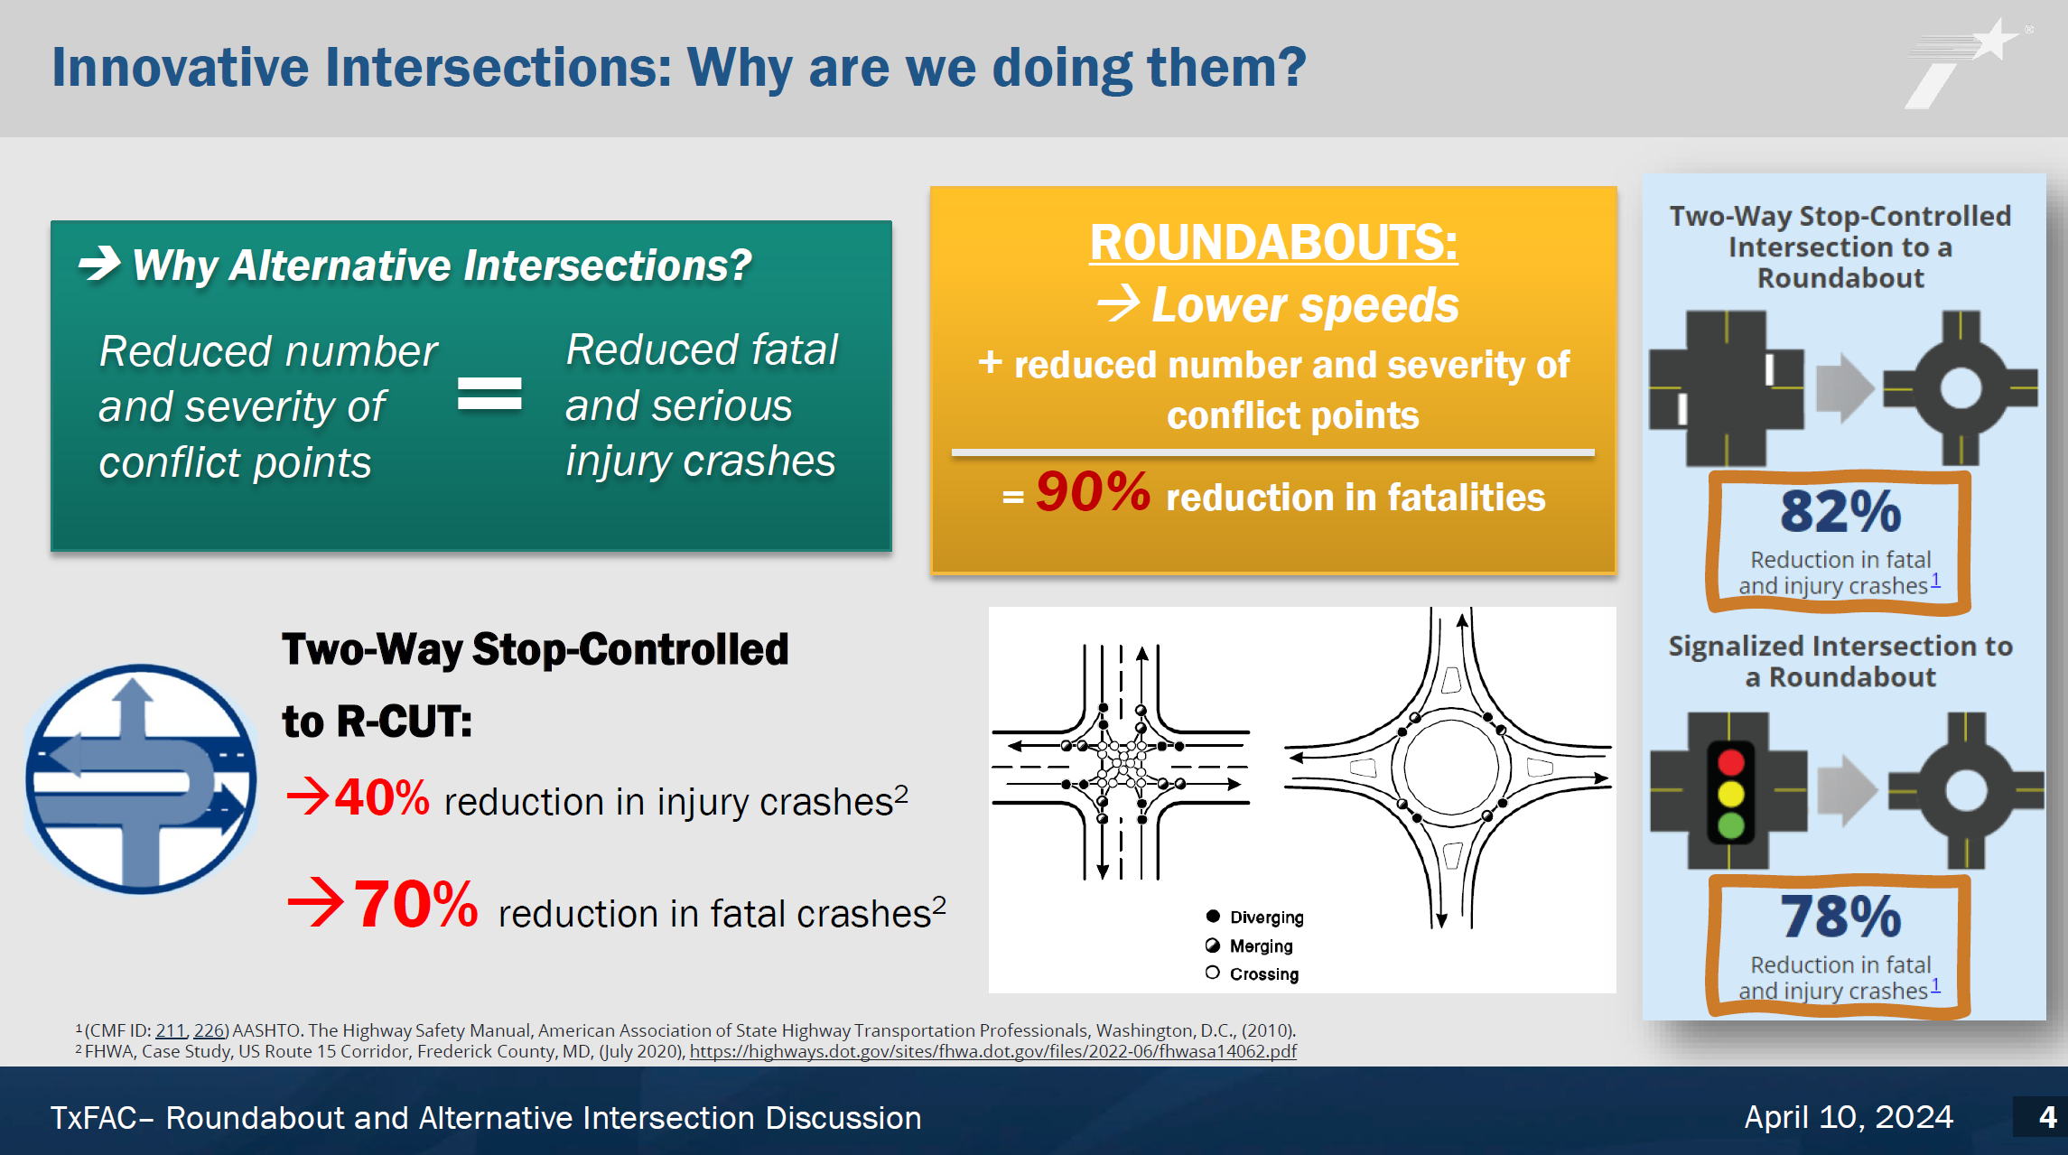
Figure 10. Innovative Intersections: Why are we doing them?; slide from TxFAC #40 presentation.

The bedrock of why roundabouts are supported by TxDOT’s Design Division is how they improve safety dramatically with an incredible safety record and statistics.

Ms. Austin noted 32% of fatal crashes are intersection related; so, we know the problem. Roundabouts and innovative intersections provide real solutions for saving lives. With roundabouts, there are more than just safety, operational, resiliency, and maintenance benefits. Roundabouts keep working when the power goes out. Florida is working on a quick resiliency action to turn a traditional interchange into a roundabout during hurricane recovery.

Chair Emmett pointed out that public education on these points is critical. In his experience, the public think roundabouts are a step backwards and the issue is that drivers ignore traffic signals.

Commissioner New provided his comments on roundabouts. Regarding freight, sometimes there are restrictive roundabouts in the wrong place near a retail or warehouse center on local roads. From a TxDOT perspective, the design should be sensitive to the mix of vehicles using the roundabout including school buses and large trucks. In addition, he focused on the importance of school buses being able to use roundabouts. He noted that there is resistance to these intersections especially as in the past, TxDOT has removed them and is now supporting them.

Ms. Cruz added that in her experience, a community had an intersection with a lot of accidents, so the roundabout was recommended by the local government. The public came out in force against it, so the city council voted against the roundabout despite education and safety statistics. There needs to be a targeted marketing/promotion effort.

TxDOT’s new Roundabout and Alternative Intersection Design (RAID) program will look at innovative intersections. The vision is to see an exponential increase in implementation of roundabouts and alternative intersections and see a corresponding decrease in intersection-related fatalities. The Design Division is working on advocation, education, and support.

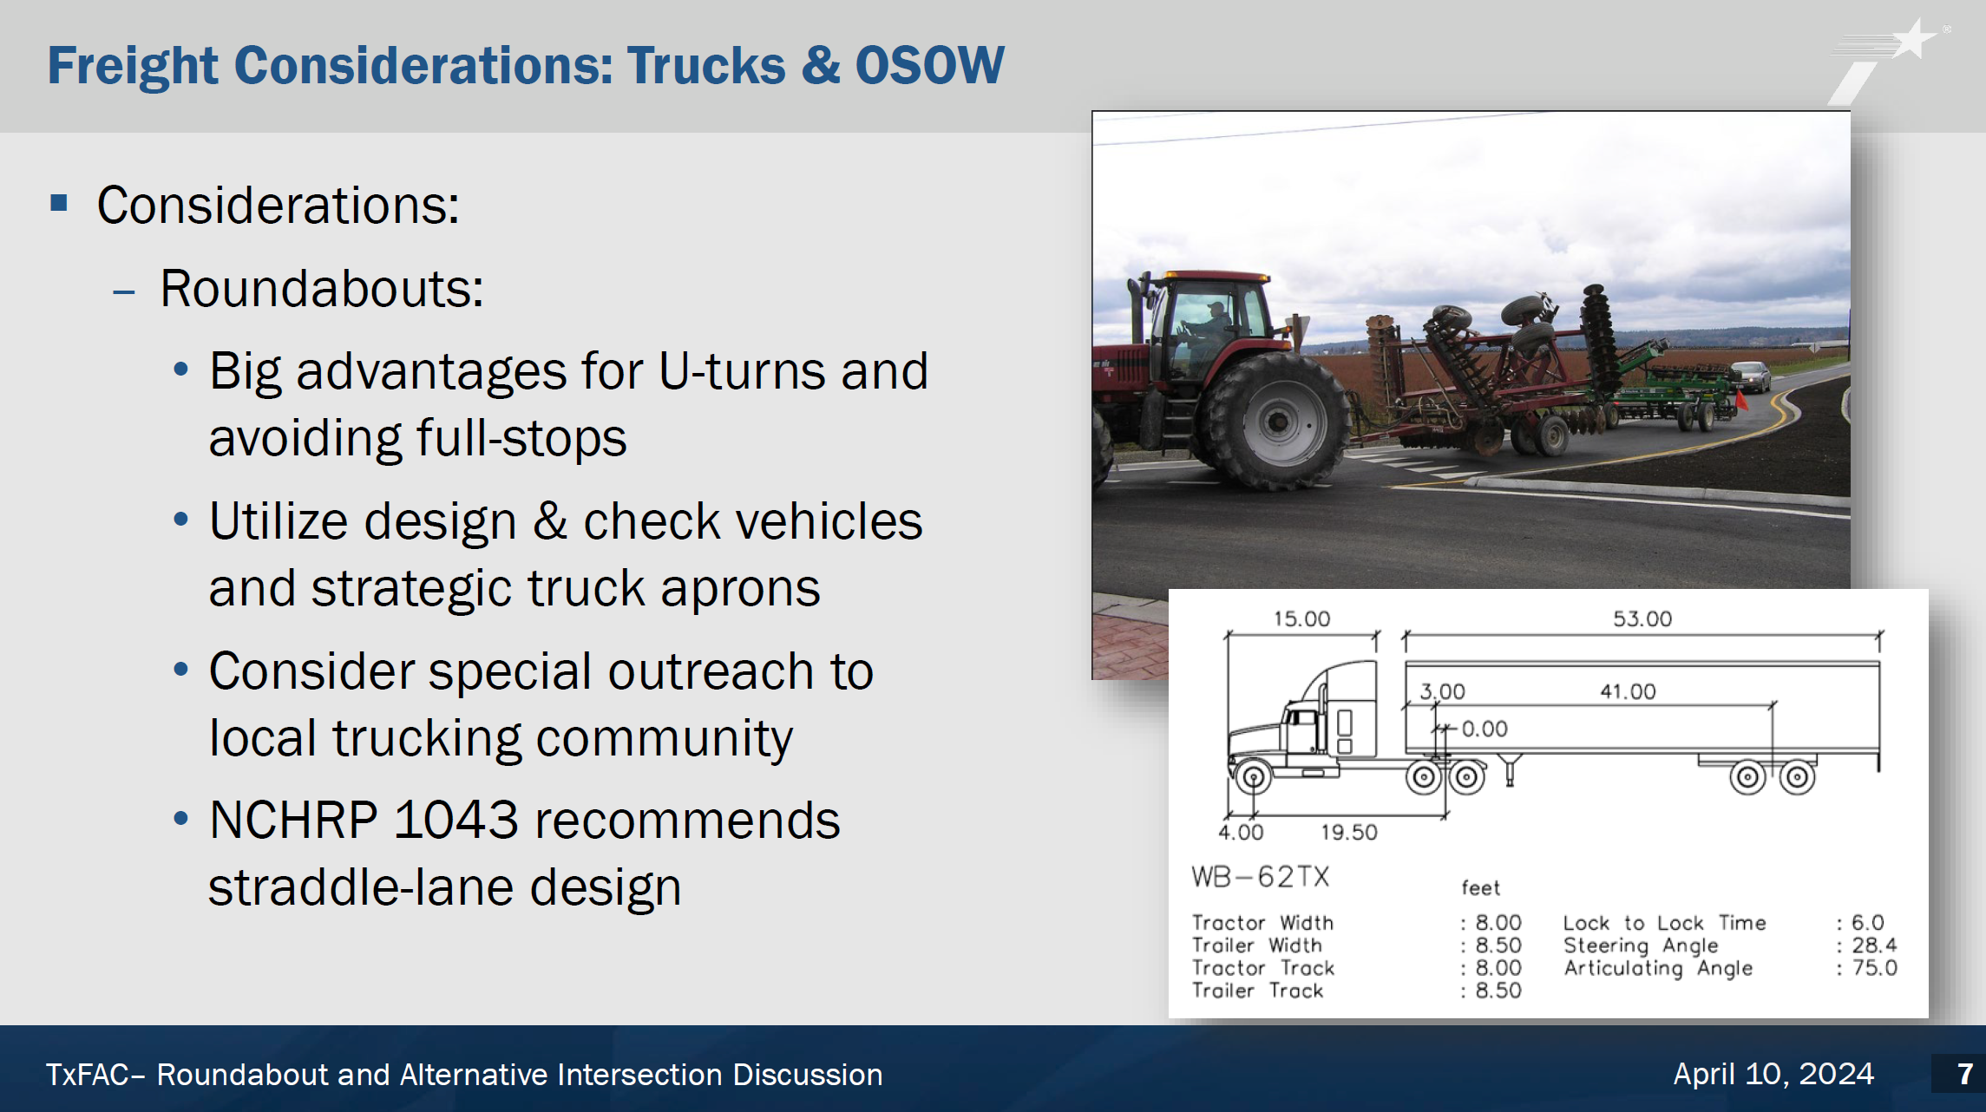
Figure 11. Freight Considerations: Trucks & OSOW; slide from TxFAC #40 presentation.

The key relevance to this committee is that roundabouts can be designed to support truck use. Roundabouts can accommodate U-turns for large and overweight trucks. The preference is the straddle lane design so truckers can straddle two lanes. The new design manual will include information on lane usage. Also, a well-placed truck apron can allow for oversize and overweight vehicles.

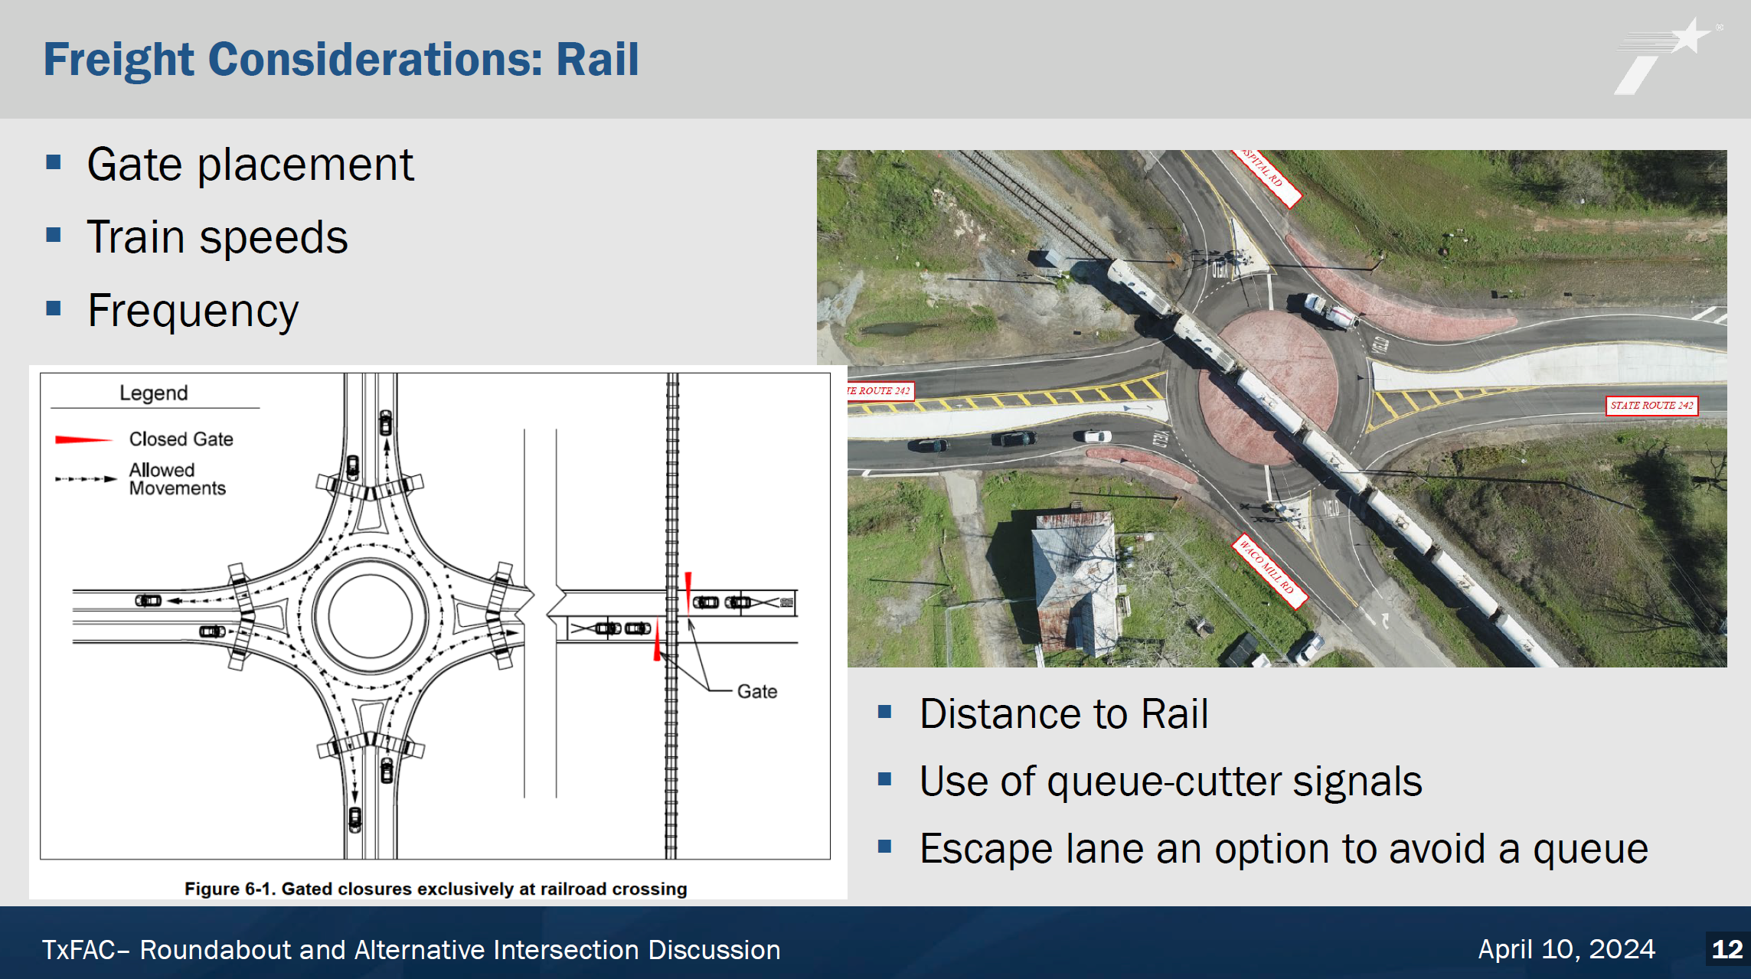
Figure 12. Freight Considerations: Rail; slide from TxFAC #40 presentation.

Rail is also a consideration, and it is possible to design as long as there is active coordination with the railroad.

The Design Division is updating the design manual and training curriculum. This briefing is part of the stakeholder engagement underway for this program.

Chair Emmett thanked her for her enthusiasm and reiterated that the concern is public education. He recommended Ms. Austin get on the radio program, Road Dog Trucking hosted by Mark Willis, to augment outreach.

Mr. Ortiz stated they are hearing roundabouts recommended by developers; this option holds promise.

Ms. Cruz noted that in her experience, there has been a concern about who maintains the landscaping in the center of a roundabout.

8. Future Meetings and Final Remarks

Chair Emmett noted future meetings will be held, and Mr. Graham asked the committee for their priorities and feedback.

Mr. Guenther said he serves on the USDOT, Maritime Terminal System National Advisory Committee. There are discussions about a national multimodal freight network and a national maritime strategy that this committee should consider engaging in. Ms. Mays said they were aware of discussions on those topics and that they will try to invite Allison Condon, the undersecretary for the multimodal office, to a future committee meeting. She mentioned they review federal transportation related strategies such as a study by Congress about truck driver compensation and how that impacts safety.

Ms. Mays added that TxDOT plans to add up to 10 additional members to the committee and asked for recommendations.

Chair Emmett adjourned the meeting at 12:07 p.m.

