Title of project

# Generic map of road. Project profile

Lorem sed malesuada fermentum sodales. Quisque vitae enim risus. Nullam gravida eleifend nisl, aliquet mollis ipsum dictum non. Curabitur accumsan quis orci ac mattis. Vivamus ut diam purus. Donec nisl lorem, mollis a ullamcorper porta, laoreet ut nulla.

Lorem sed malesuada fermentum sodales. Quisque vitae enim risus. Nullam gravida eleifend nisl, aliquet mollis ipsum dictum non. Curabitur accumsan quis orci ac mattis. Vivamus ut diam purus. Donec nisl lorem, mollis a ullamcorper porta, laoreet ut nulla.

# Cultural resources surveys

Before TxDOT approves a transportation project for construction, its Cultural Resources team studies how the project may impact historical and archeological sites. The first step is to identify known and potentially important sites that are at least 45 years old within a project area through field survey. The survey results shape the project planning process.

Archeological surveys may include one or more of these tasks:

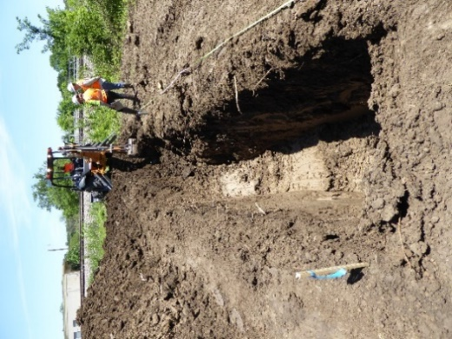

* Gaining “right of entry” to private property to conduct the survey
* Shovel testing
* Trenching
* Screening
* Hand or machine excavations
* Laboratory analysis

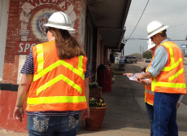Historic resources surveys include written and photographic documentation from the roadway, as well as library and local research. Surveys record the following for each resource:

* Location
* Construction date
* Architectural style
* Whether it meets National Register of Historic Places listing requirements

## Field Survey Work

TxDOT hires professional environmental consulting firms to complete cultural resources surveys. TxDOT supervises consultants and reviews submitted documentation. Consultants must have a certain amount of education and expertise prior to working on TxDOT projects.

# Project contacts

|  |  |  |
| --- | --- | --- |
| District Project Engineer or Manager Name Email address Phone number | District Environmental Coordinator Name Email address Phone number | TxDOT Archeologist or Historian Name Email address Phone number |

# Frequently Asked Questions

## Who is TxDOT?

We are the state agency responsible for planning, designing, constructing, maintaining, and operating state transportation facilities including roads, bridges, waterways, and airports in Texas.

## What are cultural resources?

A term that collectively refers to buildings, bridges, archeological sites, cemeteries, sacred or religious landmarks, agricultural landscapes, and objects like sculptures and roadside markers.

Why does TxDOT complete cultural resources surveys?   
Cultural resources surveys help TxDOT better understand how a proposed project may impact buildings, places, landscapes, objects, or sites that are important to the prehistory and history of our state. Once cultural resources are identified, TxDOT works to design transportation projects that limit harmful impacts.

## Why does TxDOT have historians and archeologists?

TxDOT’s Cultural Resources team ensures the agency follows laws related to the preservation of the historic built environment and archeological resources, such as the National Historic Preservation Act and the Antiquities Code of Texas. The team is tasked with balancing progress with the need to preserve significant resources and places.

## Why are you taking photos of my property?

We are completing a survey of cultural resources that may be impacted by a proposed transportation project. The photographs are for recordkeeping purposes only. All photos are taken from the public right of way unless we have right of entry permission from the property owner.

## Why are you digging? What happens to any artifacts you find?

Shovel tests help archeologists locate archeological sites. They are minimally invasive, and the ground is always restored to its original appearance, or as close as reasonably possible. If artifacts are found, TxDOT follows federal and state laws when caring for them. All artifacts found on public lands are managed by the State of Texas and stored at certified facilities for protection and research purposes. All artifacts recovered from private property are returned to the landowner after documentation.

## But my property isn’t that old?

TxDOT studies properties that are 45 years old or older.

## What qualifies a property to be historic?

TxDOT looks for properties that are at least 45 years old that have a documented connection with a historic event or notable person, or that have notable architectural or engineering design.

## Who decides if a property is historic?

TxDOT historians and archeologists determine whether a property is historic after completing research and survey work. We also talk to the Texas Historical Commission, County Historical Commissions, and other state and local groups interested in history, historic preservation, and archeology to learn more.

## What happens if my property is determined to be historic?

TxDOT’s determinations about historical significance are for transportation planning purposes. They are not formal designations and require no obligations from you. Still, we encourage you to share information about your property’s history with our archeologists and historians if they contact you.

## How long does it typically take to plan and build a transportation project? Where are we in the process?

The planning process can take several months to years, depending on the size and complexity of the project. Cultural Resources surveys are part of the “Design & Environmental” phase, where TxDOT reviews project plans based on possible environmental impacts and public input.

## Are you taking my property for the project?

If you wish to discuss this project's impacts to your property with TxDOT, please call the project contacts listed on the front of this sheet.

# Instructions—Cultural Resources Management FAQ

TxDOT ENV-CRM created this Frequently Asked Questions (FAQ) sheet for TxDOT staff and consultants to share with members of the public interested in cultural resources management work. The form can be handed out at public meetings, mailed with right of entry (ROE) requests, or given to property owners when completing field survey work.

1. The first side of the form is customizable and should include project–specific information. Please fill out the following sections:

* Title of project
* Project profile
* Project map
* Project contacts

These sections are highlighted in the document to signal that they are editable. The highlighting will disappear when you print the form or save it as a PDF.

1. Do not print this page.