

Texas Freight Advisory Committee Meeting #41
July 24, 2024, 8 a.m. to 12 p.m.
In-Person Meeting at AllianceTexas
Circle T Ranch, 2451 Westlake Parkway, Westlake, TX 76262

ATTENDEES

Committee Members | Organization | Attendance
Judge Ed Emmett – Chair | Rice University | Yes
Adriana Cruz | Office of the Texas Governor | Yes- Virtual Attendee
John Esparza | Texas Trucking Association | Dana Moore  serving as proxy
Roger Guenther | Port Houston | Bruce Mann  serving as proxy
Miriam Kotkowski | Tecma Transportation Services | Yes
Charlie Leal | Texas Farm Bureau | Did not attend
Robert MacDonald | Texas Association of Metropolitan Planning Organizations (TEMPO) | Did not attend
Tiffany Melvin | North American Strategy for Competitiveness | Rachel Connell  serving as proxy
Lindsay Mullins | BNSF Railway | Yes
Rolando Ortiz | Killam Development Ltd. | Yes
Keith Patridge | McAllen Economic Development Corp. | Did not attend
Clint Schelbitzki | Union Pacific Railroad (UPRR) | Yes
Gerry Schwebel | International Bank of Commerce, San Antonio | Yes
Sean Stibich | Port of Victoria | Yes
Paul Treangen | TNW Corporation | Yes
Matt Woodruff | Kirby Corporation | Did not attend

Total Count of Committee Present: 10

TxDOT

Andrew Canon
Kale Driemeier
Tyler Graham
Brent Johnson
Caroline Mays
Commissioner Alvin New
Erika Kunkel
Farideh Dassi
Leah Casey
Luis M. Villareal
Sergio Vasquez
Wesley Starnes
Yvette Flores
Emily Clisby
Nicole Lawson
Humberto “Tito” Gonzalez, Jr.
Mildred Litchfield

Agency/Consulting Team
Jeff Cleland | Amazon
Paula Dowell | HNTB
Eva Esquivel | HNTB
Jeremy Upchurch | HNTB
William Long | Poznecki-Camarillo, LLC
Robert Elizondo | Poznecki-Camarillo, LLC
Elizabeth Story | Poznecki-Camarillo, LLC
Laura C. Freeland | South Dallas Inland Port

Elected Officials
Rep. Jill Dutton | Texas House of Representatives District 2
Brad Johnson | Texas House of Representatives District 2 Legislative Staff

Other Attendees
Matt Larseingue | BNSF
Genevieve Bales | FHWA
Tracy Michel | Garver
Nick Konen | Hillwood
Russell Laughlin | Hillwood
Dhruva Lahon | Kimley-Horn
Mike Johnson | NCTCOG
Savannah Briscoe | NCTCOG
Valerie Alvarado | NCTCOG
Mark Hutchins | NETEX (Hunt Co.)
Michael Looney | San Angelo Chamber EDD
Roger Horton | SHEA Transportation
Feleceia Wilson | Southern Dallas County Inland Port Transportation Management Association
Frankie Wilson | Southern Dallas County Inland Port Transportation Management Association
Peter Le Cody | Texas Rail Advocates.org
Charles Lino | Town of Pecos City, Texas
Allan Rutter | TTI
Jason Wallis | TTI
Jeff Warner | TTI
Sushant Sharma | TTI
Lizzie Welch | WSP

1. Welcome and Introductions

Judge Ed Emmett, Texas Freight Advisory Committee (TxFAC) Chair and Fellow in Energy and Transportation Policy Rice University’s Baker Institute for Public Policy, welcomed the committee at 8:12 a.m. He opened the meeting noting that Texas is the model for freight and this committee is a key part of that.

Commissioner W. Alvin New, Texas Transportation Commission, added that he appreciates everyone attending and their involvement in this committee.

Caroline Mays, TxDOT Director of Planning and Modal Programs, thanked Judge Emmett for his leadership of the committee and the committee members for providing TxDOT with valuable insights about freight movement. Ms. Mays added that she represents TxDOT and the United States through the American Association of State Highway and Transportation Officials (AASHTO). She mentioned she shares best practices from this committee with AASHTO. She also thanked Russell Laughlin with Hillwood and Alliance for hosting the meeting at their facilities.

Chair Emmett stressed the importance of the work by the committee by saying that transportation is like the circulatory system of a body. He then introduced Texas State Representative Jill Dutton and mentioned that she will be speaking about rural rail districts. He added that rural rail districts are critical to the future of freight movement in Texas.

Representative Jill Dutton, Texas House of Representatives District 2, stated that rail in her district is her number one priority. She said she is here to advocate for the Northeast Texas Rural Rail District (NETEX). She mentioned wanting support for more funding for NETEX and to upgrade the rail system to a Class 2 rail designation. She added that would increase the travel speed from 5-10 mph to 20-25 mph. She said the revenue they receive is used for upkeep on the current rail system in their area. She mentioned that rail infrastructure improvements are needed because the current infrastructure includes outdated materials. She shared nails around the room from 1937-1949 as examples of how outdated some of their infrastructure is. She said they transport steel, lumber, grain, and some hazardous material. She concluded by saying that rail is the future in the United States and Texas.

Chair Emmett said he would like to discuss rail districts at a future committee meeting. He suggested the Texas Legislature evaluate these rail districts and how they can be improved. He then thanked Representative Dutton for joining us and for her efforts to improve transportation infrastructure.

2. Host’s Welcome and Updates from Hillwood

Russell Laughlin, Executive Vice President of Strategic Development and Innovation, Hillwood, welcomed the committee to the Circle T Ranch. He mentioned it is a 40,000 square foot facility and that they have 2,500 head of Black Angus cattle that graze on their 30,000 acres. He said they entertain people from all over the world and fashioned the facility to give them a true sense of Texas.

Hillwood has its focus on transportation, economic development, and the integration of technology into transportation. Mr. Laughlin said that in 1987-89, they partnered with TxDOT on SH 170 in the first state public/private partnership that delivered a state highway on-system with a private developer.

AllianceTexas is a 27,000-acre, master-planned development by Hillwood Properties encompassing industrial, logistics, corporate office, retail, aviation, multifamily housing and more. He noted there are two Class 1 railroads that connect them to the freight network. He said there are 575 corporate residents and 85 top ranked companies that have generated 56,000 direct jobs. He added that there is a population of over two million people within 20 miles of AllianceTexas.

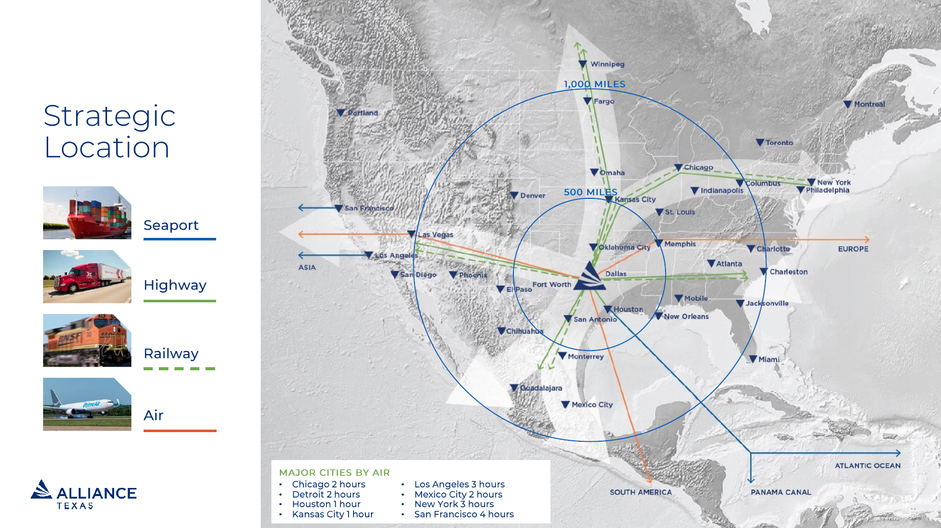
Figure 1. Updates from Hillwood; slide from TxFAC #41 Presentation.

Mr. Laughlin detailed the corporate partners within AllianceTexas. He said AllianceTexas has attracted some of the world’s most globally recognized brands across an array of industries with its pioneering spirit and entrepreneurial mindset. He then mentioned logistics and e-commerce companies like Walmart and Amazon. He said megapolitan areas will be developed by 2025, which are large metropolitan areas.

Mr. Laughlin noted that Perot Field Fort Worth Alliance Airport is the 19th largest cargo airport in the country and that it is the world’s first industrial airport. He stated there is a large enough runway to accommodate any kind of air cargo from anywhere in the world. He said they are focused on their mobility innovation zone, where they work with industry partners to test technology related to air and rail transport. He mentioned there are investors and organizations that share ideas through AllianceTexas. He then said drone delivery service was tested at AllianceTexas and that there are many industry partners who are deploying technology that is focused on the supply chain.

Mr. Laughlin mentioned other projects at AllianceTexas including: an integrated intermodal depot with BNSF, a Smart Connected Corridor, AV truck port, a resilient micro power grid and connection to the Texas freight corridor.

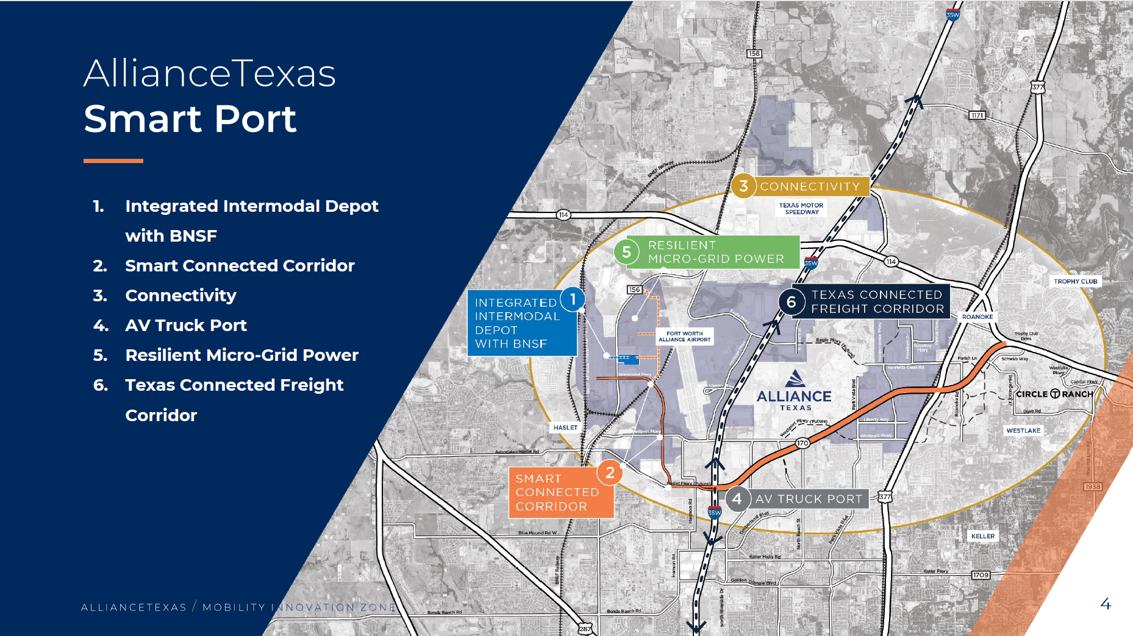
Figure 2. Updates from Hillwood; slide from TxFAC #41 Presentation.

He noted that 65% of their imported goods move south and east, but that 70% of that stays within 60 miles of AllianceTexas. Nearshoring is even more important after the pandemic disruptions. They are trying to get connected to a technology enabled corridor to enhance the movement of goods across the country. He said every day their team helps customers integrate technology into the supply chain. He discussed the funding and support needs from the State. He said the first and last mile will benefit from all of this.

Ms. Mays asked him to clarify what he meant when he said that 65% of what comes into AllianceTexas then travels on I-35 South. Mr. Laughlin said that 65% travel south using SH 114, SH 183, and I-35W. He mentioned the other 35% is split between Austin, San Antonio, Amarillo, and Tulsa, Oklahoma. He said most of that is first moved into AllianceTexas warehouses, then distributed to the supply chain.

Ms. Mays noted that it is important to address freight movements to address the congestion issue on freight corridors. Mr. Laughlin said that, due to the benefits in travel time, 30% of service providers and truckers will use the North Tarrant Expressway (toll) and 35% of Class A’s use the managed lanes in the region.

Chair Emmett said the committee needs to keep in mind how fast change is occurring in transportation and related technology. He then thanked Mr. Laughlin and AllianceTexas for all they do.

3. Amazon and the Transportation Network, Scaling and Sustainability

Jeff Cleland, Senior Manager Public Policy State and Local Transportation, Amazon, opened with a brief history of Amazon and their logistics growth. He said they have 89,000 employees in Texas. He detailed Amazon transportation services and described them as the middle mile. He said that planes, trains, and automobiles get the products to them from sellers through cross docks. He mentioned regionalization helped them distribute their items more efficiently. He continued saying that now over 75% of the goods people receive from them come from one of eight regional centers. He shared that they have two types of buildings, the first being focused on Amazon robotic sortable products with 3-10k employees focusing on smaller items and the second being non-sortable products such as dog food or furniture.

Mr. Cleland noted that then the items move to their sortation centers, which is the last stop before it hits the last mile of delivery. He stated that from sortation centers, the items could go to a postal service, UPS, or their own delivery service. He mentioned they have over 50 sortation and fulfillment centers in Texas. He added that they have 33 delivery stations across Texas.

Mr. Cleland also said Amazon has the largest charging network in the country, with over 17,000 chargers and over 15,000 electric vehicles, and anticipate more in the future. They intend not to use public stations during offline hours for Amazon Freight. He noted that there will be greater need for energy when more widespread electrification happens. As customers usually do not want packages arriving between 10 p.m. and 8 a.m., Amazon chargers their electric vehicles overnight.

Mr. Cleland added that they do drone deliveries in College Station, Texas through their Prime Air Drone Delivery Center. He said they plan to expand throughout the United States and the European Union. He mentioned the fastest drone delivery so far has been 16 minutes for a jar of peanut butter.

Mr. Cleland said they take sustainability very seriously and stated that they have three wind farms, 13 solar farms, as well as seven onsite solar locations on top of their buildings. He said they launched 50 electric trucks in California three months ago, which meet the new California emissions standards. Electric trucks have a big energy demand, but they are reliable. He stated that they have 4,000 renewable natural gas and compressed natural gas fleet of Volve trucks. He mentioned they source a lot of the renewable natural gas from dairy farms in Minnesota.

He discussed how the lack of truck parking and refueling stations for truckers led them to build their own truck stops. It also takes a long time to refuel with these new fuels. He detailed the amenities at one of their truck stop facilities near their Haslet, Texas fulfillment center. He said there are plenty of parking spots for personal vehicles and trucks. He noted there needs to be more public/private partnerships on overnight truck refueling centers for gas and electric vehicles. He said this is better for the company and truckers. The lack of truck parking is a national problem.

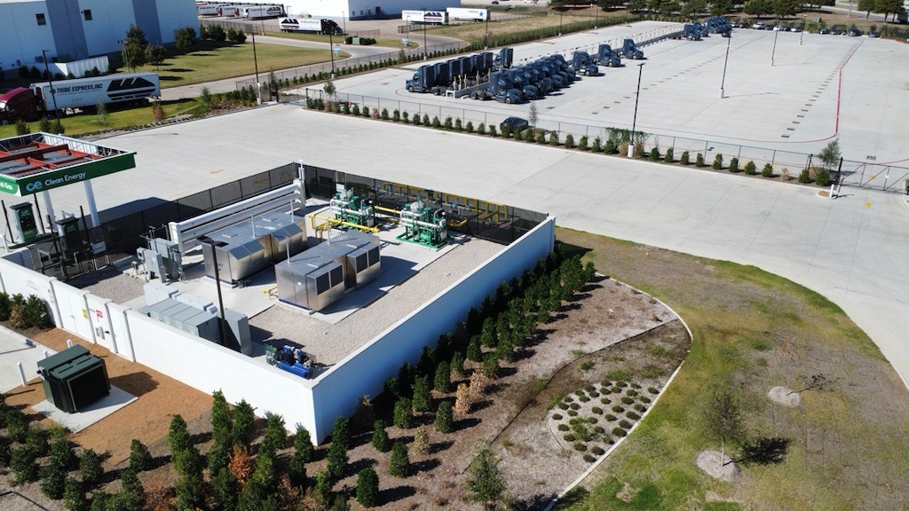
Figure 4. Amazon and the Transportation Network; slide from TxFAC #41 Presentation.

Mr. Cleland said that truckers need safe parking areas throughout the State. He mentioned that JB Hunt handles most of their freight. He concluded his presentation by saying that hydrogen, electric, and natural gas are the future.

Lindsay Mullins, with BNSF Railway, noted that stolen cargo and trucker safety are issues on the railroads. Mr. Cleland added that it is organized crime. Ms. Mays agreed. She stated that it is a major issue in the US and Mexico that is not widely discussed.

Ms. Mays also suggested that everyone rethink how truck parking is provided. She suggested a hotel with a restaurant and amenities for truckers while they wait.

Mr. Cleland said there is a good network for truck stops but mentioned more are needed. He said the truck stops need to be close to major freight corridors. He noted that TxDOT could use available state right of way on corridors for truck parking or to sell to the private sector to create parking.

Ms. Mays said that the major shippers need to analyze their staging areas to help avoid truckers being parked along the streets near their facilities.

Sean Stibich with the Port of Victoria asked if they have looked at hydrogen as a fuel. Mr. Cleland answered saying they have looked at it and the technology is still being developed. He mentioned that sourcing hydrogen is harder than sourcing natural gas.

Chair Emmett said that long-haul trucks are unlikely to use hydrogen because of the current size of the storage tanks that are needed to power a vehicle. He asked how they are working with the hydrogen company called Clean Energy. Mr. Cleland noted that Clean Energy exclusively works with the Amazon fleet, but they may open up to other companies that may adopt the technology and increase their capacity. He said that hydrogen-powered vehicles are sometimes classified as hazardous materials in some states, which restricts where the trucks can be used.

Gerry Schwebel with the International Bank of Commerce asked about the growth of their fleet in the last 5-10 years and what the expectation is over the next 5 years. Mr. Cleland said that they started delivering their own packages in 2018 and now they have over 65,000 trailers on the road in the United States. He said they have over 100,000 last mile vehicles on the road and are now the largest parcel ground delivery network. He said they grew their ground fleet post-pandemic.

Mr. Laughlin asked how rail and logistics centers can help Amazon during their peak seasons. Mr. Cleland answered that Amazon Prime Day is way for Amazon to offer great deals to our customer outside of the holiday season and begin to test their network prior to the busy holiday season each year. He said it indicates where they need excess capacity. He said there is a lot of planning throughout the year to meet the demand.

Mr. Laughlin asked about their electrified fleet, specifically whether they are encountering issues with local distribution feeder capacities and how these issues might be impacting their fleet management. Mr. Cleland answered that their 33 delivery stations are being built with conduit in the ground for pavement chargers, and most are connected to the grid. He said they have not had energy issues in Texas, but they have experienced some in California and New York. He said it really depends on what part of the country they are in and lots of planning is required to set up those charging stations.

Ms. Mays asked if they use solar power. Mr. Cleland responded saying they do use solar power in some of their buildings and solar farms to support their Amazon Web Services (AWS) facilities.

Miriam Kolkowski with Tecma Transportation Services said she is curious about the mileage for their trucks before they need to refuel. Mr. Cleland said their last mile electric delivery vans have a range over 150 miles per day but rarely need to travel that far. He said their long-haul electric vehicles pose unique challenges given the long distances they travel daily. He said they mainly use electric vehicles only in the last mile of the network, except for 50 EV trucks in California.

Commissioner New asked what the difference in cost is between the electric truck and trailer compared to regular trucks. Mr. Cleland answered that they are approximately two to three times more expensive. Commissioner New added that the cost is one of the challenges to transit adopting electric buses.

Ms. Mays asked how many packages Amazon delivers every day, month, and year. Mr. Cleland answered saying it is over 50 million packages every day.

4. Updates from the South Dallas Inland Port

Laura C. Freeland, Executive Director, South Dallas Inland Port, opened with a description of port operations and her role. She mentioned they are a non-profit and she oversees the workforce transportation system, which is over 120 square miles of inland port. They have access to I-20, I-45, I-35, and Union Pacific’s railroad. She then discussed the Fort Worth Region’s connectivity to the nationwide freight network. The property values have increased over 50% and provided economic growth to the South Dallas region. She continued describing the strong economic growth of the region by saying they have 31,000 direct jobs associated with the port and over two billion dollars in labor income.

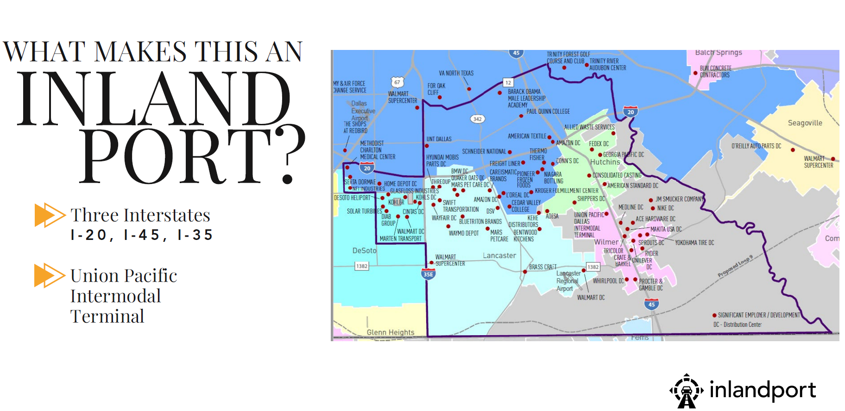Figure 5. Updates from the South Dallas Inland Port; slide from TxFAC #41 Presentation.

Ms. Freeland noted the benefits to inland port regional communities and said they are creating pathways to prosperity. Entry-level jobs are becoming technology roles, and a free job training program at Dallas College will provide an 80% chance of passing Walmart’s technician job entry exam. She stated they have strong partnerships with local colleges and universities to enhance the labor force and meet the new workforce needs.

She mentioned what makes them unique is that they are made up of five cities, are individual developer-driven, have no Port Authority or overarching strategic team, and offer workforce on-demand transportation for 120 square miles.

Ms. Freeland discussed the potential opportunities for their area, mentioning that there are over 100,000 people that live in the 120 square miles. Small distribution centers improve jobs and the community. She then discussed their infrastructure activities that have taken place in their area, including the 2012 Southern Dallas County Infrastructure Analysis, the 2021 $12.8 million RAISE Grant, the 2024 $25 million RAISE Grant for road expansion, the DCIP Flood Protection Planning Study, and the development of Loop 9.

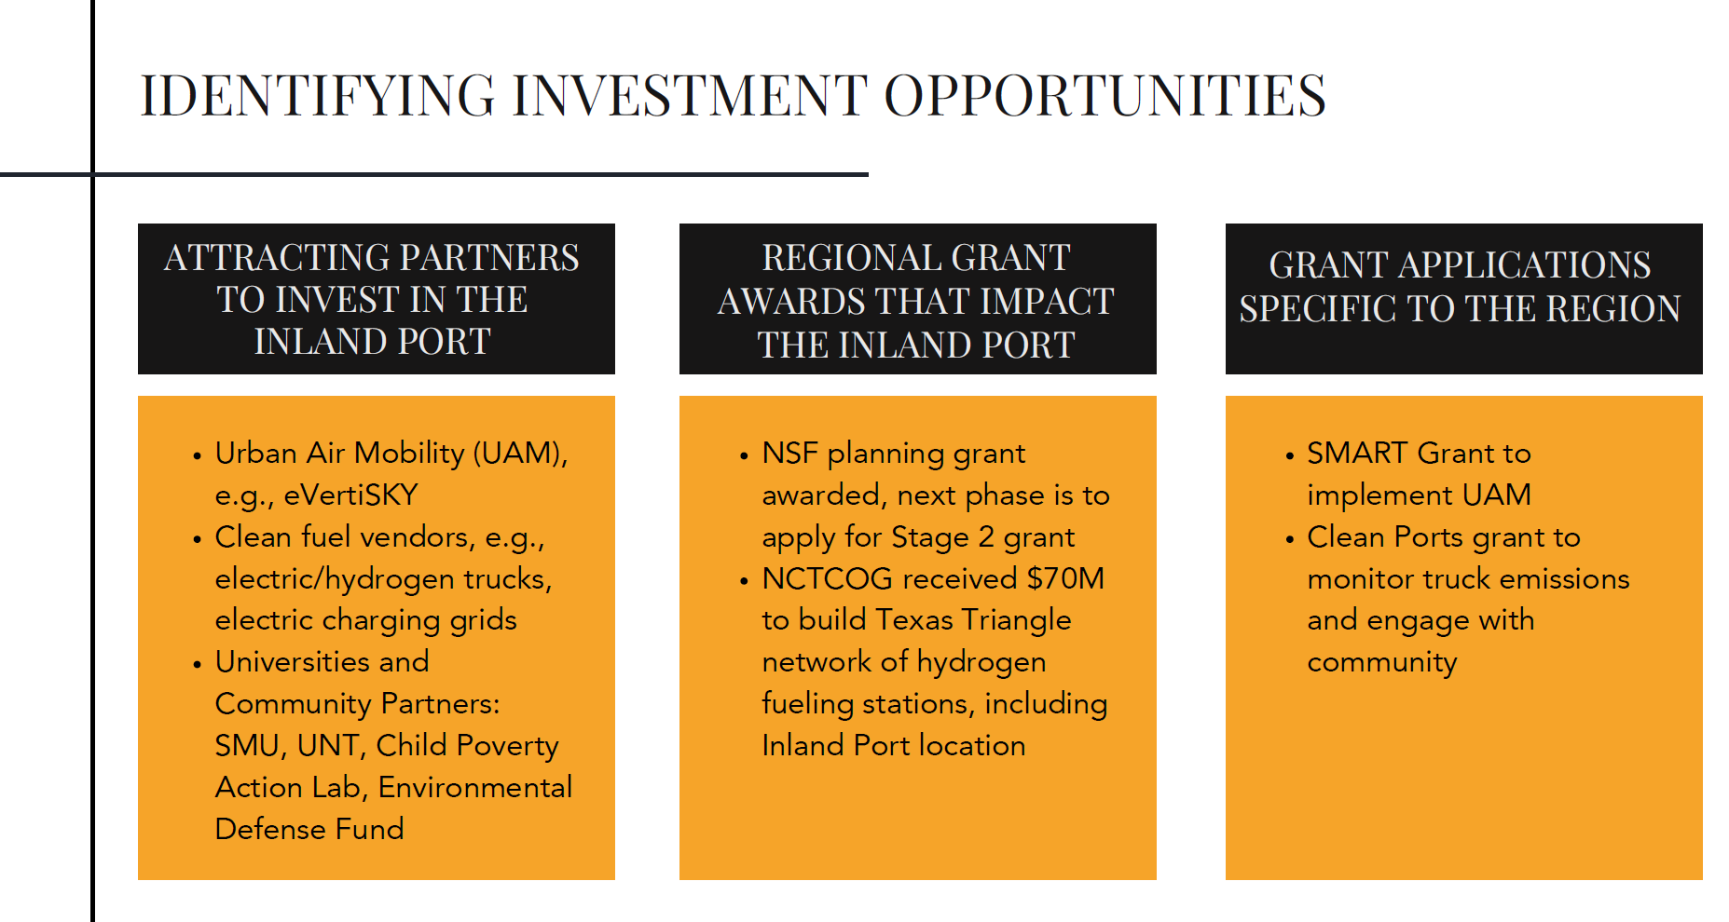
Figure 6. Updates from the South Dallas Inland Port; slide from TxFAC #41 Presentation.

She noted the creation of a local government corporation and said they are a regionwide entity advocating for the development of the inland port. They are identifying investment opportunities, and they are attracting partners to invest in the inland port for regional grant awards that impact the inland port and for grant applications specific to the region. She then said the local universities are writing their grant applications. She said they want to create a logistics ecosystem that is based on innovation, and that they focus on the first and last mile.

Chair Emmett asked which legal entity defined their boundary. Ms. Freeland answered it is an unofficial boundary that they use to create the workforce transportation.

Chair Emmett followed up and asked if they are a non-profit. Ms. Freeland responded by saying the Inland Port Transportation Management Association is a non-profit.

Mr. Laughlin asked Ms. Freeland to describe the grant more and who is involved. Ms. Freeland answered that it is a National Science Foundation Grant and UNT is taking the lead. She continued saying it includes UT Arlington, Dallas College, Southern Methodist University, and the Choctaw Nation of Oklahoma. She said the first phase is the planning phase and it involves a planning grant focused on workforce development. She said their focus is on solving big logistics problems, and the next stage is to present their ideas to the National Science Foundation.

Clint Schelbitzki with Union Pacific Railroad asked her to discuss the federal delegation and what is being asked of them by the Inland Port. Ms. Freeland said there have been a lot of visits and coordination by legislative officials. She said many legislators want to know about available grants and how they can support in pursuing them.

Mr. Schwebel asked how they maneuver through local politics, specifically about sustainability and the importance of their projects to the region. Ms. Freeland responded that the end game brings everyone together. She gave the example that Loop 9 is helping the entire region, and everyone wants to get involved to improve transportation in the community. She said they stay connected with residents and share messages on how they help the community.

5. Railway and Road Grade Separation Funding

Ms. Mullins, BNSF Railway, opened with an explanation of barriers to building grade separations. She mentioned that TxDOT does a great job creating and funding projects with grade separations, but that the cost is a barrier to the local governments.

She detailed the work she does with local public officials and local government associations to better understand what is keeping them from creating grade separations at rail crossings. She discussed congestion due to trains stopping in communities being chaotic and impactful, including for emergency service access. Ultimately, the cost associated with building grade separations to avoid those situations is the issue.

Ms. Mullins then asked if there is a role for the state to help local communities pay for grade separations, specifically in certain locations that are freight corridors. She stated that federal law says railroads must pay 5% of projects associated with rail related infrastructure improvements. She shared that they are working with communities across the nation to get grants for local projects. Texas has the most grade crossings in the nation. Congestion points are around places like AllianceTexas, Port Houston, and the South Dallas Port. She said TxDOT has requested money from the legislature to build grade separations. Her goal is for the committee to discuss this investment and policy issue and see how they can support funding for grade separations.

Mr. Laughlin asked if they have a prioritization plan that addresses congestion on railroads and identifies the top 15 congested crossings. Ms. Mullins responded that they have worked with TxDOT on the Houston/Beaumont Freight Study and the Dallas/Fort Worth Freight Study that identified some locations. She mentioned that perhaps it has to be on a freight corridor and tied to the supply chain.

Mr. Schelbitzki said that they developed a priority list, which all partners agreed on, and systematically funded all the items on the list. He added that in Houston, the Houston Rail Transportation Group looks at pinch points from a transportation perspective and collectively seeks funding.

Bruce Mann with the Port of Houston said they look at Houston as a region and develop a program to review grant opportunities.

Mr. Laughlin said that working with grants makes a lot of sense. He said commerce to the state from the three ports are impacted by the last mile and constricted roadways. He stated they have 175,000 people traveling the rail crossing by the AllianceTexas facility.

Ms. Mullins said the railroad can be a constraint to the community and grade separations are an important issue the state should fund.

Mr. Schwebel said the railroads are critical to the community, and they need to communicate with the community how they partner with local industries and what measures they are taking to improve congestion. He said the railroads should share with communities what their role is and the challenges they are facing.

Rolando Ortiz with Killiam Development Ltd. said it is very hard to communicate with Class 1 railroads, and they typically work through third-party contacts to reach them.

Mr. Schwebel said they have 16 trains a day in Laredo. He said the railroads should coordinate with local communities to try to avoid congestion increases due to rail traffic.

Chair Emmett said there should be a big public relations effort by the railroads to communicate better with local communities. He mentioned that issues between state and local government make this needed collaboration difficult.

6. 10-Year Truck Parking Plan

Brent Johnson, TxDOT Roadside Facilities Section Director, opened with a description of his role and said he oversees the safety rest areas across the State. He discussed the background behind the roadside facilities section, safety rest area information, their initial 10-year implementation plan, and crash data analysis. TxDOT has aging facilities and 19 of the current rest areas were built in the 1960’s and 1970’s.

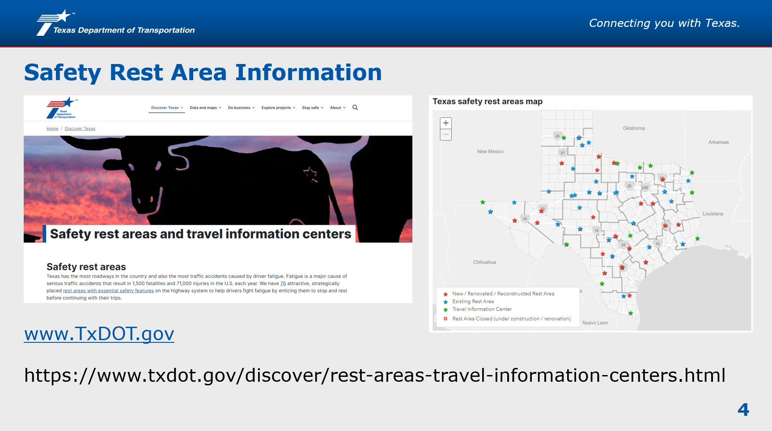
Figure 7. 10-Year Truck Parking Plan; slide from TxFAC #41 Presentation.

Mr. Johnson then discussed the evolution of the 10-year implementation plan. He went over the 2020 truck parking study and the district pavement plans where truck parking locations were identified. Through the new implementation plan, they estimate adding approximately 2,400 parking spaces to the network. Project types include safety rest areas, truck parking only, and truck parking expansion. He then discussed examples for statewide truck parking safety rest area solutions, truck parking only solutions, and truck parking expansion solutions. TxDOT currently has 1,409 truck parking spaces and expects to expand to 3,892. He said the I-10 grant will put in a truck parking available system and will soon have signage telling truckers where there is available parking for them. He added they have solar, Wi-Fi, and CCTV capabilities.

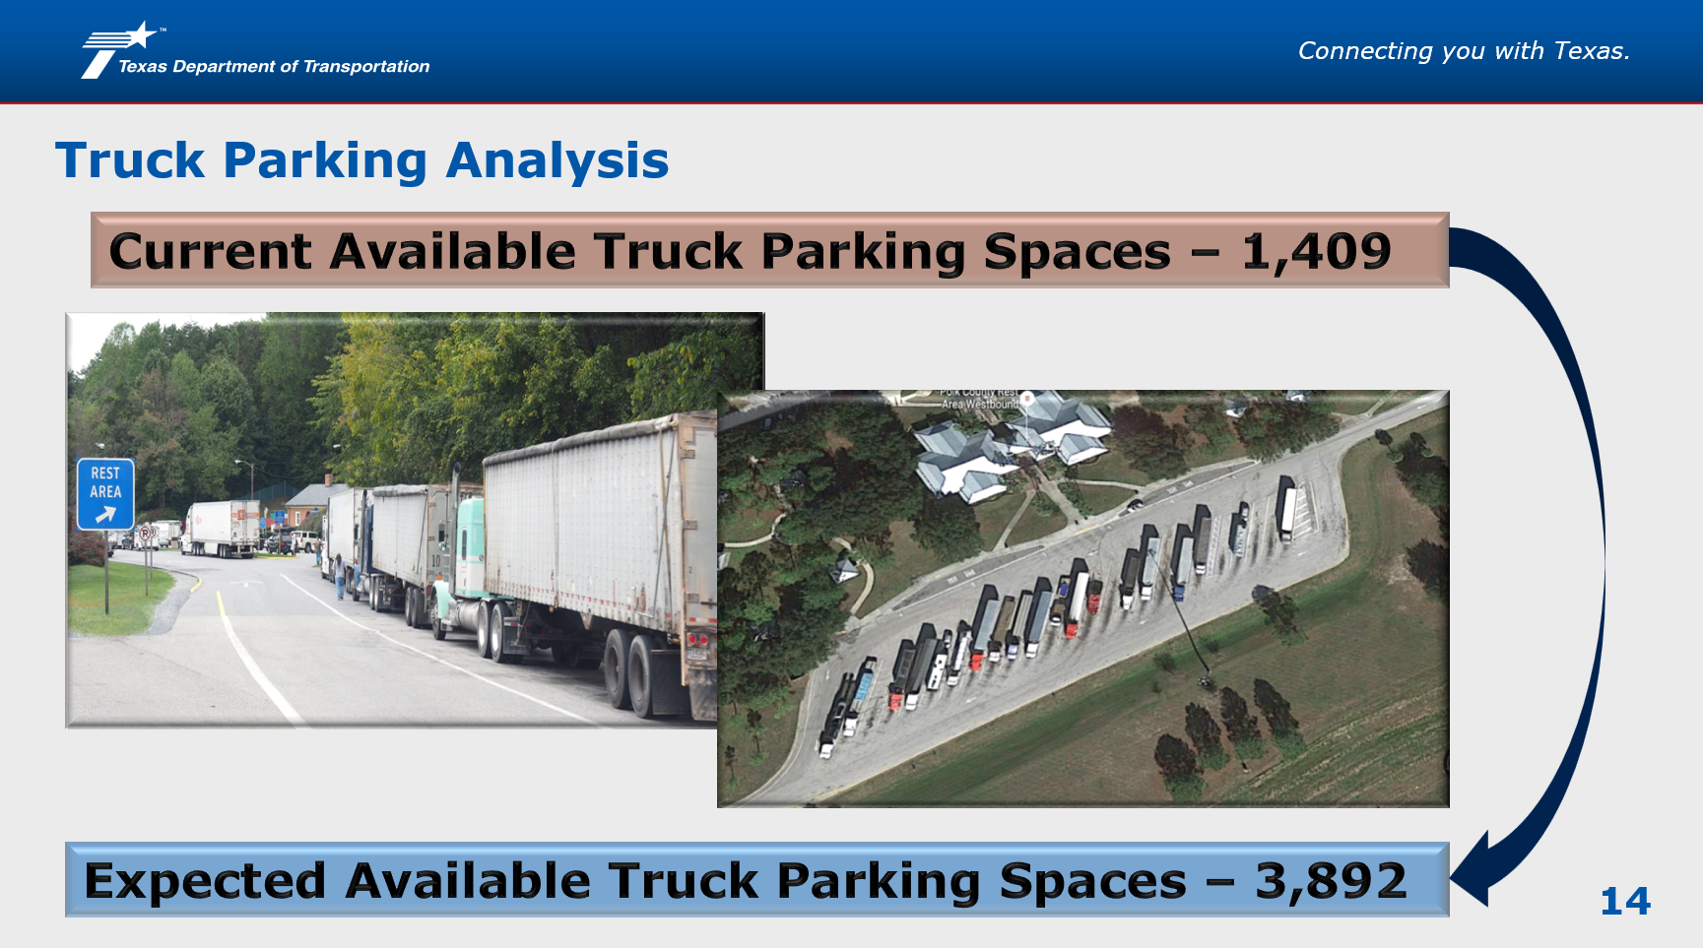
Figure 8. 10-Year Truck Parking Plan; slide from TxFAC #41 Presentation.

Mr. Cleland asked if the technology would be connected to truckers, such as through Google Maps, to inform them of rest stops. Mr. Johnson answered yes and that they would work with technology partners to connect with truckers.

Mr. Laughlin asked if there are private truck facility operators working with TxDOT on this or are they staying with their own models. Mr. Johnson responded that TxDOT is not currently participating in their studies from the private sector.

Commissioner New said that truck stops are going in everywhere, providing both parking and amenities, but it’s not enough. There is an overwhelming need for truck parking. He mentioned there is a legal structure change where truckers are to use a digital mileage tracker, and that truckers are required to pull off the road when they need to take mandatory breaks. He said safe stop areas are an important part of truck parking. He added that they will only develop in profitable areas, with TxDOT working to fill the gaps.

Chair Emmett noted that Maryland has concessions at their safety rest areas. He then asked why Texas does not have those at their safety rest areas. Mr. Johnson replied that it is against federal law. Ms. Mays added that some states were grandfathered in and can allow the sales of items at rest stops because they were built before the federal legislation was passed by Congress. Federal right of way cannot be commercialized.

Mr. Schwebel asked if TxDOT has done a study on the safety and utilization of rest areas. Ms. Mays replied that TxDOT participates in tracking that information as part of a national inventory process.

Chair Emmett asked if people used the BBQ pits at rest areas. Mr. Johnson confirmed that yes, they are used throughout the state.

Commissioner New added that most of the small rest areas are being eliminated. Many of the facilities are being built for use by larger volumes of traffic in the future. He said any facilities that are large enough may be converted to a truck pull-off area.

Ms. Mays said that TxDOT and the public provide only about 10% of truck parking across the state, with the remaining provided by private companies. She noted that Commissioner New has been a huge champion for getting the TxDOT Transportation Commission to invest money in truck parking. She said the private sector is using the truck parking plan that was developed by this committee and asking how they can partner with TxDOT to develop additional truck parking. She said they help the private sector identify where parking needs are in the system. Ms. Mays added that they are not in the business of truck parking, but they are in the business of safety.

Chair Emmett added that there is an increase in female truck drivers and that more truck drivers are accompanied by pets, indicating a need for dog parks at the truck parking locations.

7. Southeast and Far West Truck Parking Action Plans

This agenda item was postponed. Kale Driemeier, TxDOT Freight Planner, will provide an update on the Southeast and Far West Truck Parking Action Plans at the next meeting.

8. Roundtable Updates from TxFAC Members

The following TxDOT administration and individual members provided their updates:

Chair Emmett asked the two new members to introduce themselves.

Ms. Kolkowski introduced herself, noting she is from El Paso and grew up in Juarez, Mexico. She discussed her family logistics business and mentioned that she taught as a professor about supply chain logistics.

Mr. Stibich said he is the Executive Director of the Port of Victoria. He described the expansion projects they are working on and mentioned that they developed the Texas Logistics Center. He stated 2025 is the year they will see physical growth. 600+ acres are under option for lease, with more coming next year.

Chair Emmett said there is a need for flexibility in the transportation network. He mentioned the bridge collapse over the Trinity River. He said FM 787 is heavily used by gravel trucks and asked how quickly the bridge will be replaced. He asked about the adjustments needed to accommodate when a bridge goes down in system. Commissioner New responded that the type of highway and the remoteness of it is important. He said that for a bridge replacement in San Angelo, it took about 15 months. He mentioned one in Kingsland that took a few months and was a higher priority. He said he would ask the bridge division what they have learned. Chair Emmett then noted that the original bridge was not in the right place years ago and may need to be moved.

Chair Emmett then asked about the Dayton area, noting that the rail traffic has grown there. He asked if the rail overpass should be moved farther West. Mr. Schelbitzski said the project was underway.

Chair Emmett inquired about the overpass being built next to FM 146, where it connects to Highway 90. Mr. Schelbitzski said he can look into the issue and where the project is in the timeline. He noted that looking at a grade separation is better than no separation.

Chair Emmett mentioned I-69 has always been a priority and the truck traffic has increased on US 59. He asked when the two-way roadway between Laredo and Victoria will be expanded. Ms. Mays said they are working on it. Commissioner New added that while it will take decades to complete, it is a prioritized corridor. He said the UTP has improvements that will help and noted that the project requests were four times more than the budget available. Chair Emmett said the improvements are needed much further South on I-69 than in the Houston area. Commissioner New said they are going to buy right of way, put in the frontage roads, and build an interstate level facility later.

Mr. Schwebel said they have had to be creative to turn non-designated areas into freight corridor areas. He mentioned Loop 20 in Laredo as an example. There is never going to be enough funding because construction costs will always increase. He said that I-69 has been around for over 30 years and the proper funding needs to be coordinated. He said that he previously brought up how permitting would be an issue and noted that they have four Presidential permits that have been pending for years. He is encouraged that TxDOT is supporting the projects. He stated that Laredo, which is the largest port, has not had infrastructure added to it in 24 years.

Mr. Schwebel then stated his concern about the gas emissions study that TxDOT is developing. He asked how that study will be used and for an updated report on the status. His concern includes how this study could result in shutting down the ports. He requested this to be a future agenda item.

Mr. Schwebel then noted there is a challenge on the border with Southbound congestion because Mexico has moved crossing control to the military. He added that planning outside the ports of entry should be reviewed by TxDOT. Ms. Mullins asked why Mexico militarized their border operations. Mr. Schwebel mentioned the President of Mexico made that change. He said Mexico is doing 100% inspection on southbound traffic, and cargo movement is slowed down as a result.

Mr. Schwebel stated that Texas is the #1 export state and emphasized that everyone needs to examine how the US trade policy will affect Texas.

Mr. Schewebel then added that, for 31 years, Laredo has held a symposium on trade called “Pathways to Trade.” He said the USDR is going to hold a committee meeting on competitiveness at Port Laredo on September 17-19, 2024. He said the topic of the symposium will be “Opportunities in technology driving the supply chain”.

Rachel Connell with North American Strategy for Competitiveness discussed the National Roadway Digital Infrastructure Transcontinental Corridors Project. She said they are working with other states and hosting a meeting in Kansas City on August 28, 2024.

Mr. Schwebel added that they had a meeting with a representative of Canada to mitigate or reduce emergency protocols. He stressed that port of entry closures are disruptive and either stop or slow down our supply chain network.

Paul Treangen with TNW Corporation noted he is impressed Texas is moving to a multimodal discussion. He said TxDOT is writing letters of support for short line rail grants. He then said TxDOT engagement with rail has been outstanding.

Mr. Laughlin mentioned that, of all the TxDOT initiatives, he thinks technology is very important and would like to see a presentation on technology updates. He noted that today, their business is supply chain relocation and refinement, rather than new business growth.

Mr. Mann said their volumes are up 13% year over year. He said Texas will not be able to build infrastructure fast enough and the committee needs to think about what they are going to do.

Mr. Ortiz asked how roadway updates are making it into technology. The example he referred to is when there is a hazard that is noted on map/direction mobile applications.

Ms. Mays said on September 22, 2024, there is a symposium at UNT Frisco related to the National Science Foundation grant.

9. Final Remarks

Chair Emmett thanked everyone for attending and adjourned the meeting at 12:03 p.m.

