Guidance: Addressing the Monarch Butterfly in a Texas Department of Transportation Species Analysis
The monarch butterfly (Danaus plexippus) is proposed for listing under the Endangered Species Act (ESA) as threatened, with a listing decision anticipated in late 2025. Monarchs may be found statewide. Adults are found in a variety of habitats including native prairies, pastures, open woodlands and savannas, desert scrub, roadsides, and other habitats with abundant nectar plants, including urbanized areas. Although adults may be present year-round, they are primarily encountered between March and November, and are commonly observed in the spring, summer, and fall during breeding and migration. Common host plants for caterpillars and adult monarchs in Texas include milkweeds (Asclepias spp.), milkweed vines (Matelea spp.), climbing milkweeds (Funastrum spp.), swallowworts (Cynanchum spp.), and Anglepod (Gonolobus suberosus). Caterpillars are most frequently observed between April and September. Relevant habitat metrics include at least 10% cover of nectaring plants plus two milkweeds per 1,500 sq ft as a baseline assessment for potential monarch habitat. Areas within 125 feet of conventional agricultural lands may be determined to not contain suitable habitat due to the use of pesticides and herbicides that negatively impact all life stages of monarch butterflies.
Texas Department of Transportation (TxDOT) is a Partner participant in the Nationwide Candidate Conservation Agreement with Assurances (CCAA) and or Candidate Conservation Agreement (CCA) for Monarch Butterfly on Energy and Transportation Lands (Agreement). The Agreement applies to activities that occur within existing TxDOT right of way (ROW) (for example, enrolled lands) and includes maintenance and modernization of associated infrastructure. The Agreement may also apply if ROW acquisition is associated with the activities if the new ROW does not more than double existing ROW. The following types of activities are covered by the agreement:
- Maintenance – Work on TxDOT ROW (enrolled lands) that is planned and performed on a routine basis to maintain and preserve the existing transportation system, or to respond to specific conditions and events that restore the systems to an adequate level of service. Examples are culvert repairs and replacements, repair and replacement of metal beam guard fence, bridge maintenance and repairs, ditch maintenance, mowing, tree trimming, brush removal, etc.
- Modernization – Construction and other land disturbing activities involving the repair, replacement, and upgrading of existing infrastructure on existing enrolled lands. Examples include roadway rebuilds, minor widenings, the addition of passing lanes, bridge replacements, signal and intersection improvements, installation of safety end treatments, etcetera.
If the monarch is listed as endangered or threatened, incidental take resulting from the implementation of activities covered by the Agreement would be authorized by an ESA section 10 Permit associated with the Agreement. The permit would become effective upon the effective date of any final rule listing the monarch as endangered or threatened under the ESA.
The following types of activities are not covered by the agreement:
- Any off-system activity or project (for example, bridge replacement on a county road, or any other non-TxDOT owned ROW, or a locally sponsored project on locally owned ROW).
- New location projects where TxDOT has not yet acquired new ROW.
- Projects that more than double existing ROW. For example, if existing ROW is 30 acres, new ROW could not exceed 30 acres and total acreage at the end of the project could not exceed 60 acres (Figure 1).
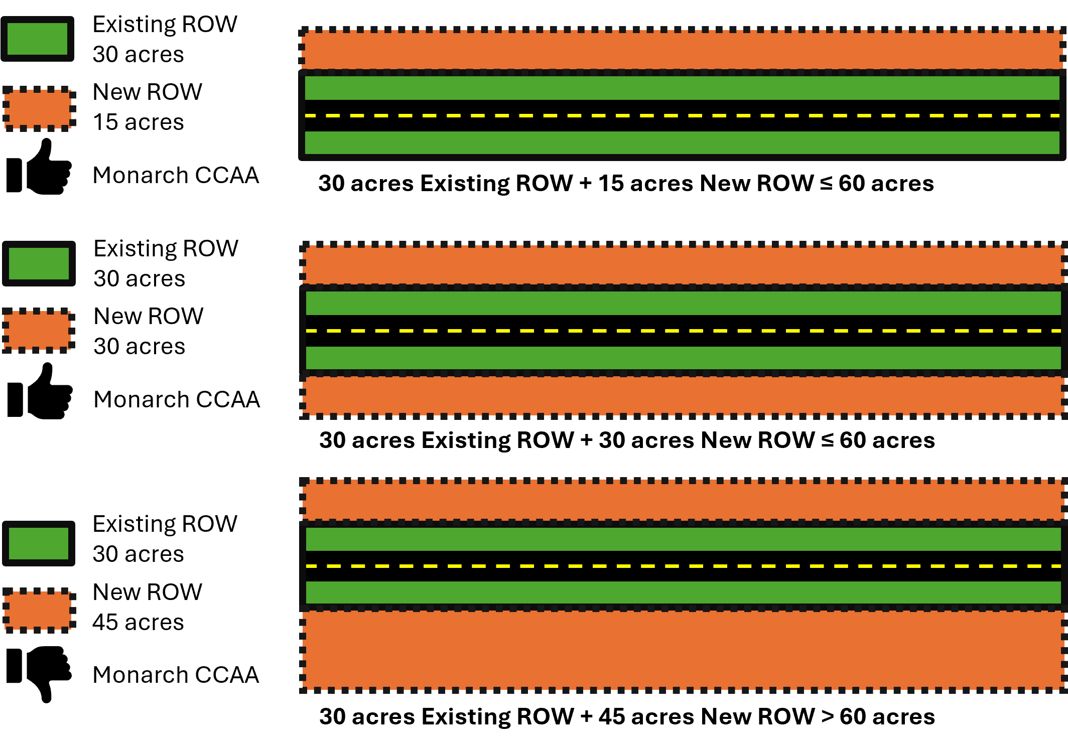
Figure 1. Visual description of new ROW applicability for Monarch CCAA
If your type of activity or project is not described above, please discuss the situation with an Environmental Affairs Division, Natural Resources Management (ENV NRM) Biologist to determine the best path forward.
General guidance and recommended language for addressing the Monarch in a TxDOT species analysis spreadsheet are provided below:
If the project is within Monarch habitat, but would not involve ground disturbing or vegetation clearing activities, and or all activities and staging areas would be entirely confined to existing infrastructure, “no effect” (for a project with a federal nexus) or “no take” (for a project with no federal nexus) can be selected in the “Effect/Take Determination for Federally Listed Species” column. In the “Explanation for Effect/Take and or Impact Determination” incorporate the following text: The project would not involve any ground disturbing or vegetation clearing activities and would not pose a threat to any life cycle stage of the monarch butterfly.
If the project does not qualify for a “no effect” or “no take” determination as instructed above, but would consist entirely of maintenance or modernization activities covered by the Agreement as defined earlier, then proceed as instructed below, depending on whether or the project has a federal nexus:
- If the project consists of maintenance or modernization activities covered by the Agreement and is 100% state-funded and does not include any other federal nexus (for example, U.S. Army Corps of Engineers Permit), then select “Take” in the “Effect/Take Determination for Federally Listed Species” column. In the “Explanation for Effect/Take and or Impact Determination” column incorporate, the following text: The monarch butterfly is a proposed for listing under the ESA as threatened, and no consultation with USFWS is required at this time. TxDOT is a partner in the Nationwide Candidate Conservation Agreement with Assurances and or Candidate Conservation Agreement for Monarch Butterfly on Energy and Transportation Lands (Agreement). The Agreement authorizes incidental take for all activities included in the proposed project should the monarch butterfly be listed as endangered or threatened.
- If the project consists of maintenance or modernization activities covered by the Agreement and is wholly or partially funded with federal moneys and/or includes a separate federal nexus, then select “may affect” in the “Effect/Take Determination for Federally Listed Species” column. In the “Explanation for Effect/Take and or Impact Determination” column, incorporate following text: The monarch butterfly is proposed for listing under the ESA as threatened, and no consultation with United States Fish and Wildlife Service (USFWS) is required at this time. TxDOT is a partner in the Nationwide Candidate Conservation Agreement with Assurances and or Candidate Conservation Agreement for Monarch Butterfly on Energy and Transportation Lands (Agreement). The Agreement authorizes incidental take for all activities included in the proposed project should the monarch butterfly be listed as endangered or threatened.
- If the project requires minor ROW acquisition, the Agreement may still apply. Contact your ENV NRM Biologist to discuss prior to completing the species analysis spreadsheet.
If the project does not qualify for a “no effect” or “no take” determination as instructed above, and does not consist entirely of maintenance or modernization activities as defined earlier, or the activities are not covered by the Agreement, and it does not apply then proceed as instructed below:
- “May effect” or “take” should be selected from the “Effect/Take Determination for Federally Listed Species” column. In the “Explanation for Effect/Take and or Impact Determination” column, incorporate the following text: The project may affect the monarch butterfly; however, the monarch is currently proposed for listing under the ESA as threatened and no consultation with USFWS is required at this time. As construction activities for this project are not anticipated to be completed prior to when a listing decision for the species is anticipated, additional coordination may be required. The project should be reevaluated at that time to determine if further action is required should the monarch butterfly be listed as endangered or threatened.
- Documentation of the commitment to reevaluate the project for impacts to monarch butterfly, if listed should be documented in a “Perform ESA Commitments” Activity in the Environmental Compliance Oversight System (ECOS) project file.
Additional steps may be necessary to address monarch butterfly on projects where consultation with USFWS is occurring for other species. Please discuss the project and consultation with an Environmental Affairs Division, Natural Resources Management (ENV NRM) Biologist.

Revision History
Table 1. Document revision history
Effective date (month year) | Reason for and description of change
May 2026 | Version 6  - Updated for accessibility compliance and TxDOT branding standards.
September 2025 | Version 5  - An update was made to fix one additional location where the proposed status language remained.
July 2025 | Version 4  - Updates included updates from candidate to proposed status and clarifications and a visual reference for projects not covered by the agreement.
July 2024 | Version 3  - Updates guidance to include additional guidance for projects not covered by the Agreement and address the extension of the proposed listing to Fiscal Year (FY) 25.
April 2022 | Version 2  - Updates guidance for projects that will not be completed prior to FY 2024.
July 2021 | Version 1  - This document provides guidance for addressing effects to the monarch butterfly in a TxDOT species analysis spreadsheet.

