

Environmental Handbook: Air Quality
This handbook outlines the process steps necessary to comply with the Clean Air Act (CAA), the National Environmental Policy Act (NEPA), and the Federal-Aid Highways code regarding potential project effects on air quality.
Contents
Environmental Handbook: Air Quality 1
1.0 Overview 5
1.1 TxDOT Policy 6
1.2 Important Definitions 6
1.3 Responsible Party 7
1.4 Applicable Project Types 8
1.5 Critical Sequencing 8
1.6 Helpful Suggestions 8
2.0 Regulatory Overview 9
2.1 Clean Air Act 9
2.1.1 Transportation Conformity 9
2.1.2 General Conformity 10
2.2 National Environmental Policy Act 11
2.3 Federal Aid Highways Code 11
2.4 TCEQ MOU 12
2.5 Compliance Paths 12
2.5.1 CAA Compliance 12
2.5.2 NEPA Compliance 13
2.5.3 Federal-Aid Highways Code Compliance 14
2.5.4 TCEQ MOU Compliance 15
3.0 Procedural Requirements 18
4.0 Document Project Scoping and Planning 23
4.1 Evaluating Risk 23
4.2 Project Scoping 23
5.0 Requirement Triggers 24
5.1 CAA Triggers 24
5.2 NEPA Triggers 24
5.3 Federal-Aid Highways Code Triggers 25
5.4 TCEQ MOU Triggers 25
6.0 Exemptions 25
6.1 CAA Exemptions 26
6.2 NEPA Exemptions 27
6.3 Federal-Aid Highways Code Exemptions 27
6.4 TCEQ MOU Exemptions 27
7.0 Public Involvement and Coordination with Resource Agencies 28
7.1 CAA 28
7.1.1 Conformity Consultation Partners Coordination 28
7.1.2 Hot-Spot Public Involvement Criteria 28
7.2 NEPA 28
7.2.1 MSAT Conference Call 28
7.2.2 Section Public Involvement Criteria 29
7.3 Federal-Aid Highways Code 29
7.4 TCEQ MOU 29
8.0 Document Documentation Requirements 29
8.1 Environmental Review Documents 29
8.2 Technical Reports for Quantitative Air Quality Analyses or Conformity 30
8.2.1 Section CO TAQA Technical Report 30
8.2.2 Quantitative MSAT Analysis Technical Report 30
8.2.3 Hot-Spot Analysis Technical Report 30
8.2.4 Transportation Conformity Report Form 31
8.3 Project File 31
9.0 Review and Approval Process 31
9.1 Technical Reports 31
9.2 Environmental Review Documents 32
10.0 Glossary 33
11.0 Abbreviations and Acronyms 35
Revision History 38

1.0 Overview
This handbook outlines the steps necessary to comply with the Clean Air Act (CAA), the National Environmental Policy Act (NEPA), and the Federal-Aid Highways code regarding potential project effects on air quality. Project sponsors can use the handbook to identify what air quality compliance obligations may be triggered by their project to scope them appropriately. Anyone with responsibility for developing compliance documentation can use the handbook to identify the general requirements to meet these obligations.
At the federal level, the Environmental Protection Agency (EPA) is responsible for the regulation and enforcement of the CAA requirements. The Federal Highway Administration (FHWA) and the Federal Transit Administration (FTA) are responsible for the regulation and enforcement of NEPA and the Federal-Aid Highways code for projects under their jurisdiction.
At the state level, the Texas Commission on Environmental Quality (TCEQ) is responsible for the regulation and enforcement of the Texas Clean Air Act (TCAA), which gives them the responsibility for developing the State Implementation Plan (SIP) required by the federal CAA and gives them the authority to establish more stringent air quality standards for Texas. TCEQ has chosen, however, to have their air quality standards mirror EPA’s National Ambient Air Quality Standards (NAAQS). Metropolitan Planning Organizations (MPOs) have responsibility for regional transportation conformity analyses and compliance with the Federal-Aid Highways code regarding Congestion Management Process (CMP) requirements. The Texas department of Transportation (TxDOT) is the state agency with responsibility for helping project sponsors of transportation projects in the state with ensuring compliance with all applicable federal, state, and local laws and regulations; including the CAA, NEPA, and the Federal-Aid Highways code.

1.1 TxDOT Policy
Body It is TxDOT’s policy to meet its compliance obligations regarding potential project effects on air quality by following the procedures in this manual, the air quality toolkit, and the Memorandum of Understanding (MOU) with the TCEQ.

1.2 Important Definitions
Body While a set of definitions for terms used in this handbook is provided in the Glossary (Section 10), some important terms are also defined here to provide context for the subsequent explanation.
Conformity is the process of determining that federal actions, such as transportation projects, conform to the SIP. FHWA/FTA projects and regionally significant State-only projects must comply with transportation conformity requirements, whereas other federal agency (e.g., the Surface Transportation Board (STB) or the Federal Railroad Administration (FRA)) actions must comply with general conformity requirements.
The Consultation Partners are a group of federal, state, and local agencies which provide direction and review of conformity demonstrations for transportation plans, programs, and projects. The agencies include but are not necessarily limited to the EPA, FHWA, TCEQ, TxDOT, and the MPO.
The Criteria Pollutants as established by the CAA include ozone, carbon monoxide (CO), nitrogen dioxide (NO₂), sulfur dioxide (SO₂), particulate matter (PM), and lead.
A Maintenance Area (MA) is an area that was formerly designated by EPA as being in nonattainment for the NAAQS for a specific criteria pollutant but has since achieved compliance with the applicable standard and been re-designated as being in attainment-maintenance status. An attainment-maintenance area must maintain compliance with that specific NAAQS for up to two ten-year periods.
A National Ambient Air Quality Standard is the official standard EPA sets for one of its identified criteria pollutants. There are both primary and secondary NAAQS established for protection of human health and the environment, respectively.
A Nonattainment Area (NA) is an area that is currently designated by EPA as being in nonattainment for the specific NAAQS criteria pollutant.

1.3 Responsible Party
The Project Sponsor has responsibility for:
- Documenting project compliance with the CAA, NEPA, and the Federal-Aid Highways code, as applicable, regarding transportation air quality requirements,
- Initiating, directing, and documenting interagency coordination on potential qualitative and quantitative air quality analyses,
- Preparing all materials for and conducting all required and appropriate public participation, and
- Performing required air quality analyses and documenting them appropriately.
The Department Delegate has responsibility for coordination of environmental documents with TCEQ, when such coordination is required by the applicable MOU.
The MPO has responsibility for development and implementation of a CMP and preparing transportation conformity demonstrations for plans and programs when applicable. The Consultation Partners have responsibility for providing direction and review for transportation conformity determinations for transportation plans, programs, and projects.
FHWA, acting as Executive Agent for FTA, has responsibility for making all final transportation conformity determinations for plans and programs.

1.4 Applicable Project Types
All transportation projects require consideration of the project effects on air quality.

1.5 Critical Sequencing
Review and coordination of potential project effects on air quality must be completed prior to the final project decision or approval.
All projects for which conformity applies must be found to conform prior to the environmental decision or approval.
Interagency coordination for quantitative air quality analyses, when required, should occur before initiating the applicable analyses and before submission of the applicable environmental documents.
If the project requires a public hearing, all required quantitative air quality analyses should be completed and reviewed in sufficient time for the results to be presented at the hearing; unless, in the case of a Draft Environmental Impact Statement (DEIS), approval has been granted after appropriate coordination with the lead agency to defer the analysis until the Final Environmental Impact Statement (FEIS).

1.6 Helpful Suggestions
Ensuring a project’s consistency with the applicable Metropolitan Transportation Plan (MTP) and Transportation Improvement Program (TIP) throughout the project life cycle (including MTP and TIP updates, funding and timing changes, and project design concept and scope changes) will help to prevent possible conformity related delays later in the environmental clearance process.
For projects where quantitative air quality analysis is required, the preparation of a preliminary technical report for review by TxDOT’s Environmental Affairs Division (ENV) air specialist is required.
Decisions of the Consultation Partners regarding hot-spot analyses require public involvement, which may and should be combined with NEPA public involvement activities. Under unique circumstances, public involvement for a hot-spot analysis may be conducted separate from NEPA and must meet requirements in the federal and state conformity rules applicable at the time of public involvement.

2.0 Regulatory Overview

2.1 Clean Air Act
The CAA is codified at 42 United States Code (USC) 7401-7671q, and the statute pertains to transportation conformity and to general conformity. Section 7506(c) prohibits federal agencies from providing funding or approving any activity that does not conform to an applicable SIP. It also prohibits MPOs from giving their approval to any “project, program, or plan” that does not conform to a SIP. A SIP is developed for EPA designated nonattainment or maintenance areas (NA/MA) of the state and is combined into a statewide SIP. Attainment areas are exempt from conformity requirements.

2.1.1 Transportation Conformity
The transportation conformity requirement is substantive, and the Code of Federal Regulations (CFR) provides the implementing regulations in Subpart A of 40 CFR 93. State transportation conformity rules, which largely address the conformity consultation process in Texas, are codified in the Texas Administrative Code (TAC) at 30 TAC 114.260.Transportation conformity only applies to projects in a NA/MA for ozone, CO, NO₂, or PM because these are considered transportation related pollutants (40 CFR 93.102(b)(1)).
Transportation conformity applies to both FHWA FTA projects (40 CFR 93.102(a)(1)(iii)) and to non-federal transportation projects if they are considered “regionally significant” by the MPO (40 CFR 93.102(a)(2)). Transportation conformity encompasses both regional conformity (i.e., conformity of plans and programs) and project level conformity.
The Consultation Partners have responsibility for providing direction and review for conformity demonstrations for transportation plans, programs, and projects (specifically when hot-spot requirements apply). The MPO will make an initial conformity determination on their transportation plans and programs, while FHWA makes the final conformity determination (acting as Executive Agent for FTA). For FHWA FTA projects subject to conformity, a separate project-level conformity determination by the lead federal agency is also required prior to making the environmental decision. A project level conformity determination also incorporates applicable hot-spot decisions and analyses for the project.
For projects in which transportation conformity applies, an environmental decision CANNOT legally be made until it has been demonstrated that project level conformity requirements have been met (40 CFR 93.104(d)).

2.1.2 General Conformity
General conformity requirements apply to non-FHWA/FTA federal transportation projects (e.g., STB or FRA) if they are located within a NA/MA for any of the NAAQS. General conformity requirements may also apply to certain FHWA/FTA project activities that are not otherwise covered under transportation conformity (e.g., certain recreational trails projects). These requirements are codified in Subpart B of 40 CFR 93. Each federal agency will have its own guidance on how to address air quality, but this is beyond the scope of this handbook. Consult the ENV air specialist if general conformity requirements may apply.

2.2 National Environmental Policy Act
NEPA establishes procedural requirements and is codified at 42 USC 4321-4370(h). NEPA is the impetus for the CO Traffic Air Quality Analysis (TAQA), the Mobile Source Air Toxics (MSAT) analysis, and construction emissions disclosure. 42 USC 4332 requires that all “major federal actions significantly affecting the quality of the human environment” shall include a “detailed statement” on “the environmental impact of the proposed action.”
FHWA/FTA uses guidance, rather than rule, to establish the requirements for the CO TAQA, construction emissions, and the MSAT analysis under NEPA. FHWA/FTA specifically requires the CO TAQA and air quality construction emissions in their guidance document titled FHWA Technical Advisory T 6640.8A. FHWA/FTA specifically requires and establishes criteria for the level of MSAT analysis in their latest interim MSAT guidance document.

2.3 Federal Aid Highways Code
The Federal Aid Highways code establishes substantive requirements regarding the CMP and is codified at 23 USC 101-190, and encompasses the CMP requirements. The applicable portions of the statute are from 23 USC 134(k)(3), and 134(n). The implementing regulations are provided at 23 CFR 450.322.
For federal funds to be programmed for projects adding Single Occupancy Vehicle (SOV) capacity in certain nonattainment areas, the project must be addressed in a CMP. These projects must come from a CMP which includes an analysis of reasonable travel demand reduction and operational management strategies for the corridor. In addition, “all identified reasonable travel demand reduction and operational management strategies shall be incorporated into the SOV project or committed to by the State and MPO for implementation.”

2.4 TCEQ MOU
The TCEQ MOU is a procedural requirement codified at Section 201.607 of the Texas Transportation Code. The MOU is located in rule at 43 TAC 2.301.
The MOU describes what project documents will be coordinated with TCEQ for either air quality or water quality reviews. Specifically, the MOU coordination requirements with regards to air quality will be discussed in this chapter.

2.5 Compliance Paths
The following are paths to compliance with the air quality standards for a transportation project. No matter which compliance path is followed, any analysis results and consultative efforts should be retained in the project file.

2.5.1 CAA Compliance
Regarding project-level transportation conformity consistency requirements, at the time of project decision, a project must have been found to be either:
- Exempt from transportation conformity requirements in accordance with Section 6.1 of this handbook, or
- It must be consistent with the regional conformity determination of the applicable MTP and TIP, as evidenced by an appropriately signed conformity report form. Appropriately signed means by the lead federal agency, or by the ENV air specialist for state-only projects.
Regarding project-level transportation conformity hot-spot conformity requirements, a project must:
- Be exempt from hot-spot conformity requirements in accordance with Section 6.1 of this handbook, or
- Have a Consultation Partner determination that this is NOT a “project of air quality concern” and the decision receives appropriate public involvement; or
- Have a Consultation Partner determination that this is a “project of air quality concern” and have a hot-spot analysis prepared by the project sponsor using the analysis approved by the Consultation Partners which demonstrates:
- That the project’s modeled concentrations (when combined with background concentrations) will not exceed the applicable NAAQS in the future years analyzed; or
- The project’s modeled concentrations (after accounting for background concentrations and any committed mitigation measures) will be less than the no-build scenario’s modeled concentrations in the future years analyzed.
Regarding general conformity requirements, at the time of project decision, a project must:
- Be exempt from general conformity requirements in accordance with Section 6.1 of this handbook, or
- Have an analysis which demonstrates the project emissions will be less than de minimis thresholds, or
- Have a conformity determination from the lead federal agency, with any applicable supporting analyses.

2.5.2 NEPA Compliance
Regarding CO TAQA requirements, a project must either:
- Be exempt from CO TAQA requirements in accordance with Section 6.2 of this handbook; or
- Have a CO TAQA prepared which demonstrates that the project’s modeled CO emissions (including the area’s background CO concentration) will not exceed the applicable CO NAAQS in either the project completion year or design year.
Regarding MSAT requirements, a project must:
- Be exempt from a MSAT analysis per Section 6.2 of this handbook; or
- Have a qualitative MSAT analysis prepared, which identifies the national MSAT emission trends; or
- Have a quantitative MSAT analysis prepared, which compares the modeled MSAT emission levels in the base year to the modeled MSAT emission levels in the future years analyzed.
Regarding construction emission requirements, a project must simply disclose the potential construction emissions and any project level mitigation being proposed (e.g., dust suppression, Texas Emission Reduction Program (TERP), construction contractor compliance with regulatory requirements).

2.5.3 Federal-Aid Highways Code Compliance
Regarding CMP requirements, a project must:
- Be exempt from CMP requirements in accordance with Section 6.3 of this handbook; or
- The project must come from an MPO’s adopted CMP and an analysis prepared which:
- “Identifies travel demand reduction and operational management strategies for the corridor”;
- “Demonstrates that [these strategies] cannot fully satisfy the need for additional capacity”; and
- “Identifies that all reasonable travel demand reduction and operational management strategies shall be incorporated into the SOV project or committed to by the State and MPO for implementation”.

2.5.4 TCEQ MOU Compliance
Regarding TCEQ MOU requirements, a project must:
- Be exempt from TCEQ MOU review requirements in accordance with Section 6.4 of this handbook; or
- The applicable Notice of Availability (NOA) of the draft EA or draft EIS (which is always combined with the notice of public hearing or opportunity for public hearing) will need to be coordinated with TCEQ.
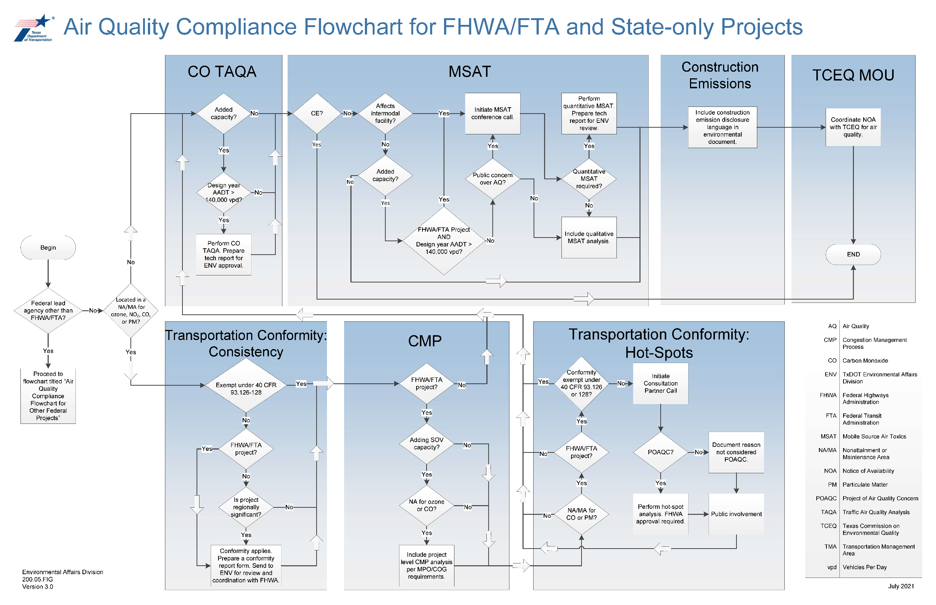
Figure 1. Project evaluation flowchart for FHWA/FTA and State Projects
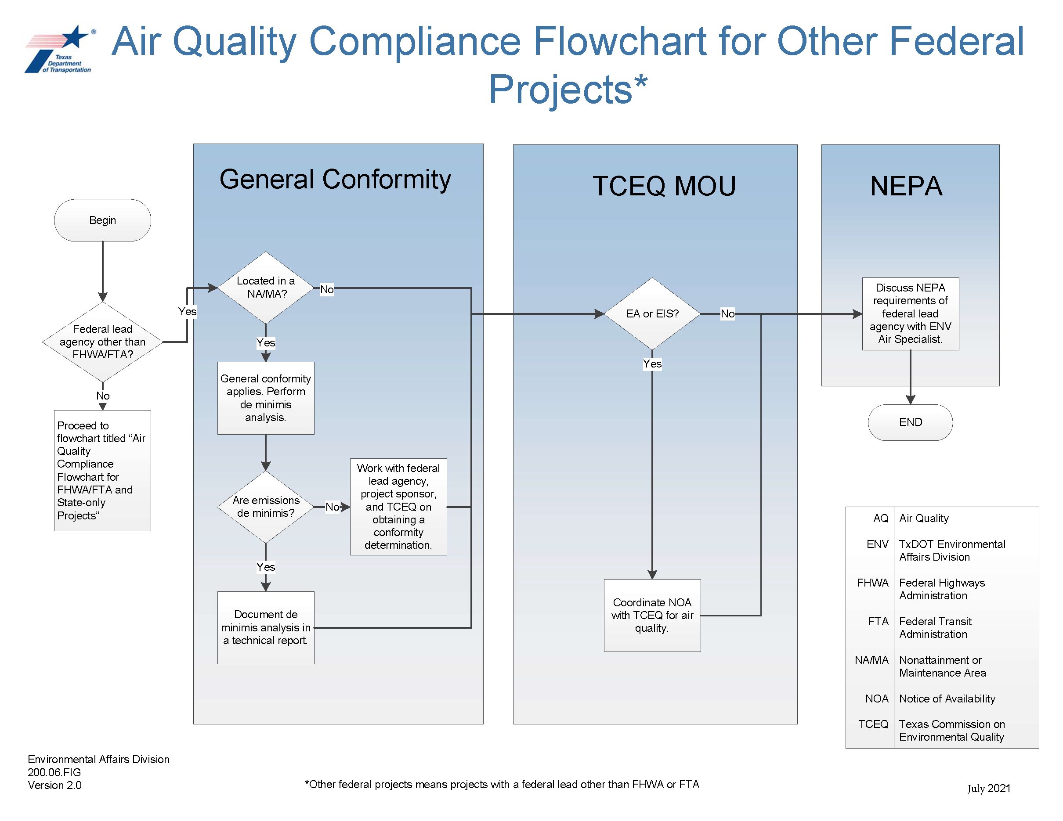
Figure 2. Project evaluation flowchart for other federal projects

3.0 Procedural Requirements
The procedural requirements outlined below were developed by TxDOT to help practitioners conduct air quality analyses and prepare documentation in accordance with the procedures developed by the EPA, FHWA FTA, and TxDOT. These are the general steps for complying with the applicable rule and guidance for the air quality resource. However, not every step will be required for every project. Proceed step by step through the following process.
Please note that the air quality toolkit will provide more detailed information on how to comply with each of these topics, including coordination and documentation requirements.
- Identify the general procedures for complying with CAA project-level transportation conformity consistency requirements by completing Steps 1.1 through 1.6 as directed.
  - Determine whether the project is exempt from transportation conformity requirements per Section 6.1 of this handbook. If so, continue to Step 1.2. If not, proceed to Step 1.3.
  - Determine whether the project is exempt from general conformity requirements per Section 6.1 of this handbook. If so, proceed to Step 3. If not, consult with the ENV air specialist regarding how to address potential general conformity requirements and proceed to Step 3.
  - Determine whether the project is exempt from hot-spot requirements per Section 6.1 of this handbook. If so, continue to Step 1.4. If not, proceed to Step 2.
  - Prepare a conformity report for the project. Continue to Step 1.5.
  - Coordinate the conformity report with FHWA/FTA at least 60 days prior to project decision or approval. Continue to Step 1.6.
  - Maintain the final approved conformity report in the project file. Proceed to Step 3.
- Identify the general procedures for complying with CAA project-level transportation conformity hot-spot requirements by completing Steps 2.1 through 2.7 as directed.
  - Initiate coordination with the Consultation Partners to have them make a determination as to whether this is a “project of air quality concern”. Continue to Step 2.2.
  - Identify whether the Consultation Partners determined that this is a “project of air quality concern”. If so, continue to Step 2.3. If not, proceed to Step 1.4.
  - Initiate additional coordination with the Consultation Partners to identify an appropriate methodology and parameters for a hot-spot analysis. Continue to Step 2.4.
  - Perform the applicable hot-spot analysis and prepare a hot-spot technical report. Continue to Step 2.5.
  - Based on the results of the hot-spot analysis, determine if any mitigation measures are required. The project sponsor must provide a written commitment to any agreed upon mitigation measures. Continue to Step 2.6.
  - Coordinate the hot-spot technical report with the Consultation Partners for their review and for a FHWA decision. Once the report is approved, continue to Step 2.7.
  - Maintain the hot-spot technical report in the project file. Proceed to Step 1.4.
- Determine whether a CO TAQA is required by completing Steps 3.1 through 3.4 as directed.
  - Determine whether the project is exempt from CO TAQA requirements per Section 6.2 of this handbook. If so, proceed to Step 4. If not, continue to Step 3.2.
  - Prepare a CO TAQA technical report. Continue to Step 3.3.
  - Send the CO TAQA technical report to the ENV air specialist for review. Continue to Step 3.4.
  - Maintain the approved CO TAQA in the project-file. Continue to Step 4.
- Determine whether a MSAT analysis is required by completing Steps 4.1 through 4.7 as directed.
  - Determine whether the project is exempt from MSAT requirements per Section 6.2 of this handbook. If so, proceed to Step 5. If not, continue to Step 4.2.
  - Determine whether the project will trigger MSAT coordination per Section 5.2 of this handbook. If so, continue to Step 4.3. If not, proceed to Step 4.7.
  - Initiate a MSAT conference call to receive a determination as to whether a quantitative MSAT analysis is required. If required, continue to Step 4.4. If not required, proceed to Step 4.7.
  - Prepare a quantitative MSAT analysis technical report. Continue to Step 4.5.
  - Send the quantitative MSAT analysis technical report to the ENV air specialist for review. Continue to Step 4.6.
  - Maintain the approved quantitative MSAT technical report in the project file. Continue to Step 5.
  - Determine whether the project is adding capacity. If so, include the qualitative MSAT analysis in the project file. Continue to Step 5.
- Determine whether a CMP analysis is required by completing Steps 5.1 through 5.4 as directed.
  - Determine whether the project is exempt from CMP requirements per Section 6.3 of this handbook. If so, proceed to Step 6. If not, continue to Step 5.2.
  - Verify that the project comes from the MPO’s adopted CMP. Continue to Step 5.3.
  - Identify and document any travel demand reduction strategies and operational management strategies for the corridor. Continue to Step 5.4.
  - Identify and document any reasonable travel demand reduction and operational management strategies that shall be incorporated into this specific project. Continue to Step 6.
- Prepare the air quality finding statements for inclusion in the project file or environmental review documents. Continue to Step 7.
- Determine whether the NOA of the draft EA or draft EIS (which is always combined with the notice of public hearing or opportunity for public hearing) requires coordination with TCEQ by completing Steps 7.1 through 7.2 as directed.
  - Determine whether the project is exempt from TCEQ MOU requirements per Section 6.4 of this handbook. If so, proceed to Step 8. If not, continue to Step 7.2.
  - Verify that TxDOT will coordinate the NOA with TCEQ after ENV review.
- Coordinate with the ENV air specialist on any substantive or critical air quality comments received regarding the environmental review document.
The procedure is complete.

4.0 Document Project Scoping and Planning
This section provides information on air quality compliance risks associated with a project and how these risks are incorporated into the scoping process.

4.1 Evaluating Risk
Use this manual and the associated air quality toolkit to identify the general air quality risks associated with projects.
- If transportation conformity is a project risk, ensure that the project is and remains consistent with the applicable MTP and TIP throughout the project’s life cycle. If not consistent, work with the District and the MPO on amending the plans appropriately. A conformity report will need to be coordinated with FHWA to receive a project-level conformity determination. Final action (environmental document and/or project authorization) cannot be taken on a project for which conformity applies until a project-level conformity determination has been made by FHWA.
- If a hot-spot analysis is a project risk, the analysis must only be prepared after the applicable Consultation Partners coordination. The Consultation Partners must approve the analysis methodology, while FHWA must approve the hot-spot analysis.

4.2 Project Scoping
Use this manual and the associated air quality toolkit to identify the general air quality risks associated with projects.
NOTE: The air quality toolkit includes additional detail on applicable coordination requirements, content of quantitative air quality analyses, and additional resources which will help the project sponsor incorporate air quality activities into the project schedule.
In terms of the timing of air quality activities:
- A conformity report form should be coordinated at least sixty days prior to an environmental decision. Maintaining consistency of the project to the plans (MTP and TIP) during plan updates and after project design, cost, or schedule changes is key to maintaining project conformity. Consult with the local district and MPO if consistency concerns arise.
- The quantitative MSAT analysis must have the appropriate MSAT consultation prior to initiation of the analysis.
- A potential hot-spot analysis must have appropriate Consultation Partner coordination prior to initiation of the analysis. Detailed traffic information, project maps, and schematics will be necessary for the Consultation Partners to make a determination regarding applicability of a hot-spot analysis for the project. The Consultation Partners must approve the analysis methodology, while FHWA must approve the hot-spot analysis.

5.0 Requirement Triggers
The following are triggers for when a project would be subject to air quality compliance under the various applicable statutes.

5.1 CAA Triggers
- Transportation conformity applies if the project is NOT exempt in accordance with Section 6.1 of this handbook.
- Coordination with the Consultation Partners is required if the project is NOT exempt from the hot-spot requirements in accordance with Section 6.1 of this handbook.
- A hot-spot analysis is required for projects if the Consultation Partners have made the determination that it is a “project of air quality concern”.
General conformity applies if the project is NOT exempt in accordance with Section 6.1 of this handbook.

5.2 NEPA Triggers
- A CO TAQA is required if the project is NOT exempt in accordance with Section 6.2 of this handbook.
- MSAT consultation is required if the project is in proximity to populated areas and is NOT exempt from a MSAT analysis in accordance with Section 6.2 of this handbook and any of the following apply:
  - The project is a FHWA/FTA project and is adding capacity and has an Annual Average Daily Traffic (AADT) greater than the 140,000 vehicles per day, or
  - The project affects or is affected by an intermodal facility or another facility which may be a large generator of diesel traffic, or
  - The project is adding capacity, and the public has expressed air quality concerns specifically about this project (the consultation process would assess if the public concerns would be addressed by conducting a quantitative MSAT analysis).
- A qualitative MSAT analysis is required if the project is NOT exempt from an MSAT analysis in accordance with Section 6.2 of this handbook and:
  - The project does not trigger MSAT coordination, or
  - The project does not otherwise require a quantitative MSAT analysis after MSAT consultation.
- Potential air quality construction emissions must be disclosed at least qualitatively for all projects that will lead to construction.

5.3 Federal-Aid Highways Code Triggers
A CMP analysis is required if the project is NOT exempt in accordance with Section 6.3 of this handbook.

5.4 TCEQ MOU Triggers
TCEQ MOU coordination applies if the project is NOT exempt in accordance with Section 6.4 of this handbook.

6.0 Exemptions
The following are exemptions for when a project would be subject to air quality compliance under the various applicable statutes.

6.1 CAA Exemptions
The following are exempt from project-level transportation conformity consistency requirements:
- Projects in attainment or unclassifiable areas of the State for all NAAQS;
- Projects with a federal lead agency other than FHWA or FTA;
- Projects that are only located in nonattainment or maintenance areas for lead or SO2;
- Projects of the types identified in 40 CFR 93.126 or 93.128 (generally only applies to non-added capacity projects); or
- Projects of the types identified in 40 CFR 93.127, only if also exempt from hot-spot requirements as indicated below;
- Non-federal projects, only if they are NOT considered regionally significant by the MPO;
- Projects of the type identified in the EPA’s PM Hot-spot Analyses: Frequently Asked Questions, including:
  - Road diets;
  - Auxiliary lanes less than 1 mile in length;
- Ramp metering.
The following are exempt from project-level transportation conformity hot-spot requirements:
- Projects that are NOT within a NA/MA for CO or PM;
- Non FHWA/FTA projects; or
- Projects of the types identified in 40 CFR 93.126 or 93.128.
- The following are exempt from general conformity requirements:
- Projects in attainment or unclassifiable areas of the State for all NAAQS;
- FHWA/FTA projects for which transportation conformity applies (40 CFR 93.153(a)); or
- Non-federal actions.

6.2 NEPA Exemptions
The following are exempt from the CO TAQA requirements:
- Projects that do NOT add capacity; or
- Projects that do NOT exceed an AADT of 140,000 vehicles per day in the project’s estimated time of completion (ETC) and design year;
- The following are exempt from MSAT requirements:
- FHWA CE projects (23 CFR 771.117); or
- Projects of the types listed in 40 CFR 93.126; or
- Non-added capacity projects with no meaningful impacts on traffic volumes or vehicle mix.

6.3 Federal-Aid Highways Code Exemptions
The following are exempt from CMP analysis requirements:
- Non-federal projects; or
- Projects that are NOT in a nonattainment area for ozone or CO; or
- Projects that are NOT adding SOV capacity; or
- Projects that are NOT within a Transportation Management Area (TMA).
- Projects that are identified as safety improvements or for the elimination of bottlenecks per
23 CFR 450.322(e).

6.4 TCEQ MOU Exemptions
The following are exempt from the TCEQ MOU coordination requirements:
- CE projects.

7.0 Public Involvement and Coordination with Resource Agencies

7.1 CAA

7.1.1 Conformity Consultation Partners Coordination
Texas has developed an interagency consultation process under the State transportation conformity rule 30 TAC 114.260. The project sponsor will request that the MPO initiate Consultation Partners coordination when such coordination is triggered in accordance with Section 5.1 of this handbook. The coordination is needed for the Consultation Partners to determine if a project is subject to a hotspot analysis and, if one is needed, to have them concur with the analysis methodologies and to review the final analysis. The Consultation Partners include but are not limited to the EPA, FHWA, TCEQ, TxDOT, and the MPO.

7.1.2 Hot-Spot Public Involvement Criteria
In regards to the Consultation Partners’ decisions regarding potential hot-spot analyses, there are public involvement requirements per 40 CFR 93.105(e). This public involvement requirement can and should be combined with and satisfied through NEPA public involvement, if any is planned. If NEPA public involvement is not used, then any conformity public involvement shall be at least equivalent to NEPA public involvement, and the appropriate type of public involvement will be determined during the Consultation Partners coordination.

7.2 NEPA

7.2.1 MSAT Conference Call
The project sponsor will have the local TxDOT District initiate this call when such coordination is triggered in accordance with Section 5.2 of this handbook. The participants of the conference call should include personnel from: the TxDOT District, the project sponsor, the ENV air specialist, the contractor, and the MPO. Since NEPA assignment, FHWA no longer participates in this MSAT consultation. Meeting minutes should be prepared by the project sponsor or their contractor following the conference call and distributed to all participants.

7.2.2 Section Public Involvement Criteria
The CO TAQA, MSAT, and air quality construction emission elements do not have specific public involvement criteria.

7.3 Federal-Aid Highways Code
There are no specific public involvement criteria for project level CMP analyses.

7.4 TCEQ MOU
The Department Delegate will coordinate the applicable NOA of the draft EA or draft EIS (which is always combined with the notice of public hearing or opportunity for public hearing) with TCEQ for air quality reviews, when required. All CE projects are exempt from this coordination; whereas all EA and EIS projects must be coordinated.

8.0 Document Documentation Requirements

8.1 Environmental Review Documents
The air quality section should be prepared by the project sponsor or their contractor. See the air quality toolkit for more specific guidance on preparing the air quality section of these documents. Using the toolkit should minimize the potential for document revisions.
For projects where no formal NEPA document is prepared, applicable technical reports will document compliance with air quality requirements.

8.2 Technical Reports for Quantitative Air Quality Analyses or Conformity

8.2.1 Section CO TAQA Technical Report
The CO TAQA technical report should be prepared by the project sponsor or their contractor. The report should compare the modeled CO emissions (including the area’s background CO concentration) of the project to the CO NAAQS in both the project completion year and design year and document one of the following:
- That the project’s modeled concentrations of CO emissions (when combined with background concentrations) will not exceed the applicable CO NAAQS in the ETC and design years; or
- The project’s modeled concentrations, when combined with background concentrations plus emission reductions from mitigation measures, will be less than the applicable CO NAAQS in the ETC and design years.

8.2.2 Quantitative MSAT Analysis Technical Report
The quantitative MSAT technical report should be prepared by the project sponsor or their contractor. The report should assess the future regional concentrations of MSAT compared to the base year concentrations.

8.2.3 Hot-Spot Analysis Technical Report
The hot-spot analysis technical report should be prepared by the project sponsor or their contractor. The report should find one of the following:
- That the project’s modeled concentrations of the applicable pollutant emissions (when combined with background concentrations) will not exceed the applicable NAAQS in the applicable future years; or
- That the project’s modeled concentrations of the applicable pollutant emissions, when combined with background concentrations, will be less than the no-build scenario’s modeled concentrations of the same pollutant emissions in the applicable future years; or
- The project’s modeled concentrations, when combined with background concentrations plus emission reductions from mitigation measures, will be less than the no-build scenario’s modeled concentrations of the same pollutant emissions in the applicable future years.

8.2.4 Transportation Conformity Report Form
For projects subject to transportation conformity, a conformity report form shall be prepared by the project sponsor or their contractor. The report should find and document that the project is consistent with the conformity determination for the current MTP and TIP, that all applicable hot-spot requirements have been addressed, and must receive approval from ENV and FHWA, as applicable, by the time of the environmental decision.

8.3 Project File
Regarding air quality, the administrative record should contain the following.
- The transportation conformity report form, if required
- A summary of any interagency consultation that occurred in relation to a quantitative air quality analysis
- Any final air quality technical reports or studies prepared for the project
- If applicable, TCEQ coordination comments and TxDOT’s official response

9.0 Review and Approval Process

9.1 Technical Reports
The project sponsor or their designated contractor is responsible for preparing and submitting the applicable technical reports for quantitative air quality analyses or transportation conformity to the ENV air specialist for review. A hot-spot analysis technical report must also be reviewed by the Consultation Partners and approved by FHWA. The Transportation Conformity Report should be submitted at least 60 days prior to the anticipated environmental decision.
After ENV air specialist approval of the technical report, a summary of the analysis can be incorporated into the environmental review document.

9.2 Environmental Review Documents
The project sponsor is responsible for preparing and submitting the applicable environmental review documents to ENV for review.
The Department Delegate will coordinate the environmental review document with TCEQ, after the ENV review is complete, as applicable.
If EPA provides any comments on an environmental review document, these must receive a written response after consulting with ENV.

10.0 Glossary
Conformity is the process of determining whether a transportation plan, program, or project conforms to the purpose of the SIP.
Consistency is the process of ensuring that a project is consistent with the applicable transportation plans (MTP & TIP, or Statewide Transportation Improvement Program (STIP)). Although not inherently related to air quality, project consistency with the applicable transportation plans is integral to demonstrating compliance with transportation conformity requirements.
Environmental Decision is either a CE concurrence, a Finding of No Significant Impact (FONSI), or a Record of Decision (ROD).
Mobile Source Air Toxics are compounds that are considered air toxics by EPA and that have been identified as being associated with mobile sources. In the context of transportation projects, it specifically refers to the nine-primary mobile source air toxics: acetaldehyde, acrolein, benzene, 1,3-butidiene, diesel particulate matter plus diesel exhaust organic gases (diesel PM), ethylbenzene, formaldehyde, naphthalene, and polycyclic organic matter.
National Ambient Air Quality Standards are the national standards developed by EPA for the six criteria pollutants identified in the CAA. The EPA, in conjunction with state air quality agencies, has established a network of air monitors throughout the nation which monitor these criteria pollutants. Exceedances of these NAAQS can result in the EPA designating an area in non-attainment for that specific criteria pollutant.
Quantitative Air Quality Analyses may include CO TAQA, Quantitative MSAT, or Hot-spot Analysis.
A regionally significant State-only project is one that is considered regionally significant in the conforming MTP but has no FHWA/FTA funding or action (e.g., interstate access justification).
The State Implementation Plan is the State’s overall air quality plan to achieve compliance with the NAAQS. Nonattainment areas have a local SIP which is incorporated into the State’s overall SIP. The SIP often contains a Motor Vehicle Emissions Budget (MVEB) for a particular nonattainment area that is the basis for achieving regional conformity.

11.0 Abbreviations and Acronyms
Table 1. Abbreviations and acronyms
Abbreviation or Acronym | Definition
AADT | Annual Average Daily Traffic
AQ | Air Quality
CAA | Clean Air Act
CE | Categorical Exclusion
CFR | Code of Federal Regulations
CMP | Congestion Management Process
CO | Carbon Monoxide
DEIS | Draft Environmental Impact Statement
EA | Environmental Assessment
ECOS | Environmental Compliance Oversight System
ECPD | Environmental Project Development Manual
EIS | Environmental Impact Statement
ENV | TxDOT’s Environmental Affairs Division
EPA | Environmental Protection Agency
ETC | Estimated Time of Completion
FHWA | Federal Highway Administration
FEIS | Final Environmental Impact Statement
FONSI | Finding of No Significant Impact
FRA | Federal Railroad Administration
MOU | Memorandum of Understanding
MPO | Metropolitan Planning Organization
MSAT | Mobile Source Air Toxics
MTP | Metropolitan Transportation Plan
MVEB | Motor Vehicle Emissions Budget
NAAQS | National Ambient Air Quality Standard
NA/MA | Nonattainment Area/ Maintenance Area
NEPA | National Environmental Policy Act
NO₂ | Nitrogen Dioxide
NOA | Notice of Availability
PM | Particulate Matter
ROD | Record of Decision
SIP | State Implementation Plan
SO₂ | Sulfur Dioxide
SOP | Standard Operating Procedure
SOV | Single Occupancy Vehicle
STB | Surface Transportation Board
STIP | Statewide Transportation Improvement Program
TAC | Texas Administrative Code
TAQA | Traffic Air Quality Analysis
TCAA | Texas Clean Air Act
TCEQ | Texas Commission on Environmental Quality
TERP | Texas Emission Reduction Program
TDM | Travel Demand Model
TIP | Transportation Improvement Program
TMA | Transportation Management Area
TxDOT | Texas Department of Transportation
USC | United States Code

Revision History
Table 2. Document revision history
Effective date (month year) | Reason for and description of change
March 2026 | Version 7  - Updated for accessibility compliance and TxDOT branding standards.
July 2021 | Version 6  - Included a general update to the handbook. Specifically, references to regional emissions analysis exemptions were added, United States Code (USC) references were updated to the 2018 edition, TCEQ MOU processes were updated, the air quality compliance flowcharts were updated, and references to the EPA’s PM Hot-spot Analyses: Frequently Asked Questions were added.
May 2017 | Version 5  - Updated the air quality compliance flowchart.
January 2017 | Version 4  - Included updates to the MSAT requirements and references based on FHWA’s updated Interim MSAT Guidance dated October 18, 2016.
January 2016 | Version 3  - Included a general update to the handbook. Specifically, general conformity and TCEQ MOU requirements were updated to make the formatting consistent with other analyses.
August 2014 | Version 2  - Revised Fig 1 Project Evaluation Flowchart for Air Quality Studies to better describe the evaluation process.
February 2014 | Version 1  - Outlined the steps to comply with the CAA, NEPA and the Federal-Aid Highways Code regarding potential project effects on air quality.

