Notice of Change for Large Construction Sites: Determination Process
If one or more of the following changes to the original Notice of Intent (NOI) or Notice of Change (NOC) is required:
- Legal name changes
- Address and Contact information change (such as a change in the Area Engineer)
- Regulated entity site information change
- Change to general characteristics provided on original form (such as an increase is acreage of soil disturbance)
- Change in relevant information in NOI
- Previously unidentified changes
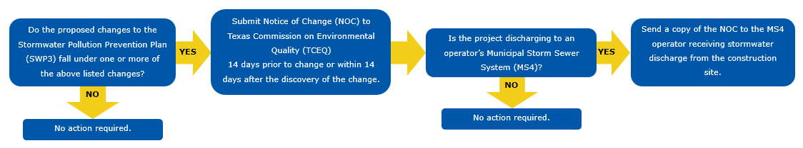
Figure 1. Decision flowchart for Stormwater Pollution Prevention Plan (SWP3) changes and Notice of Change (NOC) notification requirements.
For Contractors:
- Upon written concurrence of the Texas Department of Transportation (TxDOT) Engineer, the Contractor will submit a NOC, if applicable, to the Texas Commission on Environmental Quality (TCEQ) within 14 days of discovery of a change or revision to the NOI, required by the Construction General Permit (CGP).
- The Contractor will provide a signed copy of the NOC to the TxDOT Engineer and to any other Municipal Separate Storm Sewer System (MS4) operators at the time of submittal.
- When a NOC is submitted by either party, it should be reviewed by both parties to ensure the other party does not need to submit an NOC also, depending on what information is being changed.

