Automatic Authorization Process for Large Construction Activities
Circle (blue) – Texas Department of Transportation (TxDOT) actions
Rectangle (yellow) – TxDOT and Contractor actions
Hexagon (red) – Contractor actions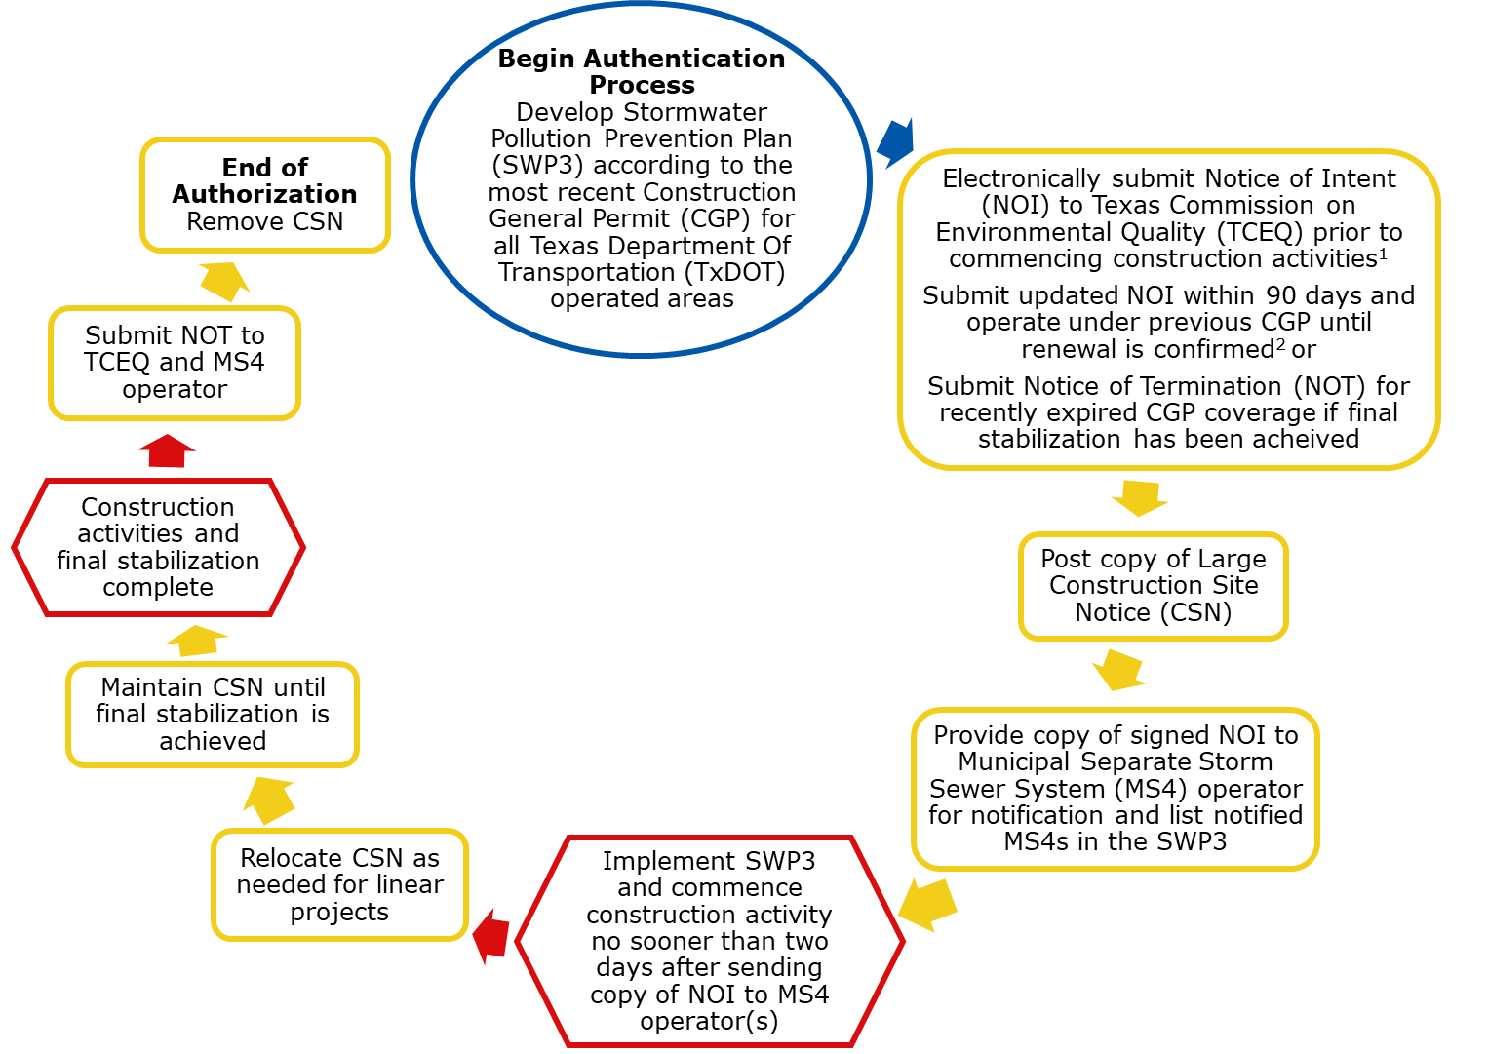
Figure 1. TxDOT large Construction General Permit (CGP) authorization process flow.

If an additional primary operator is added after the initial Notice of Intent (NOI) is submitted, the additional primary operator must meet the same requirements for existing primary operator(s), as indicated above.
If construction is ongoing under a recently expired CGP.

