

Guidance: Stormwater Pollution Prevention Plan
Section 1. Administrative Requirements
Contents
Guidance: Stormwater Pollution Prevention Plan 1
Administrative Requirements 4
1.0 Permit Applicability 4
1.1 Regulatory Requirements 4
1.2 Department Requirements 5
1.3 Eligible Discharges 6
1.4 Permit Coverage Limitations 7
1.4.1 Post-Construction Discharges 7
1.4.2 Prohibition of Non-Stormwater Discharges 7
1.4.3 Compliance with Water Quality Standards 8
1.4.4 Impaired Receiving Waters and Total Maximum Daily Loads Requirements 8
1.4.5 Discharges to the Edwards Aquifer Recharge or Contributing Zone 9
1.4.6 Discharges to Specific Watersheds and Water Quality Areas 10
1.4.7 Protection of Streams and Watersheds by Other Governmental Entities 11
1.4.8 Indian Country Lands 11
1.4.9 Exempt Oil and Gas Activities 11
1.4.10 Agricultural Activities 11
1.4.11 Endangered Species 11
1.4.12 Storage of high-level radioactive waste 12
1.4.13 Other 12
2.0 Authorization Process 12
2.1 Co-Permitted Stormwater Pollution Prevention Plan Development 12
2.2 Obtaining Authorization 13
2.2.1 Construction Activities Disturbing Less than One Acre 13
2.2.2 Small Construction Activities - Projects Disturbing One Acre but Less Than Five Acres 13
2.2.3 Large Construction Activities - Projects Disturbing Five Acres or More 14
2.2.4 Obtaining Authorization to Discharge after General Permit Expiration 15
Figure 1. Determining Construction General Permit Authorization Requirements Based on the Amount of Soil Disturbed 17
Figure 2. Automatic Authorization Process for Small Construction Activities 19
Figure 3. Authorization Process for Large Construction Activities 20
2.3 Secondary Operator Status 21
2.4 Alternative Texas Pollutant Discharge Elimination System Individual Permit Coverage 21
2.5 SWP3 Availability for Review 22
3.0 Retention of Records 23
Revision History 24
List of Figures
Figure 1. Stormwater permitting requirements by total disturbed soil area. 16
Figure 2. TxDOT Small Construction General Permit (CGP) authorization process flow 17
Figure 3. TxDOT large Construction General Permit (CGP) authorization process flow. 18

Administrative Requirements

1.0 Permit Applicability

1.1 Regulatory Requirements
Authority to administer the National Pollutant Discharge Elimination System (NPDES) was delegated to the Texas Commission on Environmental Quality (TCEQ) by the United States Environmental Protection Agency (EPA). TCEQ administers the Texas Pollutant Discharge Elimination System (TPDES) to regulate stormwater discharges from various sources to surface waters of the state. Under the TPDES, TxDOT’s construction (and some maintenance) operations are regulated by the Construction General Permit TXR150000 (CGP) which applies to stormwater discharges from construction projects that disturb one acre or more of soil or are part of a common plan of development with the potential to disturb one acre or more of soil. The CGP requires Texas Department of Transportation (TxDOT) to implement a Stormwater Pollution Prevention Plan (SWP3) that describes Best Management Practices (BMPs) designed to decrease erosion from and capture sediment generated by construction projects as defined in the Construction General Permit:
“Construction activity includes soil disturbance activities, including clearing, grading, excavating, construction-related activity (for example, stockpiling of fill material, demolition), and construction support activity. This does not include routine maintenance that is performed to maintain the original line and grade, hydraulic capacity, or original purpose of the site (for example, the routine grading of existing dirt roads, asphalt overlays of existing roads, the routine clearing of existing rights-of-way, and similar maintenance activities). Regulated construction activity is defined in terms of small and large construction activity.”
The project specific SWP3 must identify the project location, responsible parties (Department and Contractor), areas of soil disturbance, stormwater pollution prevention measures during project construction, documents inspections and related project information. This guidance will further detail requirements TxDOT and the Contractor must follow to comply with the CGP and SWP3.
In addition to the NPDES and TPDES, discharges to waters of the state are regulated under the Texas Water Code (TWC) Chapter 26 Water Quality Control to prevent pollutants from being discharged into those waters. Additional Texas Administrative Code (TAC) rules, such as those related to spill response and petroleum storage, may also apply to various activities occurring on our construction sites. The combination of state and federal regulations governing water quality and pollution control on construction sites makes it important that SWP3 are developed and followed.

1.2 Department Requirements
Per Texas Department of Transportation’s (TxDOT) policy, as defined in the Plans, Specifications and Estimate (PS&E) Preparation Manual, a SWP3 is required for any TxDOT project with soil disturbing activity. SWP3 requirements apply to both Construction and Maintenance projects that meet the definition of construction activity per the CGP, and for projects that disturb less than one acre of soil but have Environmental Permits, Issues, and Commitments (EPICs) dependent on stormwater quality controls and water quality measures (such as United States Army Corps of Engineers (USACE) permits and Best Management Practices (BMPs) for aquatic species). Two separate SWP3 templates will be provided for Designers: one version of the template for projects with less than one acre of soil disturbing activities but have EPICs that are dependent on stormwater quality controls and water quality measures (such as USACE permits and BMPs for aquatic species) and one version of the template for projects with one acre or more of soil disturbing activities. The Designer should ensure they have selected the appropriate version of the SWP3 Summary Sheet for their project. These sheets are posted on the Design Division’s Roadway Standards page.
Projects that do not disturb soil and do not have EPICs dependent on stormwater controls and water quality measures are not required to include these SWP3 Summary Sheets. Verify with environmental staff if you are unsure if EPICs apply. Projects without the need for an SWP3 should follow the guidance outlined in the Design Division’s Final PS&E Processing checklist.
Where discrete construction projects occur within a larger common plan of development or sale but are located ¼ mile or more apart and the area between the projects is not being disturbed, each individual project can be treated as a separate plan of development or sale, provided that any interconnecting road, pipeline or utility project that is part of the same “common plan” is not included in the area to be disturbed. The district should make the determination on a project-by-project bases whether the conditions of the project warrant it be combined into one SWP3 or if separate SWP3s will need to be developed.
There is an important distinction for Local Government Let Projects as these projects will need to instead follow guidance in the Local Government Project Management Guide - that can be found in the Local Government Projects Toolkit.

1.3 Eligible Discharges
The CGP permits the following discharges associated with construction activity:
- rainfall runoff
- snow melt runoff
- surface runoff and drainage
- stormwater discharges associated with construction support activities
- allowable non-stormwater discharges including:
  - uncontaminated water used to control dust
  - the routine external washing of vehicles and the external portion of buildings, structures, and pavement to remove mud, dirt, or dust, so long as detergents and soaps are not used and where spills or leaks of toxic or hazardous material have not occurred (unless proper clean up and mitigation measures have been implemented)
  - dewatering of uncontaminated ground water or spring water so long as proper best management practices are implemented
- other permitted discharges, such as dewatering as defined in the CGP so long as appropriate controls are utilized during the activities
A separate NPDES, TPDES or TCEQ permit must authorize any other discharges that are combined with discharges authorized by CGP.

1.4 Permit Coverage Limitations
The CGP identifies the following permit coverage limitations:

1.4.1 Post-Construction Discharges
Discharges that occur after construction activities have been completed and after the construction site and any supporting activity site(s) have undergone final stabilization, are not eligible for coverage under the CGP. The CGP does not authorize discharges originating from sites following the submission of the Notice of Termination (NOT) for large construction activities or removal of the appropriate Construction Site Notice (CSN) for small construction activities. Refer to 2.0 Authorization Process Authorization Process and Appendix A of this guidance for the submission of the NOT and the proper removal of the CSN.

1.4.2 Prohibition of Non-Stormwater Discharges
Discharges not comprised entirely of stormwater associated with construction activity are prohibited under the CGP, except for the discharges listed in 1.3 Eligible Discharges. Examples of prohibited discharges include soap, solvents, or by-products of washing vehicles and equipment, fuels, oils or by-products of vehicle and equipment maintenance and wastewater from wash out of concrete, paint, or stucco work areas.

1.4.3 Compliance with Water Quality Standards
Discharges that have the potential to impact surface water quality are not eligible under the CGP. TxDOT is prohibited from discharging stormwater to surface waters or waters of the United States that would cause, have the reasonable potential to cause or contribute to a violation of water quality standards or that would fail to protect and maintain existing designated uses, such as, aquatic life, recreation, public drinking water supply and aquifer protection. If the TCEQ’s Executive Director determines that an activity will impact water quality, the Executive Director may require an application for an individual permit or alternative general permit to authorize such discharges.

1.4.4 Impaired Receiving Waters and Total Maximum Daily Loads Requirements
The CGP does not authorize stormwater discharges to an impaired waterbody on the latest EPA-approved Clean Water Act (CWA) Section 303(d) List or waters with an EPA-approved or established Total Maximum Daily Load (TMDL) in the latest Texas Integrated Report of Surface Water Quality for CWA Sections 305(b) and 303(d), which lists the Category 4 and 5 water bodies. TxDOT shall determine if construction activities are discharging to impaired waters as described above. By preparing an SWP3 and meeting CGP requirements, TxDOT is addressing any obligations to meet TMDL requirements.
If a project site discharges to impaired water bodies with an approved TMDL, these discharges are not authorized under the CGP unless they are consistent with the approved TMDL. The SWP3 should contain the TMDL information and the TMDL Implementation Plan (I-Plan) conditions, goals, and requirements applicable to the construction activity discharges.

1.4.5 Discharges to the Edwards Aquifer Recharge or Contributing Zone
The CGP does not authorize discharges within the Edward Aquifer Recharge or Contributing Zones without compliance with the Edwards Aquifer Rule. The following districts and counties are located within the regulated zones of the Edwards Aquifer:
Austin District
- Hays County
- Travis County
- Williamson County
San Antonio District
- Comal County
- Bexar County
- Medina County
- Uvalde County
Laredo District
- Kinney County
For construction activities within the TCEQ-regulated zones of the Edwards Aquifer, TxDOT must prepare an Edwards Aquifer Protection Plan (EAPP) for approval by the TCEQ Edwards Aquifer Protection Program prior to the commencement of any construction activity, which includes the initial disturbance of soils associated with clearing, grading, or excavating activities or any other construction-related activities including stockpiling of fill material and demolition. The timeframe for technical review and approval of the EAPP by the TCEQ is 90 days by rule.
For new discharges located within the Edwards Aquifer Recharge Zone, or within areas upstream from the recharge zone and defined as the Contributing Zone (CZ), operators must meet all applicable requirements of and operate according to 30 TAC Chapter 213 (Edwards Aquifer Rule) in addition to the provisions and requirements of this general permit.
For existing discharges located within the Edwards Aquifer Recharge Zone, the requirements of the agency approved Water Pollution Abatement Plan (WPAP) under the Edwards Aquifer Rule are in addition to the requirements of this general permit. BMPs and maintenance schedules for structural stormwater controls, for example, may be required as a provision of the rule. All applicable requirements of the Edwards Aquifer Rule for reductions of suspended solids in stormwater runoff are in addition to the requirements in this general permit for this pollutant.
For large construction activities (projects disturbing five acres or more), TxDOT and the Contractor must submit a copy of the Notice of Intent (NOI) to the appropriate TCEQ regional office if discharges occur within 10 stream miles of the Edwards Aquifer Recharge Zone. Provisions of the Edwards Aquifer Rule may require additional BMPs and maintenance schedules. TxDOT is required to implement and follow all applicable requirements of the Edwards Aquifer Rule within the regulated zones.

1.4.6 Discharges to Specific Watersheds and Water Quality Areas
The CGP does not authorize stormwater discharges to water quality areas and watersheds if prohibited by 30 TAC Chapter 311 (relating to Watershed Protection). The Watershed Protection Areas protected under 30 TAC Chapter 311 include Lake Travis, Lake Austin, Inks Lake, Lake Buchanan, Clear Lake Watershed Water Quality Management Area, Lake Houston Watershed Water Quality Management Area, the Colorado River Watershed, Lyndon B. Johnson Lake, Marble Falls Lake, Lake Worth, Eagle Mountain Lake, Lake Bridgeport, Cedar Creek Lake, Lake Arlington, Lake Benbrook, Richland-Chambers Lake, and quarry regulation in the John Graves Scenic Riverway. Discharges associated with pesticide application authorized by the TCEQ, federal or state statute are exempt from the discharge prohibition in Subchapters A, B and F of 30 TAC Chapter 311.

1.4.7 Protection of Streams and Watersheds by Other Governmental Entities
The CGP does not limit the authority or ability of federal, other state or local governmental entities from placing additional or more stringent requirements on TxDOT construction activities or discharges from TxDOT construction activities. The CGP does not limit the authority of a home-run rule municipality provided by Section 401.002 Organization, Powers, and Duties of Committee in the Texas Local Government Code.

1.4.8 Indian Country Lands
Stormwater discharges to Indian Country lands are not authorized under the CGP. Authorization for these lands must be obtained by the EPA.

1.4.9 Exempt Oil and Gas Activities
Stormwater discharges from construction activities related to oil and gas exploration and processing are not covered by the CGP.

1.4.10 Agricultural Activities
Stormwater discharges from agricultural activities that are not point source discharges are not subject to TPDES requirements.

1.4.11 Endangered Species
The CGP does not authorize discharges that would adversely affect a listed endangered or threatened aquatic or aquatic-dependent species or its critical habitat unless the requirements of the Endangered Species Act are satisfied. Federal requirements related to endangered species apply to all TPDES permitted discharges. If potential impacts to threatened or endangered species are present, TxDOT must provide additional project-specific controls or BMPs to ensure the protection of endangered or threatened species.

1.4.12 Storage of high-level radioactive waste
Discharges of stormwater from construction activities associated with construction of a facility licensed for the storage of high-level radioactive waste by the United States Nuclear Regulatory Commission are not authorized by the CGP.

1.4.13 Other
Nothing in Part II. of the general permit is intended to negate any person’s ability to assert force majeure (act of God, war, strike, riot, or other catastrophe) defenses.

2.0 Authorization Process

2.1 Co-Permitted Stormwater Pollution Prevention Plan Development
It is TxDOT policy that TxDOT and its Contractors will operate as co-permittee Primary Operators under a shared SWP3 on construction projects (with exceptions as outlined in Section 2.3 Secondary Operator Status in this section). This shared SWP3 will cover portions of the project within TxDOT right-of-way (ROW).
TxDOT is the Primary Operator with operational control over plans and specifications and is responsible for development and maintenance of the SWP3 and conducting stormwater inspections for the CGP. The Contractor is the Primary Operator with day-to-day operational control and is responsible for implementing activities that are necessary to ensure compliance with the SWP3 and other environmental requirements.
Both TxDOT and the Contractor must independently obtain authorization to discharge under the CGP. The co-permitted shared SWP3 must include the name of each co-permittee, the signature of each co-permittee and clearly defined co-permittee responsibilities. Following the contents as outlined in this guidance will fulfil these requirements. For authorized large construction activity sites, the SWP3 must also include the submittal date of each NOI to TCEQ or the individual permit authorization numbers.
Per Item 7.7 Preservation of Cultural and Natural Resources and the Environment of TxDOT’s Standard Specifications for Construction and Maintenance of Highways, Streets and Bridges (2014) for project specific locations (PSLs) off-right of way, the Contractor is fully responsible for meeting CGP requirements associated with those activities, and TxDOT does not engage in a shared SWP3 or co-permittee status for those PSLs.

2.2 Obtaining Authorization
TxDOT will obtain CGP authorization under one of the following scenarios depending on the size of the construction activity. See Figure 1. Stormwater permitting requirements by total disturbed soil area. to determine which authorization process to follow.

2.2.1 Construction Activities Disturbing Less than One Acre
For projects disturbing less than one acre, the SWP3 Summary Sheets satisfy TxDOT’s documentation requirements for stormwater pollution prevention. No CGP authorization or coordination with the TCEQ is necessary.

2.2.2 Small Construction Activities - Projects Disturbing One Acre but Less Than Five Acres
Small construction activities include demolition, clearing, grading, and excavating that result in land disturbance of equal to or greater than one acre and less than five acres of land. Small construction activity also includes the disturbance of less than one acre of total land area that is part of a larger common plan of development or sale if the larger common plan will ultimately disturb equal to or greater than one and less than five acres of land. Small construction activity does not include routine maintenance that is performed to maintain the original line and grade, hydraulic capacity, or original purpose of the site (for example, the routine grading of existing dirt roads, asphalt overlays of existing roads, the routine clearing of existing rights-of-way and similar maintenance activities). See Figure 2. TxDOT Small Construction General Permit (CGP) authorization process flow for the authorization process for small construction activities.
Small construction activities conducted by TxDOT are authorized immediately following compliance with the applicable conditions of the CGP unless located in an area regulated by the Edwards Aquifer Rule. Small construction activities that fall under the jurisdiction of the Edwards Aquifer Protection Program are not authorized under the CGP until all conditions of the Edwards Aquifer Rule are met. Construction activities may commence once all applicable conditions are met.
TxDOT will use a programmatic approach to delegation of signatories for reports. A hard copy of the delegation of signatories form will be submitted to TCEQ by TxDOT’s Executive Director to fulfill the requirement for TxDOT’s small construction projects. A copy of this form will be kept in all SWP3 binders for small construction projects under Attachment 2.7.

2.2.3 Large Construction Activities - Projects Disturbing Five Acres or More
Large construction activities include demolition, clearing, grading, and excavating that result in land disturbance of equal to or greater than five acres of land. Large construction activity also includes the disturbance of less than five acres of total land area that is part of a larger common plan of development if the larger common plan will ultimately disturb equal to or greater than five acres of land. Large construction activity does not include routine maintenance that is performed to maintain the original line and grade, hydraulic capacity, or original purpose of the site (for example, the routine grading of existing dirt roads, asphalt overlays of existing roads, the routine clearing of existing rights-of-way and similar maintenance activities). See Figure 3. TxDOT large Construction General Permit (CGP) authorization process flow. for the authorization process for large construction activities.
The State of Texas Environmental Electronic Reporting System (STEERS) must be used to submit a Notice of Intent (NOI), Notice of Change (NOC) and Notice of Termination (NOT) for the discharge of stormwater from a construction site, unless an electronic waiver has been granted. Appendix A of this guidance will provide further explanation on the documentation required to be maintained as part of the SWP3.
Large construction sites located in an area regulated by the Edwards Aquifer Rule are not authorized under the CGP until all conditions of the Edwards Aquifer Rule are met. Construction activities may commence once all applicable conditions are met.
There is no programmatic approach for delegation of signatories for reports for large construction sites. TxDOT will use the STEERS system for submitting delegation of signatories for reports for these large sites. The STEERS form will be signed by the responsible authority as allowed by Contract Services Division (CSD) internal SharePoint site where the TxDOT’s Delegation of Authorities document is posted and the Legal Manual, Chapter 2. Names or position titles may be used on the delegation forms. The delegation of signatory for reports will be stored in Attachment 2.7 of the SWP3 Binder. An Area Engineer or other signatory may choose not to delegate signatories for reports. Signatories for reports cannot be delegated to non-TxDOT personnel.

2.2.4 Obtaining Authorization to Discharge after General Permit Expiration
CGP is set to expire on March 5, 2028, five years after the effective date of March 5, 2023. Figures 2 and 3 include possible scenarios to obtain authorization once the general permit expires if a new general permit is not adopted. These scenarios consider ongoing and scheduled construction activities for both small and large construction activities and identify the appropriate actions and deadlines to maintain or renew coverage under CGP.

Figure 1. Determining Construction General Permit Authorization Requirements Based on the Amount of Soil Disturbed
Circle (blue) – Texas Department of Transportation (TxDOT) actions
Rectangle (yellow) – TxDOT and Contractor actions
Hexagon (red) – Contractor actions
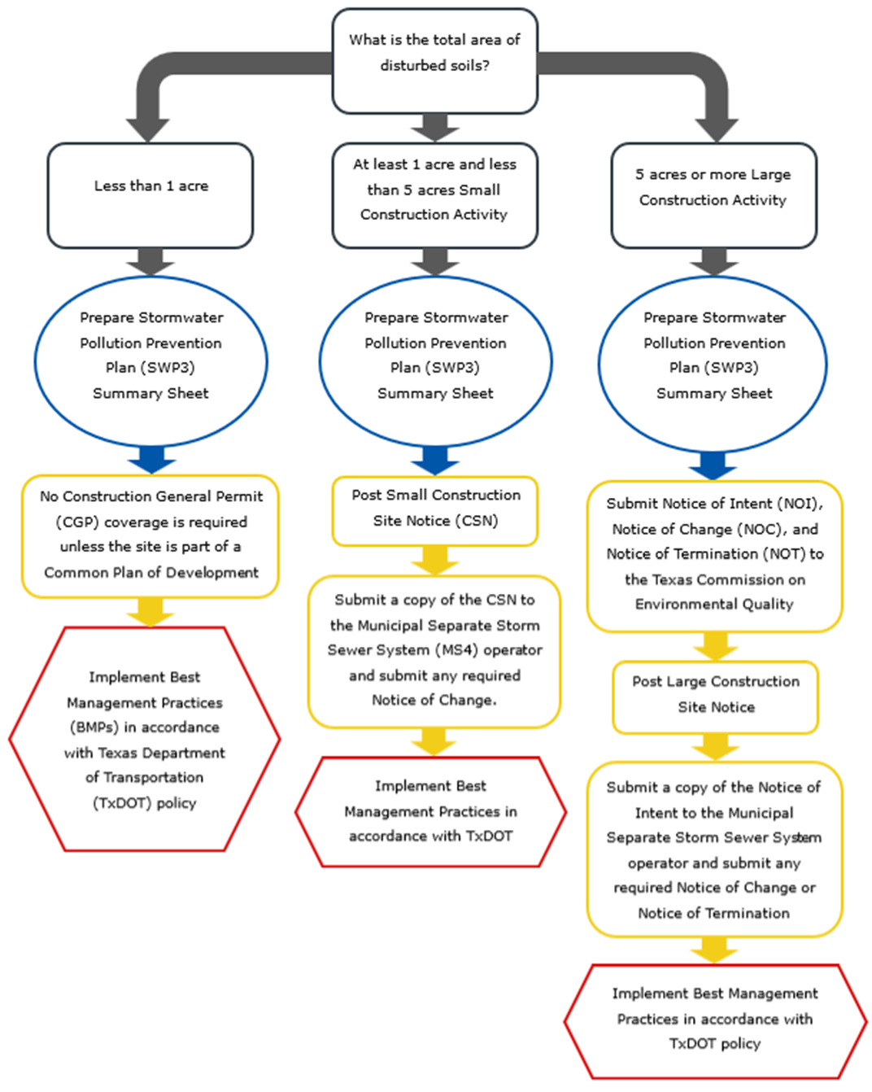Figure 1. Stormwater permitting requirements by total disturbed soil area.

Figure 2. Automatic Authorization Process for Small Construction Activities
Circle (blue) – Texas Department of Transportation (TxDOT) actions
Rectangle (yellow) – TxDOT and Contractor actions
Hexagon (red) – Contractor actions
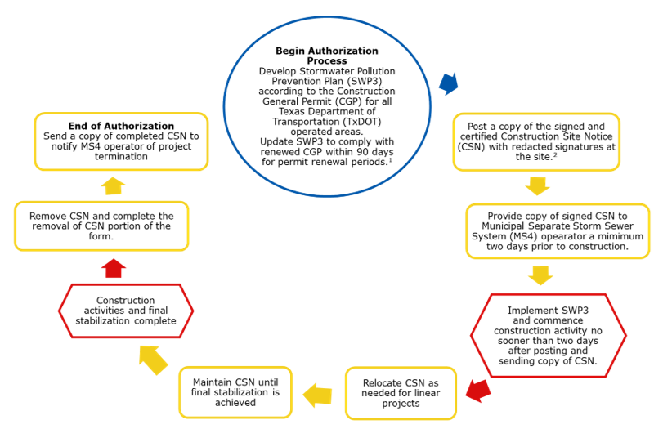
Figure 2. TxDOT Small Construction General Permit (CGP) authorization process flow

Figure 3. Authorization Process for Large Construction Activities
Circle (blue) – Texas Department of Transportation (TxDOT) actions
Rectangle (yellow) – TxDOT and Contractor actions
Hexagon (red) – Contractor actions
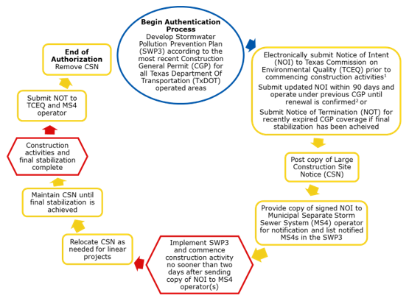
Figure 3. TxDOT large Construction General Permit (CGP) authorization process flow.

2.3 Secondary Operator Status
In some other instances, TxDOT may operate as a secondary operator rather than a primary operator. The following lists the types of projects where TxDOT could potentially be a considered a secondary operator:
- Design-Build projects
- Local-let on-system projects where TxDOT can approve or disapprove changes to the plans and specifications
TxDOT will not be considered a primary or secondary operator for Local Let Off-System projects.
The Engineer will need to evaluate on a project-by-project basis to determine operator status and include the appropriate information to define roles and responsibilities on the SWP3 Summary Sheet. Contact ENV if assistance is needed in determining secondary operator requirements.
Secondary operators must either prepare their own SWP3 or participate in a shared SWP3 that covers the areas of the construction site, where they have control over the construction plans and specifications. If there is not a primary operator at the construction site, then the secondary operator is defined as the primary operator and must comply with the requirements for primary operators.

2.4 Alternative Texas Pollutant Discharge Elimination System Individual Permit Coverage
In most foreseeable scenarios, TxDOT would be authorized under the CGP. In very rare instances, an individual TPDES permit might be required. If an individual TPDES permit is necessary, TxDOT will be required to apply for coverage at least 330 days prior to commencement of construction activities. Termination of existing coverage under the CGP should not occur until an individual permit is issued. In the following circumstances, the Executive Director may require TxDOT to apply for an individual TPDES permit:
- An approved TMDL or TMDL I-Plan is associated with the receiving waters
- The construction activity was determined to cause, has reasonable potential to cause, or contributed to a violation of water quality standards or being found to cause, or contribute to, the loss of designated use of surface water in the state
- Any other considerations defined in General Permits for Waste Discharges (30 TAC Chapter 205)
If you have any questions on a situation that might trigger Individual Permit Coverage reach out to ENV as soon as you become aware of the requirement.

2.5 SWP3 Availability for Review
TxDOT must maintain an up-to-date SWP3 Binder at the Area Office, field office or digitally for review upon request by a regulatory agency or by TxDOT personnel conducing reviews and audits of the documentation. The SWP3 can be paper or digital format. If the site is inactive or does not have an on-site location to store the SWP3, store the SWP3 at the Area Office. Ensure the CSN accurately reflects the location where the SWP3 is stored. The SWP3 must be made readily available at the time of an on-site inspection by a federal or state regulatory agency or local municipal separate storm sewer operating receiving discharges from the site. If the SWP3 is off-site, TxDOT will make the SWP3 available within 24 hours. The SWP3 and SWP3 mark-up sheets should not be kept in a vehicle or other non-central location unless an up-to-date copy of those documents is being kept elsewhere (such as in the Area Office or ProjectWise). If the original SWP3 mark-up sheets are kept in a vehicle, they must be copied and placed in the SWP3 Binder or scanned into a digital location on a weekly basis or when changes are made. It is not acceptable to keep the only up-to-date copy of any SWP3 documentation in a truck only.
TxDOT and Contractors will post CSNs at the construction site at a place readily available for viewing by the general public and local, state and federal authorities.
The CGP does not provide the general public with any right to trespass on a construction site for any reason, including inspection of a site, nor does this permit require that TxDOT or its Contractors allow members of the general public access to a construction site.
See Appendix A Completing the CSN, NOI, NOC, and NOT for additional information on site posting requirements.

3.0 Retention of Records
TxDOT and the Contractor must retain SWP3 records for a minimum period of three years from the NOT submittal date. Refer to the NOT discussion in Appendix A of this guide for more information regarding proper termination of CGP authorization. The retained records must include:
- A copy of the SWP3
- All reports and actions required by the CGP, including a copy of the CSN
- All data used to complete the NOI, if requesting authorization for a large construction site
- All records of submittal of forms submitted to the operator of any Municipal Separate Storm Sewer System (MS4) operators receiving the discharge and to the secondary operator of a large construction site.

Revision History
Table 1. Document revision history
Effective date (month year) | Reason for and description of change
May 2026 | Version 4  - Updated to comply with accessibility and TxDOT branding standards.
June 2023 | Version 3  - Revisions based on updates of the reissued March 5, 2023, Construction General Permit (CGP). In Section 1.1, added definition of construction activity, as per the CGP. Also, added local government language. Added clarification for when the SWP3 is needed to Department Requirements and clarification for determining common plan of development applicability under Section 1.2. Section 1.4 includes clarification to Permit Coverage Limitations for discharges including those within the Edwards Aquifer Zone, Indian Country Lands, agricultural activities, and exempt oil and gas activities. Section 2.2 summarizes changes to required delegation of signatories forms for both large and small construction sites. Section 2.5 includes clarification that the Stormwater Pollution Prevention Plan (SWP3) binder may be in electronic format but must be readily available within 24 hours and cannot be stored in vehicle unless second up-to-date copy is available through ProjectWise or in Area Office. Section 2.5 also refers to Appendix A for information on proper posting of the Construction Site Notice and clarifies that the CGP does not provide the public with any right to trespass on a construction site.– add in here Construction Site Notice (CSN) tweaks & binder storage clarifications.
June 2022 | Version 2  - Corrected language pertaining to the authorization process. It also added clarification to the SWP3 availability for review section on where the SWP3 binder should be stored.
June 2021 | Version 1  - This section covers CGP permit applicability and authorization process related to TxDOT projects

PS&E Preparation Manual. Revise 2024. https://www.txdot.gov/content/dam/txdotoms/des/pse/pse.pdf
Hale. 2016. “TxDOT and Contractor Co-Permittees SP 506-003 and SP 007-004” memorandum.
Millikan. 2013. “Storm Water Compliance – Requirements for Construction Projects Let By Local Governments” memorandum.
Design-Build Administration Manual. April 2025.

