Automatic Authorization Process for Small Construction Activities
Circle (blue) – Texas Department of Transportation (TxDOT) actions
Rectangle (green) – TxDOT and Contractor actions
Hexagon (red) – Contractor actions
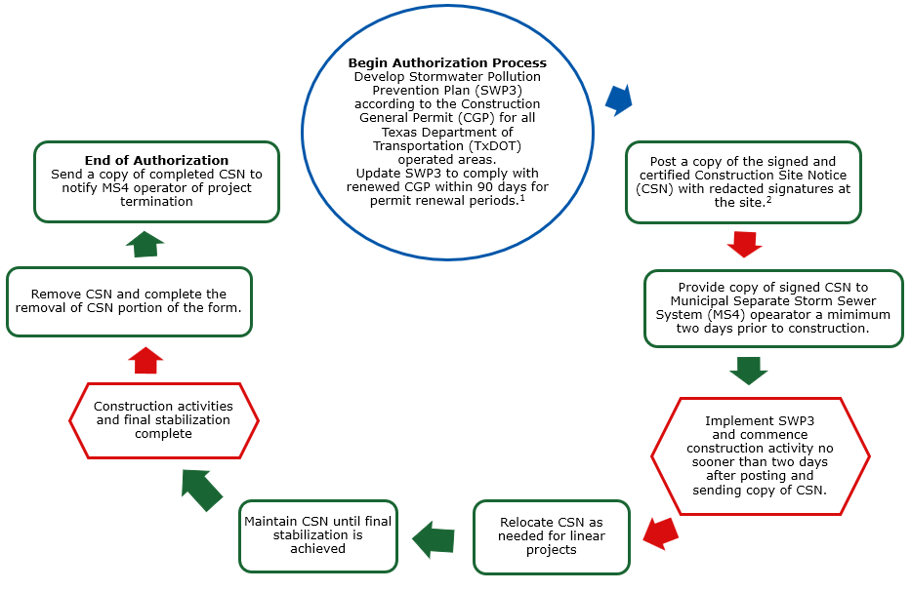Figure 1. TxDOT Small Construction General Permit (CGP) authorization process flow.

The posted Construction Site Notice (CSN) should have redacted signatures where signatures are present. The original signed and certified CSN should be maintained onsite in the Stormwater Pollution Prevention Plan (SWP3) Binder and available for review by an applicable regulatory authority.
If construction is ongoing under a recently expired CGP. Texas Commission on Environmental Quality (TCEQ) renews the CGP on a five-year cycle.

