Determining Construction General Permit Authorization Requirements Based on the Amount of Soil Disturbed
Circle (blue) – Texas Department of Transportation (TxDOT) actions
Rectangle (yellow) – TxDOT and Contractor actions
Hexagon (red) – Contractor actions

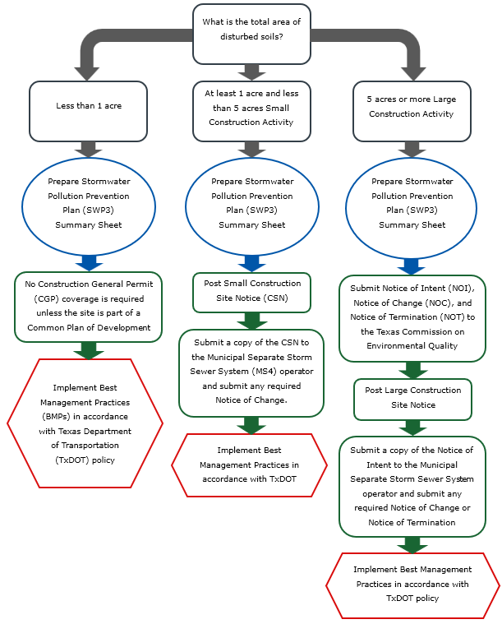
Figure 1. Stormwater permitting requirements by total disturbed soil area.

If the site is within a Common Plan of Development with a disturbed area of 1 acre to less than 5 acres, include all acreage of the Common Plan of Development and follow the requirements for sites greater than or equal to 1 acre and less than 5 acres.
If the site is within a Common Plan of Development with a disturbed area of 5 acres or more, include all acreage of the Common Plan of Development and follow the requirements for sites greater than or equal to 5 acres.
The addition of a project specific location (PSL) within 1 mile of any project limits could increase the total area and disturbed area for the project above the threshold for less than 1 acre and greater than or equal to 1 acre and less than 5 acres sites triggering additional Stormwater Pollution Prevention Plan (SWP3) and Construction General Permit (CGP) requirements.

