Best Management Practice Section and Design Job Aid: Sediment Trap
Construction stormwater Best Management Practice (BMP) must be installed, inspected, maintained and removed in accordance with Texas Department of Transportation (TxDOT) manufacturer specifications, where applicable, and the Construction General Permit (TXR150000).

Description
Sediment traps are small, excavated areas contained by stone embankments that slow sediment laden runoff enough to allow suspended particles to settle before being discharged.
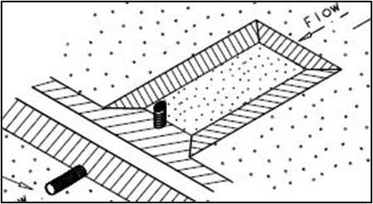
Figure 1. Schematic of a sediment basin or sediment trap with a pipe outlet installed in a flow channel to collect settling sediments.

Types
Sediment Basin or Sediment Trap with Pipe Outlet
Curb Inlet Sediment Trap
Sediment Trap with Level Stabilized Outlet
Drop Inlet Sediment Trap

Application
Sediment traps are utilized at locations where concentrated flows require a protected inlet or outlet to contain sediment prior to discharge. They are effective on large construction sites where a sediment basin is not feasible due to site or construction method restrictions. Sediment traps act as a sediment barrier to remove sediment from stormwater runoff before it leaves the construction site. General use includes:
- Sediment control in concentrated flows
- Reduce concentrated flow velocity
- Substitution for infeasibility of sediment basin
- Additional sediment control leaving basin

Advantages
- Effectively traps medium and large sized particles from sediment laden runoff
- Reduces flow velocities
- Provides temporary storage for runoff

Disadvantages
- Requires a lot of surface area
- Not as effective at removing fine silt and clay particles
- Not effective for “live” channels
- Can cause upstream flooding

Design Criteria
- Drainage area for the sediment trap should not exceed 5 acres.
- The stone outlet sediment trap capacity should be 1800 cubic feet per acre ($\frac{1}{2}$ inch over the drainage area).
- Traps should be placed within drainage ditches, preceding ditch inlets, before drainage enters a water course, or before drainage leaves the right of way.
- The minimum storage volume of the trap should be based on the volume of runoff from a designated design storm for the drainage area (2-year, 24 hour).
- The surface area of the design storage area should be at least one percent of the total drainage area.
- The embankment should be at most 5 feet high, have a maximum top width of 4 feet, and have side slopes of 2‑to‑1 (H:V) gradient or flatter.
- Embankment should be constructed with well graded stone. Stone may be wrapped in wire mesh such as a gabion basket to prevent from washing away.
- Filter stone should be placed upstream side of stone embankment if runoff contains fine silt and clay particles.

References
TxDOT Temporary Erosion, Sediment and Water Pollution Control Measures Sediment Basins and Traps (Earthwork For Erosion Control): EC (6) - 16

