Best Management Practice Section and Design Job Aid: Tree Preservation
Construction stormwater Best Management Practice (BMP) must be installed, inspected, maintained and removed in accordance with Texas Department of Transportation (TxDOT) manufacturer specifications, where applicable, and the Construction General Permit (TXR150000).

Description
Tree protection within the construction area is used to minimize erosion by protecting tree roots to allow for continued growth. Tree health and canopy density prevents splash erosion. Additionally, the tree roots provide natural soil stabilization.
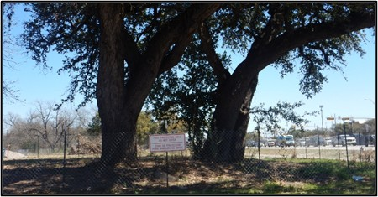
Figure 1. Tree preservation is implemented around heritage trees by installing a perimeter fence and signage.

Types
Orange Construction Fencing
Chain-Link Fence
Wood Barricade

Application
Tree protection is utilized for permanent soil stabilization, run-on and runoff control, and temporary sediment control. Tree protection should be scheduled for sites with the following:
- Healthy mature trees
- Trees listed in the threatened and endangered plants list
- Existing trees that help prevent erosion by increasing infiltration and decreasing stormwater velocity
- Construction chemical use that will not affect existing vegetation

Advantages
- Most inexpensive form of erosion control
- Most effective Best Management Practice (BMP) for soil stabilization and erosion control
- Some trees may be transplanted within the construction sites

Disadvantages
- Site conditions will dictate design and need
- Trees may need to be evaluated by an arborist
- Onsite utilities may not allow the preservation of existing trees

Design Criteria
- This BMP must be used in conjunction with construction activity scheduling and preservation of existing vegetation. Consider creating an inventory of trees onsite and identify trees that may provide added erosion and sediment control benefits.
- Identify trees that are to be protected and include the buffer on the Stormwater Pollution Prevention Plan (SWP3) Layout Sheets.
- If work is being conducted on an easement, confirm that the local government doesn’t have a tree protection ordinance.
- Preserve trees if they are on the threatened and endangered species plant list.
- On the SWP3 Layout Sheets, use the construction perimeter fence symbol to indicate the trees are to be preserved and a construction perimeter fence is needed to protect.
- The construction perimeter fence should be installed out from under the drip line of the tree to ensure adequate protection of the tree roots
- Workers, equipment, and vehicles should be situated away from existing trees to prevent trunk or root damage.

References
Texas Pollutant Discharge Elimination System (TPDES) Construction General Permit TXR150000 Part III Section F and Part IV

