Best Management Practice Section and Design Job Aid: Amphibian and Reptile Exclusion Fence
Construction stormwater Best Management Practice (BMP) must be installed, inspected, maintained and removed in accordance with Texas Department of Transportation (TxDOT) manufacturer specifications, where applicable, and the Construction General Permit (TXR150000).

Description
The Amphibian and Reptile Exclusion Fence (AREF) is a barrier structure installed on construction projects to prevent amphibians and reptiles from entering the construction site. It is used on projects with threatened or endangered amphibian and reptile species. Check with the Environmental Coordinator for project requirements.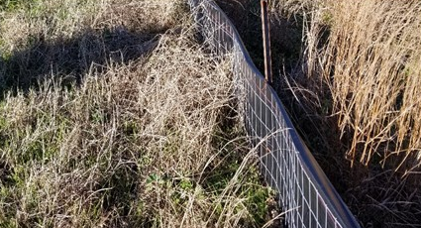
Figure 1. Amphibian and reptile exclusion fencing were installed to help prevent amphibians and reptiles from entering a construction site.

Types
Standard Amphibian and Reptile Exclusion Fence (AREF) – AREF is used in standard conditions.
Toad Exclusion Fence (TEF) - TEF has special inspection and training requirements associated with it. Include TEF Special Provision.

Application
AREF is used to prevent amphibians and reptiles from entering the project area:
- Along perimeter of project
- Around culverts extending into the project area
- Along streams and channels
- At driveways and connecting roadways
- Around temporary stockpiles
- Around trenches and excavations
- Around materials storage areas

Advantages
- Cost effective way to prevent protected amphibians and reptiles from entering the project area

Disadvantages
- If they are not installed and maintained properly, animals could enter project area

Design Criteria
- Phase installation based on species specific timeframes, such as breeding season.
- Place AREF along the perimeter of the project as the outermost Best Management Practice (BMP).
- In locations where the AREF abuts driveways, roadways, or other intersections include a j-hook as shown on the detail sheet (AREF-21).
- AREF must be designed to either fully encompass or fully exclude both ends of a culvert.
- Add any specific AREF requirements to the general notes in the plan set.
- Use AREF linestyle when showing the location of the AREF in the plan set.

References
Texas Department of Transportation (TxDOT) Amphibian and Reptile Exclusion Fence detail sheet: AREF-21
TxDOT Special Specification 5003 Amphibian and Reptile Exclusion Fence

