Texas Department of Transportation
Safer by Design (SBD) Tool

https://sbd.txdot.gov

Users’ Guide

by Texas Department of Transportation
February 2024 V1.0

Contents
1. Introduction and Disclaimer 1
2. Users and Roles 2
3. Registered User - Login and Logout 3
4. Registered User - Create a Project 5
5. Safety Assessment 7
6. Registered User - Project Management 18
7. TxDOT Division-Level Administrator - Management 21

1. Introduction and Disclaimer
Texas Department of Transportation (TxDOT) and Texas A&M Transportation Institute (TTI) developed Safer by Design (SBD) tool (formerly known as Safety Scoring Tool or SST) with the aim to provide Transportation Engineers a simple and straightforward methodology that directly incorporates data driven safety considerations into the roadway design process. The ultimate goal is to prevent crashes, reduce fatalities and injuries as a result of crashes on Texas roadways. The safety assessment process is based on analytical methods available to the Tool development team, including but not limited to American Association of State Highway and Transportation Officials (AASHTO) Highway Safety Manual, National Cooperative Highway Research Program (NCHRP) Reports, TxDOT Roadway Design Manual, TxDOT Research and Technology Implementation Division (RTI) research projects, the U.S. Department of Transportation Federal Highway Administration (FHWA) CMF Clearinghouse, and published journal articles. In some circumstances, the Tool development team made minor adjustments to the analytical methods to make the Tool user friendly.
Many features are developed specifically for this Tool to meet the goals. This Guide describes how to use this Tool as well as the features. There is also a Frequently Asked Questions (FAQ), which addresses specific questions related to assumptions, design elements and options in the Tool. These questions were collected from a series of in-person and virtual demonstration workshops held prior to the official launch of this Tool.
It should be noted that the analytical methods may be updated. The Tool is designed to be upgraded periodically to include the latest methods and research results, to improve user experience, and to fix issues. These upgrades may be implemented by TxDOT and TTI without prior notice.
To maximize the benefit of this Tool on reducing crashes on roadways, TxDOT intend to make this Tool publicly available to local transportation agencies, and other organizations who would like to improve roadway safety through design and safety evaluation. Users and roles are discussed in Section 2. It is important to disclaim that:
- TxDOT and TTI will not share user information or project data stored in this Tool without written approval from users.
- The safety assessment results are solely used for improving safety and should not be used for any other purpose.
- This Tool is developed to assist Transportation Engineers conduct safety assessment and design safer roads. It should not be used as a simple decision-making tool. Engineering judgements should be used while utilizing this Tool.
- TxDOT and TTI are not responsible for any misleading, or incorrect results generated from this Tool.
- When selecting analytical methods, the Tool development team selected those that are conducted based on Texas roadway characteristics when possible. The safety results may not reflect the accurate results if applied to a non-Texas roadway.

2. Users and Roles
There are two types of users: (1) guest user; and (2) registered user.
Any person with access to the internet can use TxDOT SBD Tool to assess safety of urban roadway segments and intersections as a guest user. The Tool works as a calculator, and no data can be saved or retrieved.
All TxDOT employees (referred to as internal users) can use this Tool as registered users using TxDOT account credentials.
Non-TxDOT employees (referred to as external users) need to contact TxDOT (DES_SaferByDesign@txdot.gov) to establish an account. Instruction and required information can be found on tool homepage (https://sbd.txdot.gov/home). It may take up to two weeks to review and approve the application. Once approved, user will receive an email with initial password.

For registered users, there are four types of roles:
- General
In addition to using the Tool as a calculator, a registered user with general role can save projects in the Tool. Specifically, a general user has the following privileges:
- Create projects
- Search, view, edit, delete, transfer, and submit self-owned projects
- District-level Manager
A registered user with role of district-level manager for certain district(s) has the following privileges:
- Create projects
- Search, view, edit, delete, transfer, and submit projects within the district(s) and self-owned projects.
For example, district-level manager of the Austin district is able to operate all projects saved in the Tool in Austin district.
- TxDOT Division-level Administrator
A registered user with role of TxDOT Division-level administrator has the following privileges:
- View all projects saved in the Tool
- Send back submitted projects
- Search, filter and download project summary table
- Manage user roles, e.g., assign a user as the district-level manager of a district

3. Registered User - Login and Logout
For registered users, to log in Tool, follow the steps below:
- Go to the Tool website home page in browser (internet explorer is not supported)

https://sbd.txdot.gov

Note that a minimum screen resolution of 1280*1024 pixels is recommended for an optimal viewing experience. This Tool is not designed for use on mobile devices (smart phones, tablets, etc.).

- Click Login Button on top right of the home page
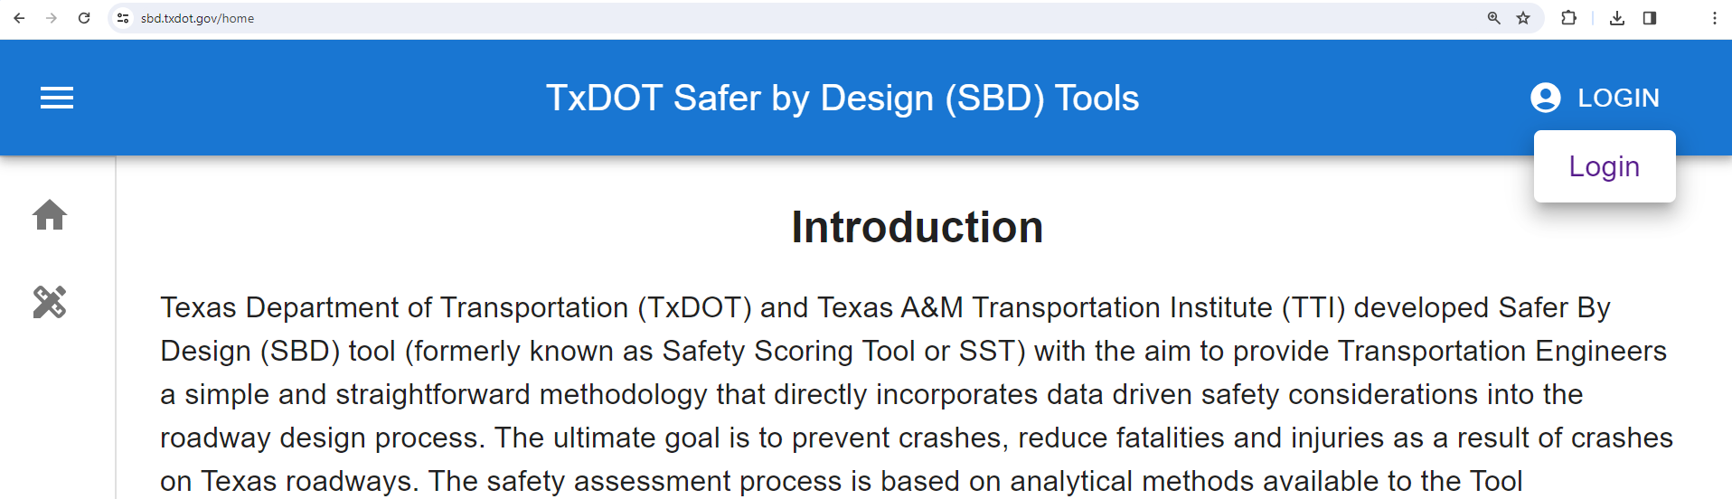

Please note that this Tool adheres to the Web Content Accessibility Guidelines 2.1 (with a few exceptions). Although the operations in the guide are initially designed for mouse-based actions, users can operate almost all the features of this Tool using either a keyboard or a keyboard interface.

- Enter email and password
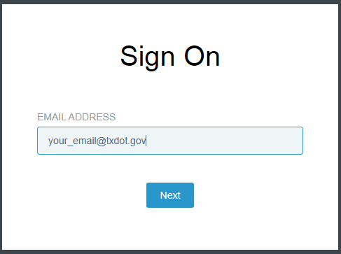
After successful login, the “WELCOME YOUR_NAME” message will display on the top right of the home page. In addition, the “Page Management” navigation bar will display on the left side of the home page.
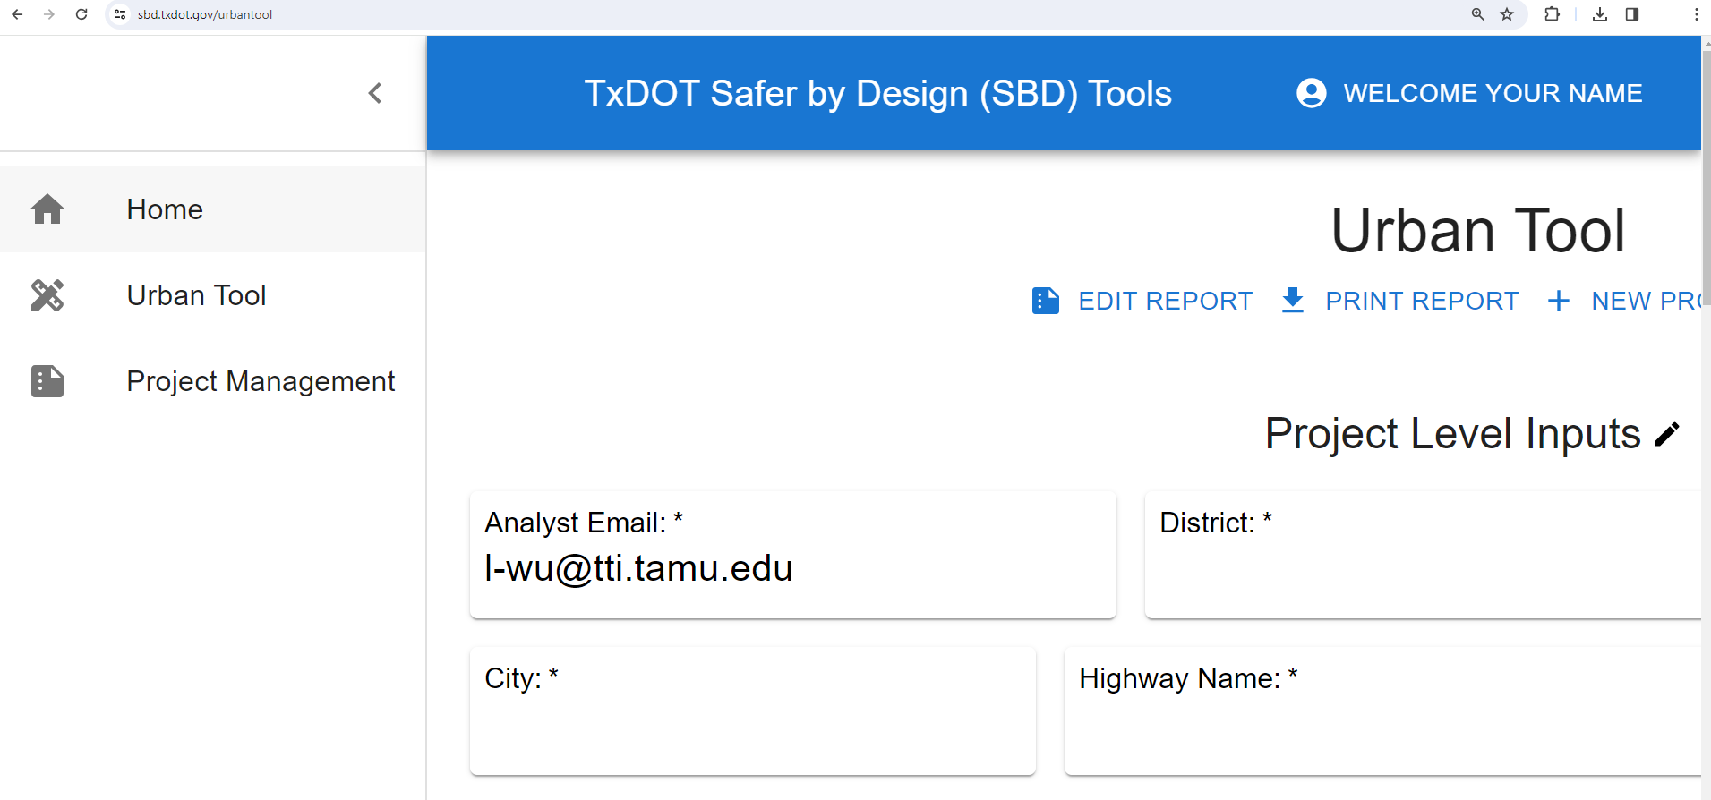
your_email@txdot.gov

4. Registered User - Create a Project
After successful login, a user with general role or district-level manager role can create projects. To create a project:
- Click Project Management on the left, then click “NEW PROJECT” button
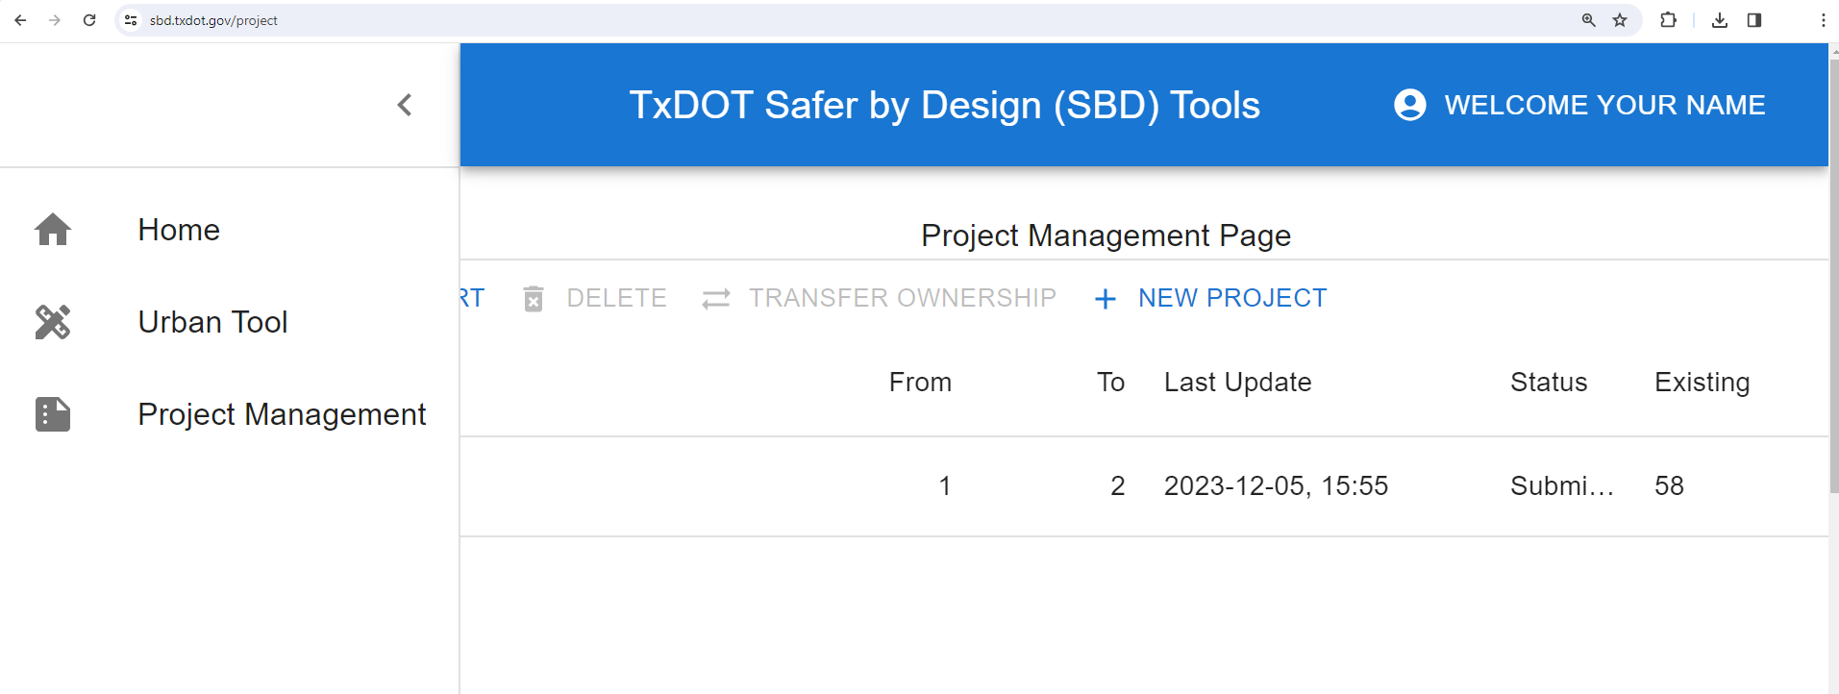

- Fill all items in the “Edit Project Information” box, then click “OK” button
The project level inputs include District, City, project CCSJ number, highway name, evaluation date, letting date, project category, number of segments, number of intersections, project start point (from DFO) and project end point (to DFO). All of these are required.
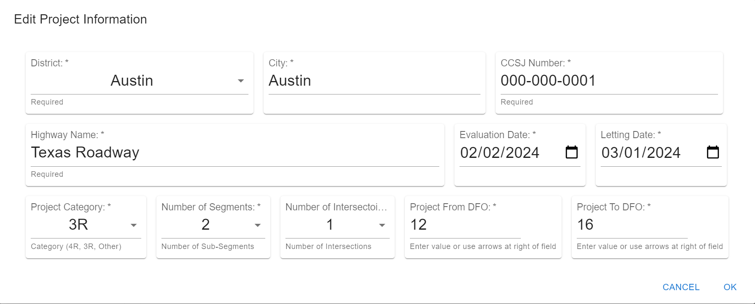
After clicking on OK, the newly created project will show in the project list under Project Management Page.
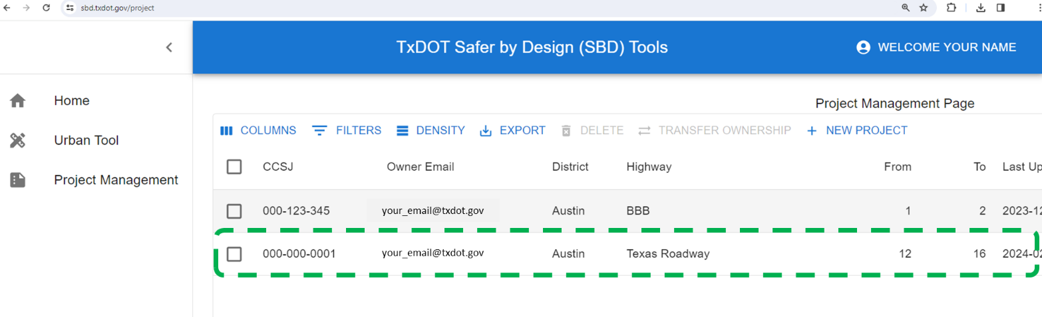
This list also shows the basic information of the project(s) associated with current login user, including CCSJ number, district, highway name, location, dates, and status.

5. Safety Assessment
For guest users to use the Tool as a stand-alone calculator for safety assessment, click on “Urban Tool” from the navigation bar, finish the Project Level Inputs (i.e., click on the pencil icon after Project Level Inputs, fill items, and click OK).
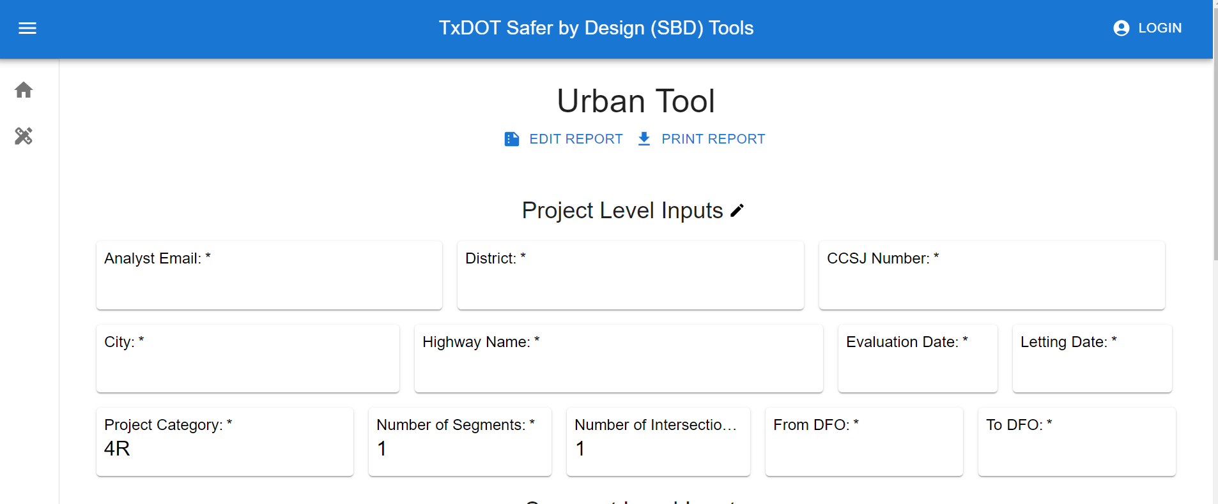
The project level inputs include District, City, project CCSJ number, highway name, evaluation date, letting date, project category, number of segments, number of intersections, project start point (from DFO) and project end point (to DFO).

For registered users, create a project first if the project has not been created (follow Section 3 of this guide), then go to “Project Management” page, locate the project to be assessed, click on the pencil icon (second last column called “Edit”).

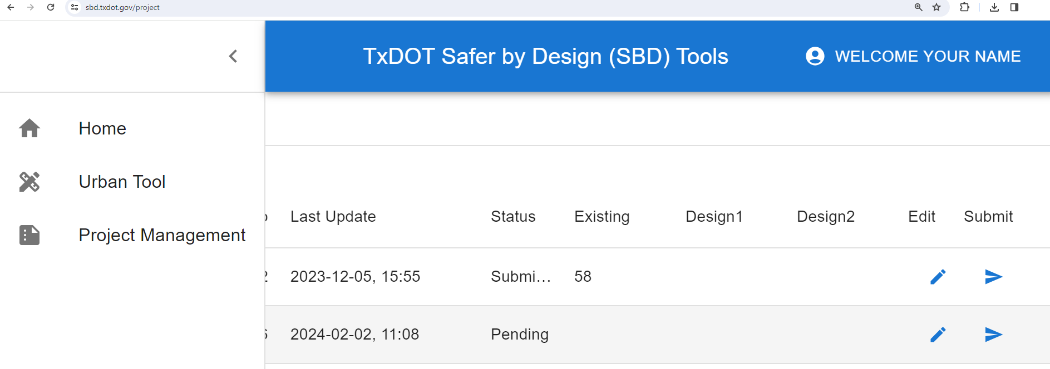

This brings the target project to “Urban Tool” Page.

For each intersection and segment:
- Click on the accordion bar to expend the inputs
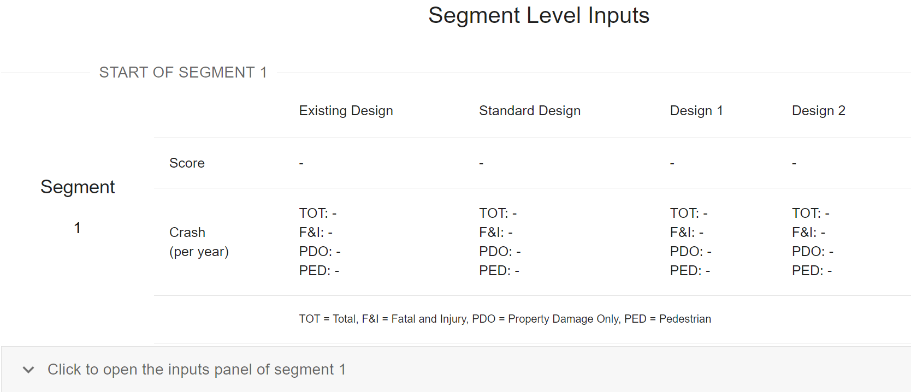
- Fill all the categories of Existing configuration
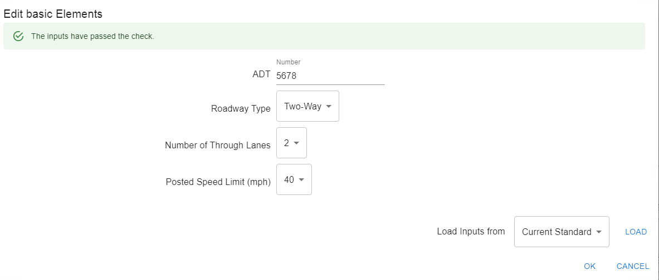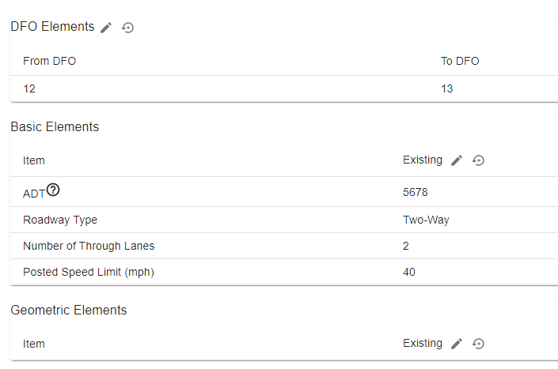
Note: (1) for certain elements, there are tips and clarifications, please hover on the question mark; (2) please refer to FAQ for questions regarding specific elements and options; (3) if concerns are not addressed from FAQ, please contact TxDOT design division (contacts can be found from https://www.txdot.gov/about/divisions/design-division.html).

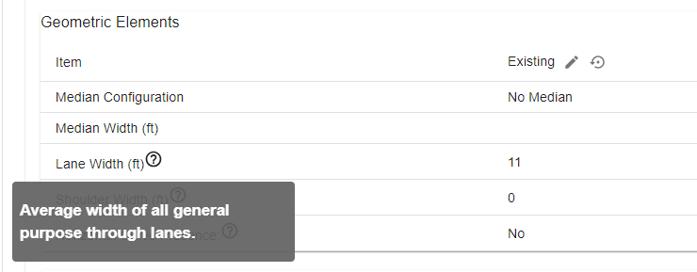

- Click “CALCULATE” button, the scores and predicted number of crashes for the current segment or intersection will display on the left side of the button.

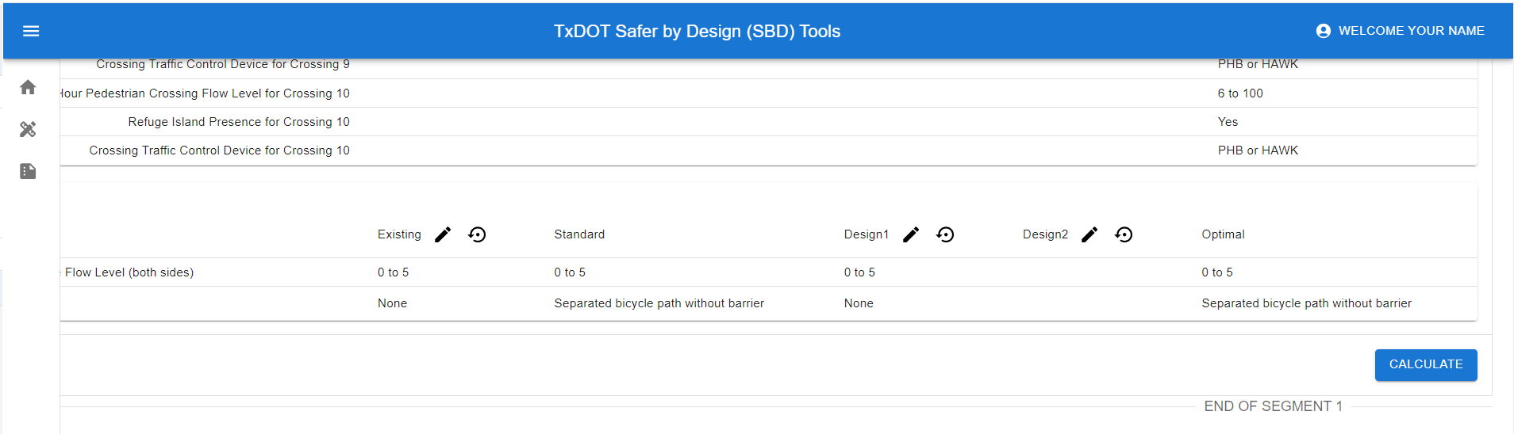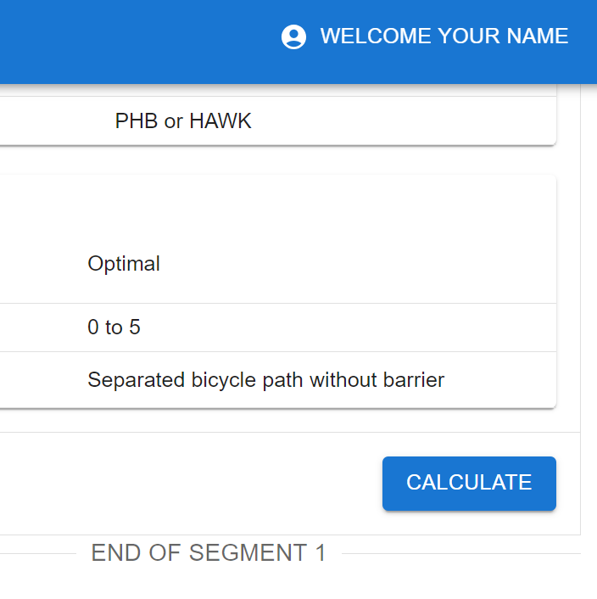

Note: (1) if an error message displays after clicking the “CALCULATE” button, please check the inputs. There are certain types of roadway segments and intersections without available safety analytic methods. For example a two-lane divided roadway is very rare, the safety performance functions and crash modification factors are not available; (2) if all inputs are valid and error message persists, please take a screenshot of the error message and inputs, and send to the Tool development team (DES_SaferByDesign@txdot.gov and SBDToolSupport@tti.tamu.edu).

- Finish Design1 and Design2 assessment as needed following the same process as Existing
There is a “Load” feature to ease the process of element input. See below on how to load inputs from another configuration.
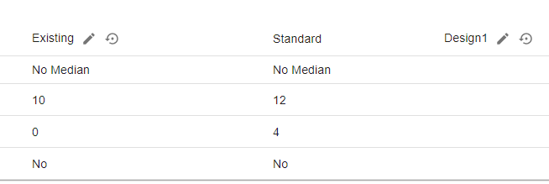
3
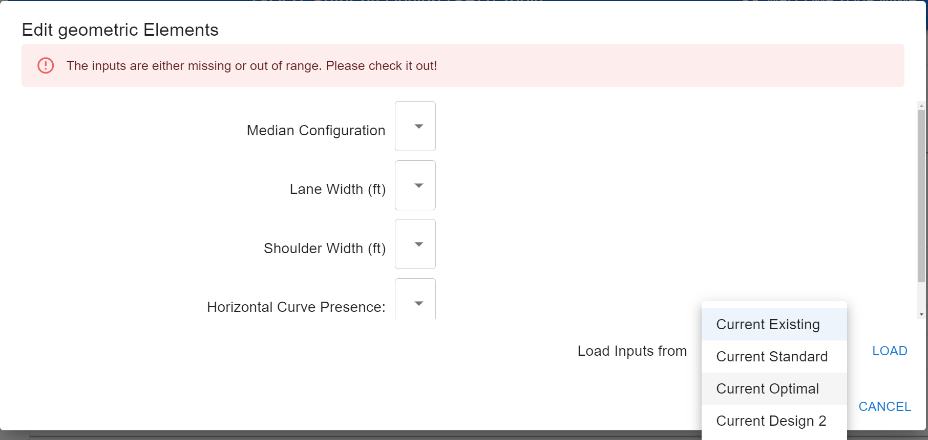
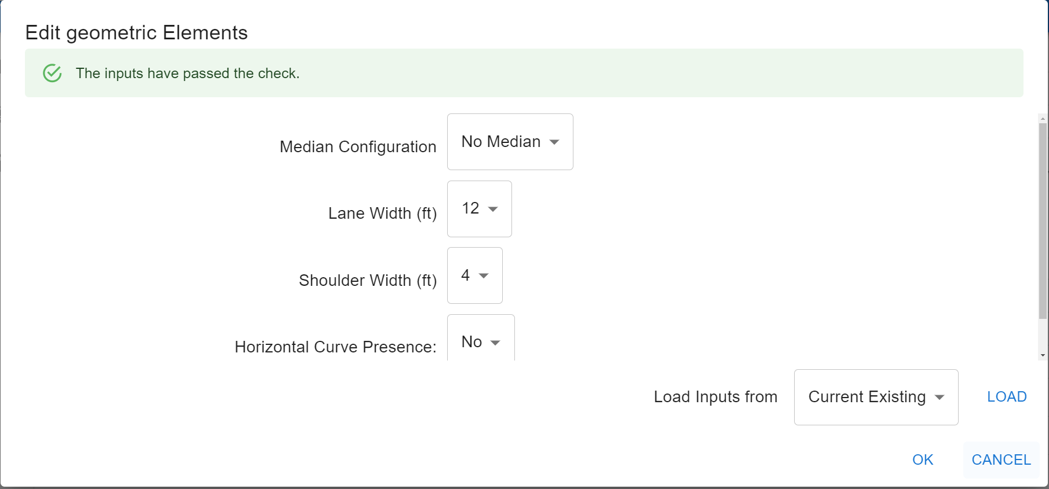
There is also vortex plot after clicking “CALCULATE” button, users can use to compare the marginal changes between different design configurations.
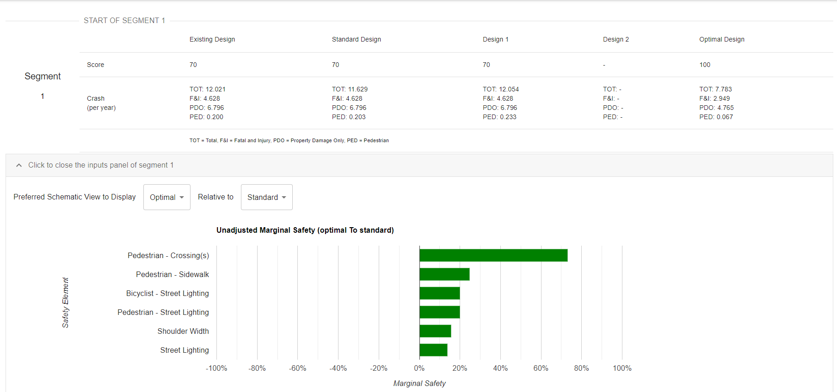

For registered and login users, Tool saves inputs and progress results every certain minutes. It is also highly recommended that users manually click “SAVE” button periodically.

- Click on “EDIT REPORT” button enables user to work on the project report.
The report includes basic information, summary table, elements increasing safety, constraints, and comments.
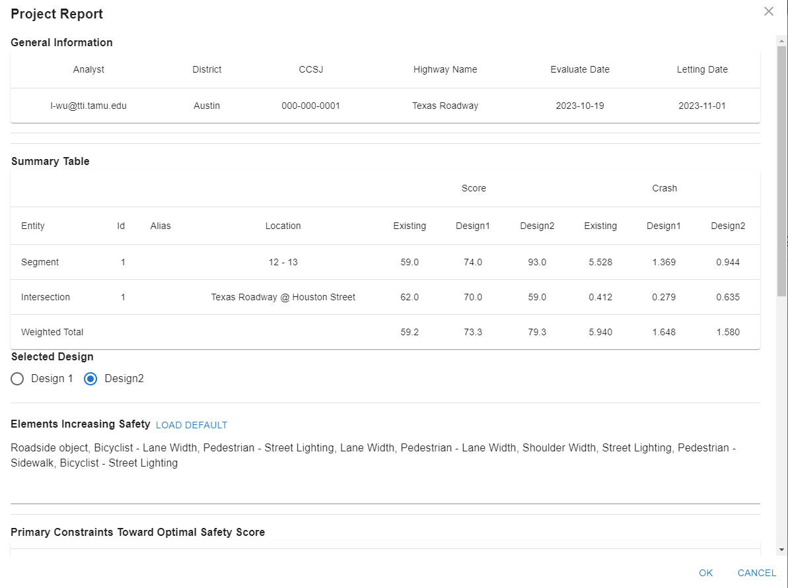
For elements increasing safety, the “LOAD DEFAULT” button will compare the selected design (i.e., Design1 or Design2) with existing configurations, and fill the report by comparison results. This feature is provided to make the assessment process easier, users are encouraged to verify the default values, and should be modified when needed.
There are primary constraints, users need to view and check the items that applies to the project.
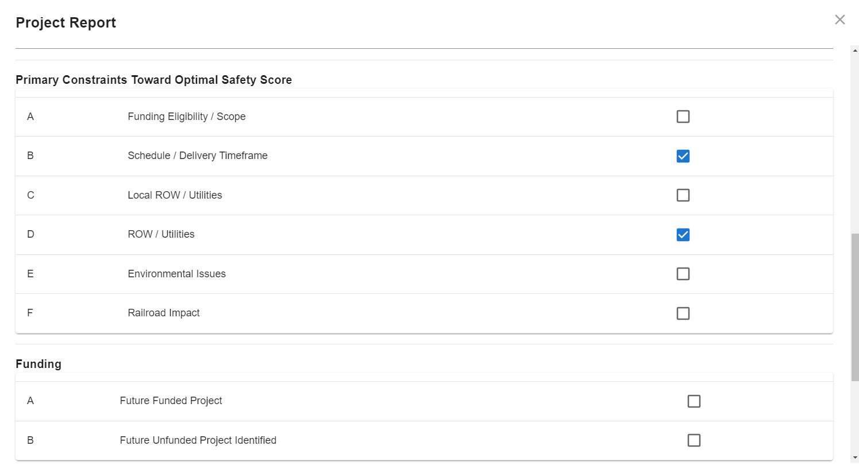
Finally, users need to estimate the additional cost and time to achieve optimal safety levels, and fill comments on primary constraints. Upon clicking on the OK button, inputs in the report sections is saved.
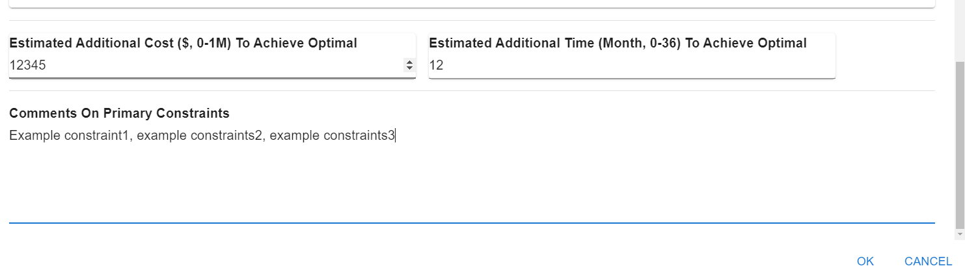

- Click on “PRINT REPORT” button enables user to download the report as a PDF or print the report.
The PDF file includes the general information, summary table, selection, elements increasing safety, constraints, comments as well as all the inputs (configurations).
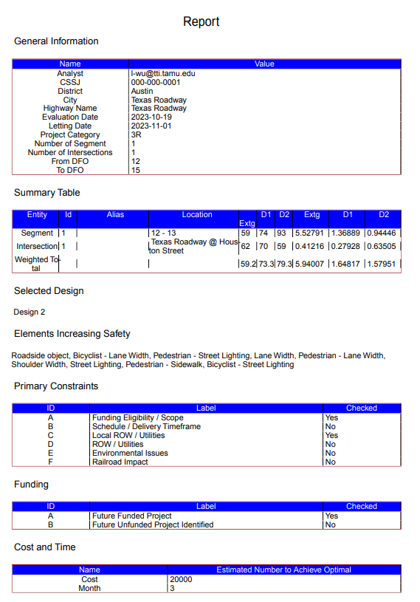
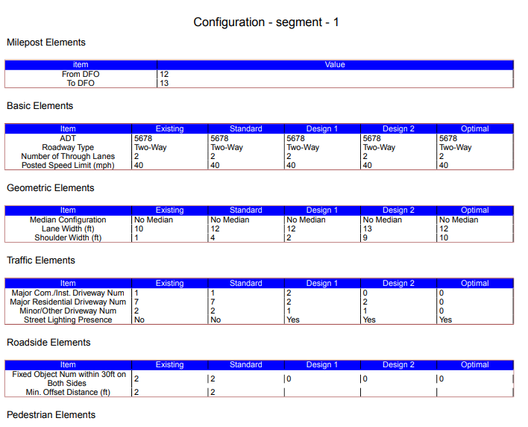
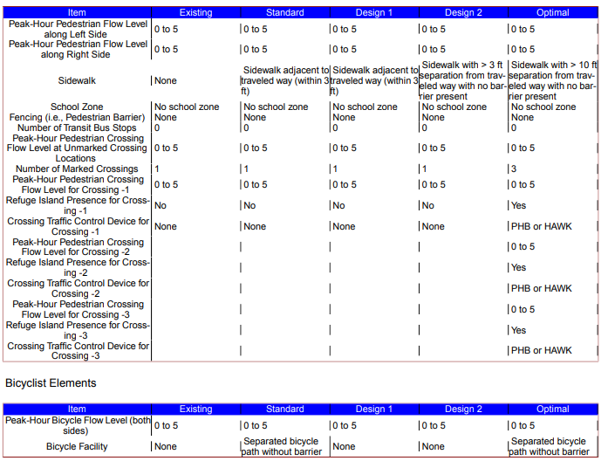

6. Registered User - Project Management
Registered users can edit a saved project. Go to the Project Management page, locate the project to be assessed, click on the pencil icon (second last column called “Edit”). Then follow the steps discussed in Section 5 Safety Assessment and click “SAVE” button.
Once the user is ready to submit a project, go to the Project Management page, locate the project to be submitted, click on the submit icon (last column called “Submit”). User may type optional message in the comments box. Then click “SUBMIT” button.
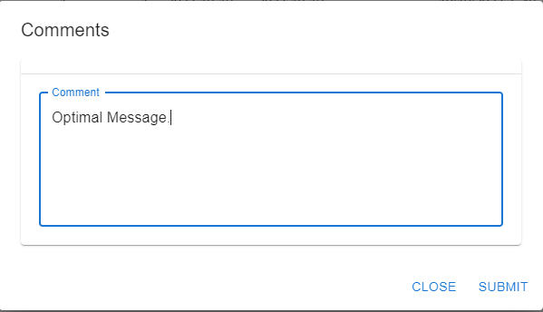

Once submitted, the status of the project will become “Submitted,” (refresh the Project Management page), and it cannot be edited, unless a TxDOT Division-level Administrator sends it back (project status becomes “Pending”).
Users can search projects using the project attributes (e.g., CCSJ, Highway, Dates), this can be done using the FILTER button in the project management page.
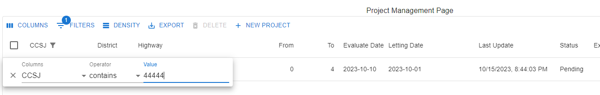
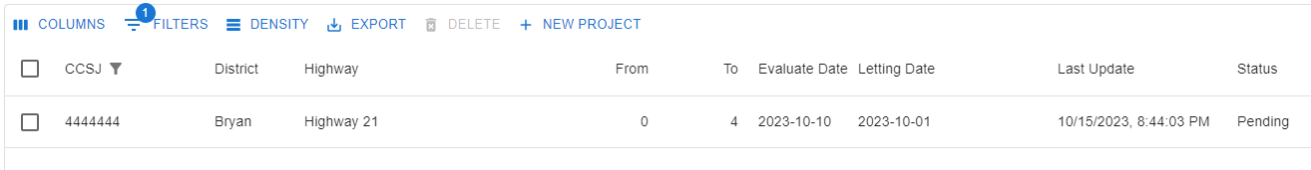

Users can also delete projects. Select projects by checking the box (first column of Project Management Page), then click “DELETE” button. After confirming, the selected projects will be deleted from Tool. Note, projects cannot be restored after deletion.
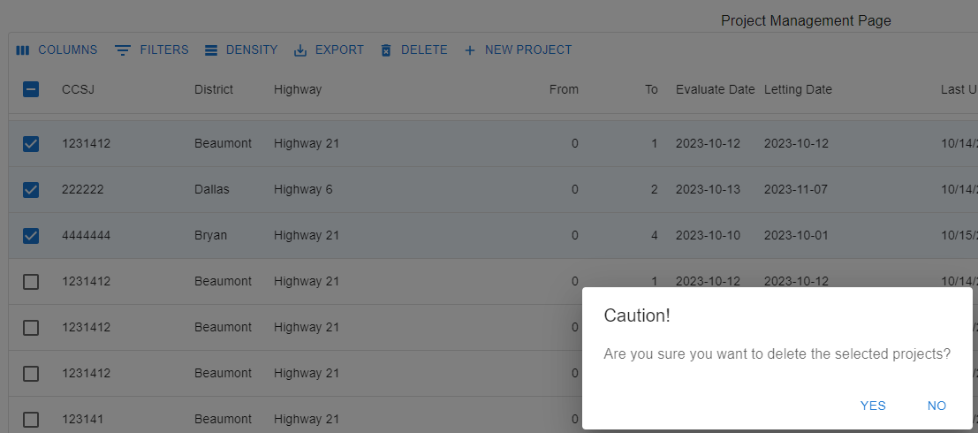

The ownership of a project can be transferred by the current owner, district level managers associated with the project district, or TxDOT division-level managers. To transfer ownership, locate and select the target project(s) on the Project Management Page, click “TRANSER OWNERSHIP”, type the email of new owner, then click “TRANSFER OWNERSHIP” button.

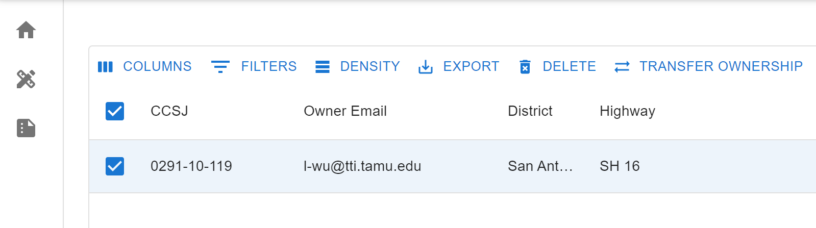
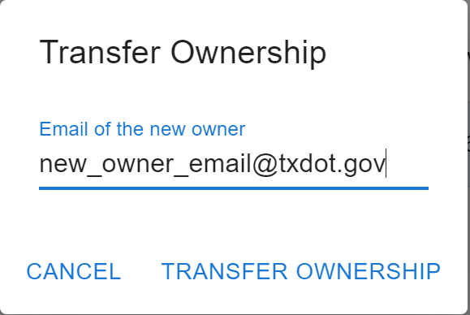
Note that once a project is transferred to a new user, the previous user will not have access to the project.

7. TxDOT Division-Level Administrator - Management
Project Management
Registered users with TxDOT Division-level Administrator roles can send back a submitted project. The process is similar to that of submitting a project (refer to Section 6).
Registered users with TxDOT Division-level Administrator roles can download summery table of selected projects as a CSV file. Select projects by checking the box (first column of Project Management Page), then click on “EXPORT” button, and “Downloaded as CSV.” A CSV file of the selected projects will be downloaded to local drive.
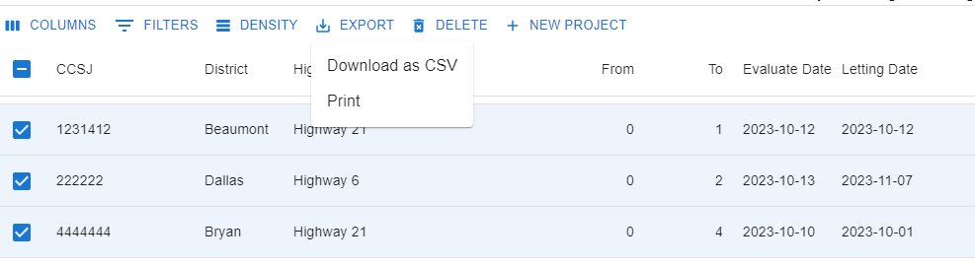

User Role Management
Registered users with TxDOT Division-level Administrator roles can add, modify, and remove roles to a registered user.
To add a registered user as a District-Level Manage, navigate to User Management Page, then click “ADD ENTRY” button. Then fill the row (at the end of this page) with email, name, role type, and district. After that click the save icon. This user is added as the manager of the selected district.
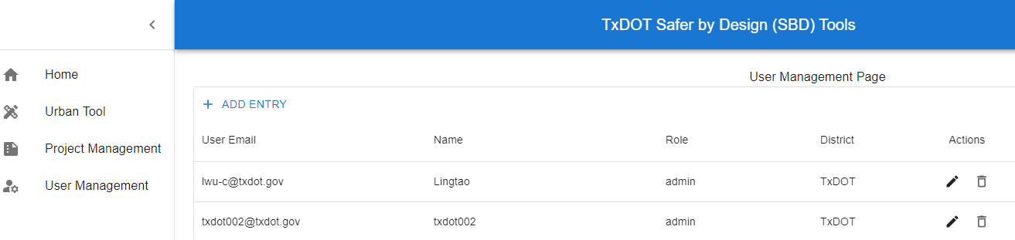

To add a registered user as a District-Level Manage, follow the same steps as adding a new district level manager, but choose Admin for Role, and TxDOT for District, then click save icon.
To update a user role, click on the pencil icon, then make changes, and click save icon.
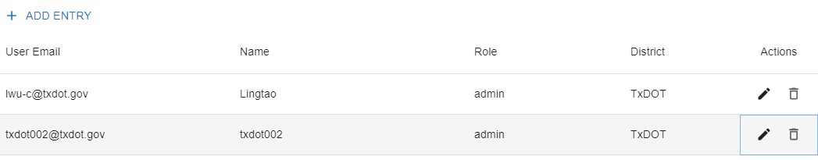

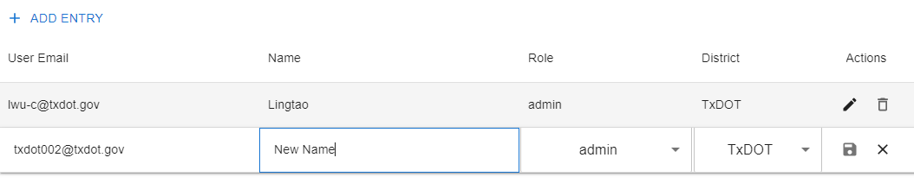
w
To delete a user role, click on the delete icon.
