Social Media Match
Behavioral Traffic Safety
Effective Date: October 1, 2023

Any deviations from these policies and guidelines must have written approval from the BTS Section Director.
Overview
In fiscal year 2016, the Texas Department of Transportation (TxDOT) launched a social media match trial program in order to explore the option of using social media as a viable source of earned media match for programs and campaigns funded by National Highway Traffic Safety Administration (NHTSA) grants. That trial has evolved into our social media match program which has the following benefits:
• Supports the goals and strategies of our state traffic safety program to reduce the number of motor vehicle-related crashes, injuries, and fatalities in Texas
• Serves as an incentive for TxDOT sub-grantees and media agencies to use social media in order to engage the citizens of our state in a more personal and collaborative way regarding the issues of traffic safety
• Evaluates processes and procedures to determine whether or not the time spent garnering social media match brings adequate value for the investment required
• Establishes the best methods for implementing a social media match program

Social media has evolved quickly into a necessary part of our safety campaigns and programs. This program has received clearance to be used for match on NHTSA grants in our State. The program will be updated regularly as the social media industry grows and changes.
Defining Social Media Match
Research has shown that any time a story is seen as an “editorial” instead of a paid message it is valued more by the public. People are often more inclined to trust what other people say rather than what an organization says about itself. Authenticity is the key. If you don’t believe that someone is being genuine; or if you think they have a hidden motivation (such as profit), then their message is easy to discount.

Earned media is especially influential when it comes to social media because social media revolves around obtaining information from people that are already known and trusted such as friends and family. It’s about public engagement and collaboration. It provides everyday people an opportunity to easily and quickly voice their opinion and participate in the discussion through comments, likes, and shares. And information spreads quickly in the social media environment.

With regard to social media, only earned media will qualify for match. Excluded from This definition are the two categories: 1) “paid media” and 2) “owned media.”

It is not customary to include paid media or owned media when calculating earned media values. The purpose of earned media is to show community support and engagement independent from the owners of the campaign. Owned media and paid media do not show a viewpoint independent from the campaign managers and does not show engagement by the community, so it is not eligible for match. See chart below for examples of paid, owned and earned media.

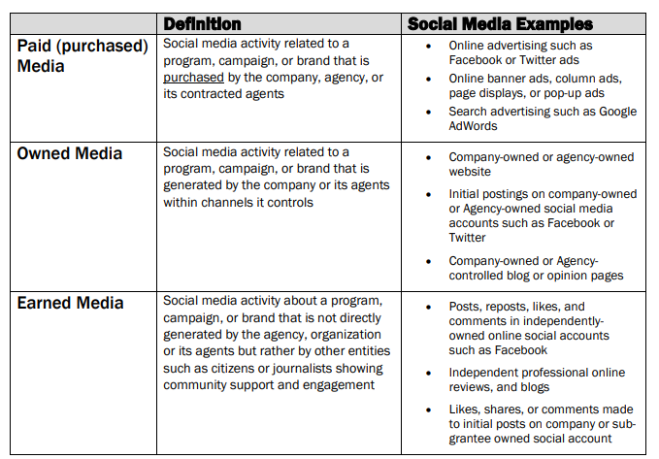

Qualifying Activities and Posts
For TxDOT’s social media match program, the social media platforms that are included are the following most prolific:
- Independent Blogs (not owned by TxDOT or a TxDOT contractor/subgrantee)
- Facebook
- Twitter
- YouTube
- Instagram

One of the benefits of social media to our Texas traffic safety program is it engages the citizens of our state in a personal and collaborative way regarding traffic safety. It utilizes social media platforms to spread awareness and find solutions to traffic safety issues. Therefore, in order to qualify, all social media activities and posts, whether they are the initial post or a shared post, the narrative on the post must contain the following:
- A specific “call to action” related to traffic safety.
- The hashtag: #EndtheStreakTX

Third party posts, which are posts that are created by others who are not part of the subgrantee agency, can be counted and do not have to follow the guidelines above if they are specifically about the grant project in question. They cannot be a general posting about the agency or subgrantee organization.

Examples
Example 1: (Yes, would count)
A post created on Facebook by the subgrantee agency, ABC State University, that appears as follows:

Thank you to our partners, XYZ Insurance Agency for their support of our recent bicycle rodeo. ABC State University reminds you to always remember to wear a helmet when riding your bike! #EndtheStreakTX
This post would count. It contains a call to action (wear a helmet when biking) and the required hashtag.

Example 2: (No, would NOT count)
An image shared to Instagram from subgrantee agency, ABC State University, that appears as follows:
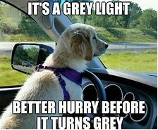

#EndtheStreakTX
This post would NOT count. While it does contain the required hashtag, it does not include a call to action so it does not meet the requirements.

Calculating Values
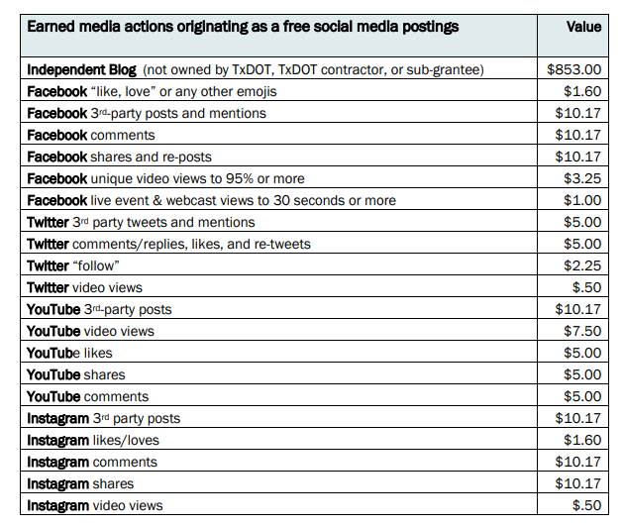
Initial postings do not count and do not have a match value. They are considered “owned media” due to being created by the company or are agency-owned. All comments, likes, shares and views on the initial post do qualify- including negative reactions and comments. Negative comments tend to produce multiple positive comments that might not have originally been posted if not for defending the original negative comment. The value of each type of action is indicated in the chart below:

Influencers
Values may be adjusted to a higher value based on whether the action/posting/tweeting is done by an “influencer” or “celebrity”. Values may be increased from the amount indicated in the chart based on the number of followers held by the person or organization who has taken the action.

Influencers must be documented by a screen capture showing the number of followers which must be over 1,000. They must not be invested in the grant.

We base our influencer formula on a standard social media measurement of “influencer accounts” called “Engagement Per Thousand” (EPM) which is:
# of followers – divided by 1,000 – multiplied by the unit value for free/volunteer actions (such as 3rd party posts) shown in the charts above.

Example:
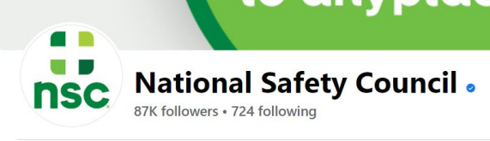
National Safety Council has 87,000 followers. If National Safety Council “liked” a subgrantee social media post, that “like” value would increase as follows:

87,000 / 1,000 = 87 x $1.60 = $139.20

Analytics
Option 1:
All social media programs offer free analytics software tools which are accessible from the front page of your organization’s profile page – in the top bar of the screen. The analytics software is called “Insights”. Once clicked, “Insights” allows the user to specify a date range and download the information into an Excel spreadsheet. The download will include information such as a list of posts with corresponding data such as likes and comments.

When calculating video views, for Facebook and YouTube only unique video views of 95% or more can be counted. Facebook live events use “Lifetime Total 30-Sec Views” since live events tend to be much longer. For Instagram and Twitter, all video views can be counted as the free analytics currently does not have the capability of detailing unique views to 95% or more.

Facebook Posts: Analytics How To
Facebook Videos: Analytics How To
Twitter: Analytics How To
YouTube: Analytics How To

Option 2:
Subgrantees may also utilize paid tracking software such as but not limited to Hootsuite, Sprout, Cision or any of the various other paid services that monitor and analyze social media platforms. The cost of the software can be reimbursed as match only and will not be paid for with grant funds.

When using either of the options above, you may provide links, however screen captures are required of the entire post so that it may be verified as a qualifying post. Posts without screen captures will not be able to be verified and risk not receiving any credit.

Documentation and Verification
Social media match must be tracked, verified, and documented. Records must be maintained including all screen captures of the posts in the event that online links become unavailable for viewing.

Analytics Spreadsheet
An analytics spreadsheet has been created to capture the social media match activity for the reporting period. The spreadsheet can be found here. It can be downloaded and saved for your use. This spreadsheet must be included when reporting social media match.

Reporting
All documentation shall be included on the Request for Reimbursement (RFR). Please do not include social media match documentation in the Performance Report (PR) unless it is necessary for performance reporting purposes. If there is no social media match to report for the reporting period, it is not necessary to report this in the RFR.

Avoid reporting more than one month of social media match per month. If this is unavoidable and a post was missed from a previous reporting period, please make the date(s) clear in your analytics spreadsheet and ensure that the date(s) are visible on the screen captures.

You may begin and end the social media match program at any time by notifying your project manager in advance.

